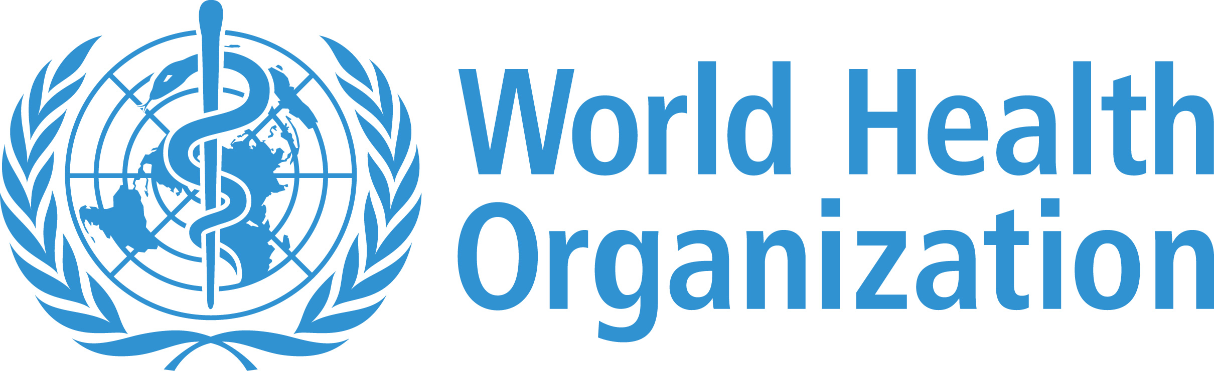

Vacancy Notice

Position: Health Cluster Coordinator Requisition No. 2100509 – Fixed Term – P5

BACKGROUND AND OBJECTIVES OF THE FUNCTION
The mission of WHO's Health Emergencies Programme (The Programme) is to help countries, and to coordinator international action, to prevent, prepare for, detect, rapidly respond to, and recover from outbreaks and emergencies.
Sensitivity: Internal & Restricted
PURPOSE OF THE POSITION.
To promote and uphold the humanitarian and public health principles by leading a coordinated and effective health sector response together with the national and international community, with
specific attention to vulnerable and marginalized populations, through effectuating WHO's
commitment to work within the framework of the Interagency Standing Committee (IASC) and the cluster approach. The incumbent will be responsible for performing a dedicated coordination, health needs assessment, strategy development and resource mobilization, supporting the implementation and, monitoring the joint incident management system and advocacy function.
DESCRIPTION OF DUTIES
Summary of Assigned Duties (Describe what the incumbent has to do to achieve main objectives; include main achievements expected):

During deployment, the duty station may change, and duties may be modified, based upon the technical needs of the Programme. Needs assessment and gap analysis
- Manage, coordinate and be the overall lead within the health cluster or at inter-cluster level for rapid health needs assessments, as well as participatory assessments (multi cluster/sector initial rapid assessments and humanitarian needs overviews, post-event risk assessment post disaster/post conflict needs assessment); be familiar with and ready to choose from existing tools to confirm that the health cluster covers all identified humanitarian health needs of the affected population.
- Collect information from all health partners on Who's Where, since and until When, doing What (4Ws), and regularly feed the database managed by the United Nations Office for the Coordination of Humanitarian Affairs (UN-OCHA). Provide consolidated feedback to all partners and the other clusters. Strategic planning
- Lead the development, in cooperation with the health cluster members, of the health sector components of the humanitarian needs overview (HNO) and humanitarian response plan Sensitivity: Internal & Restricted (HRP) as well as contingency planning for potential new events and other interagency planning,
ensure proper linkages with the incident management system, disaster risk reduction, relief and recovery to complement national health sector preparedness/response plans.
- Ensure full compliance with national and international norms and standards, oversee that cross-cutting issues are mainstreamed in the health cluster response and implementation plans, taking into account the need for local adaptation. Coordination of the health cluster
- Facilitate health partner coordination and involvement in health and other related sector assessments (e.g. nutrition, WASH), planning, information, interventions, monitoring and quality assurance, and regularly report on health services delivered to the affected population.
- Identify urgent technical gaps and training needs in relation to technical standards and protocols for the delivery of key health services to ensure their adoption and uniform application by all health cluster partners; identify opportunities for capacity building in collaboration with partners.
- Ensure appropriate links among humanitarian actions and longer-term health sector plans, incorporating the concept of “building back better” • and specific risk reduction measures.
- Convene and facilitate consultative and results-oriented meetings in line with the principles of partnership. Organize and conduct joint support missions to field operations.
- Oversee the development of a functional Information Management strategy and mechanism for the health cluster to facilitate information sharing as well as monitoring and reporting; ensure that the health cluster produces and disseminates to partners, donors, government and other stake holders’ regular updates, technical reports, bulletins and briefings on the health status of the affected people, response activities, resources mobilization, achievements, challenges and the remedial actions when necessary.
- Support national (health system) capacity building in emergency preparedness and
response in accordance with the IASC emergency response preparedness (ERP) approach and other related guidance. Resources mobilization and funds allocation
- Liaise and manage the development of resource mobilization efforts, oversee the initiation of Central Emergency Response Fund (CERF) and other pooled fund proposals and other funding documents, as required, in close collaboration with the Head of the WHO Country Office, and in consultation with the health cluster partners and the humanitarian country team.
- Establish clear and transparent prioritization criteria for vetting partners' projects for inclusion in consolidated appeals and pooled funds processes. Monitoring and evaluation
- Coordinate the development, adaptation and implementation of an indicators' monitoring framework to ensure adequate implementation of the health cluster plans; empower partners' active involvement in joint monitoring of individual and common plans of action for health interventions. Promote peer exchange of experiences and lessons learned within the cluster partnership Advocacy.
- Identify core advocacy concerns for the Health Cluster through a consultative process: develop joint cluster/ inter-cluster initiatives to ensure regular and consistent advocacy is conveyed to the RC/HC and humanitarian country team. Advocate for collective action, collective results, and collective accountability.
- Represent the Sensitivity: Internal & Restricted health cluster in inter-cluster coordination mechanisms at country/field level, contribute to jointly identifying critical issues that require multisectoral responses, and plan the relevant synergistic interventions with the other clusters concerned.
- Advocate for priorities in the health sector, including protection for health workers and health facilities and the highest possible integration of the health-related activities in the humanitarian agenda. Perform any other cluster related incident-specific duties, as required by the functional supervisor.

REQUIRED QUALIFICATIONS
Education
Essential: An advanced university degree (Master's level or above) in public health, medicine, international
health, management or social sciences or related field.
Desirable: Specialized training in emergency management, international aid, humanitarian principles, health
system recovery, and health cluster coordination.
Experience:
Essential: At least 10 years of relevant experience - at national and international level, in developing and
promoting collaborative partnerships in emergency and humanitarian relief operations, including
experience in managing and coordinating health programs in chronic and acute, suddenâ€‘onset
emergencies.
Sensitivity: Internal & Restricted

Desirable: Relevant work experience in WHO, other UN agencies, health cluster partners, relevant
nongovernmental or humanitarian organizations.
Skills
- Demonstrated knowledge of the rapid response operations and their implementation in
emergencies as related to public health, complemented by demonstrated ability to identify and manage difficult situations, to lead and direct multidisciplinary and multinational staff. In-depth knowledge of emergency relief policies and practices within the UN, other UN specialized agencies, donor agencies, national and international NGOs.
- Sound knowledge and experience about disaster prevention and preparedness programmes and the incident management system.
- Excellent negotiation skills and ability to convene stakeholders and facilitate a policy process among UN, NGOs, national health authorities and donors.
WHO Competencies
1. Teamwork
2. Respecting and promoting individual and cultural differences
3. Communicating in a credible and effective way
4. Creating an empowering and motivating environment
5. Building and promoting partnerships across the organization and beyond

Use of Language Skills
Essential: Excellent knowledge of English.

Specific skills required:
- Sensitivity: Internal & Restricted

- Knowledge of Microsoft Office software applications. Excellent presentation skills.
ADDITIONAL INFORMATION
- This Vacancy notice may be used to fill other similar positions at the same grade level in other locations within South Sudan.
  - Only candidates under serious consideration will be contacted.
  - A written test may be used as a form of screening.
  - If your candidature is retained for interview, you will be required to provide, in advance, a scanned copy of the degree(s)/ diploma(s)/certificate(s) required for this position. WHO only considers higher educational qualifications obtained from an institution accredited/recognized in the World Higher Education Database (WHED), a list updated by the International Association of Universities (IAU)/United Nations Educational, Scientific and Cultural Organization (UNESCO). The list can be accessed through the link: http://www.whed.net/. Some professional certificates may not appear in the WHED and will require individual review.
  - For information on WHO's operations please visit: http://www.who.int.
  - WHO is committed to workforce diversity.
  - WHO has a smoke-free environment and does not recruit smokers or users of any form of tobacco.
  - Applications from women and from nationals of non and underrepresented Member States are particularly encouraged.
  - WHO's workforce adheres to the WHO Values Charter and is committed to put the WHO Values into practice - https:// www.who.int/about/who-we-are/our-values
  - WHO has a mobility policy which can be found at the following link: http://www.who.int/employment/en/. Candidates appointed to an international post with WHO are subject to mobility and may be assigned to any activity or duty station of the Organization throughout the world.
  - Applications from women and from nationals of non and underrepresented Member States are particularly encouraged to apply.
  - For WHO General Service staff who do not meet the minimum educational qualifications, Please see e-Manual III.4.1, para 220./ul

How to apply: Please follow the below link
https://careers.who.int/careersection/ex/jobdetail.ftl?job=2100509&tz=GMT%2B02%3A00&tzname=Africa%2FKhartoum
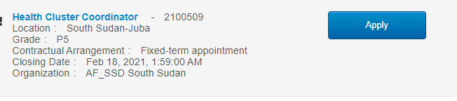

Candidates wishing to submit applications for WHO advertised positions must first create their personal accounts/profiles in Stellis. Please find attached a Quick Guide to do this.

