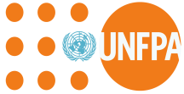
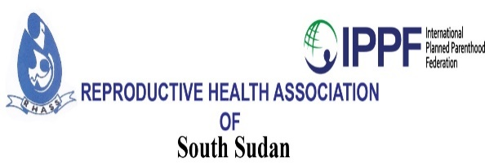

06/09/2019

Family planning advocacy, social mobilization and sensitization plan
Terms of Reference
Introduction
South Sudan has one of the highest fertility rates in the world; averaging 6.7 births per woman with an estimated population of 12,575 m. Youth under age of 30 years constitute 70% of this population and 81% of this population is rural. Unmet need for Family planning is 29.8%. The Country’s Maternal mortality ratio is still high at 789 death per 100, 000 birth and the neonatal, infant and the under 5 mortality is still a worry at 39, 60, 93 death per 1000 live birth. HIV prevalence rate is 2.5%. A big factor underlying high birth rates is the low use of modern contraception: only 2.6% of married women in the Country use modern methods of family planning. Increased use of family planning in the Country would lead to large improvements in the health of the mothers and the children, the status of women, and economic development. For these reasons, health and development partners in South Sudan are rededicating themselves to ensuring that family planning is available to all who need it.
The reasons behind this low use for Family planning vary greatly; access to modern method of contraception, lack of sufficient knowledge on Family planning, opposition to the use of Family planning by husbands or relatives due to religious or cultural reasons are some.

Purpose of this Consultancy
The Reproductive Health Association of South Sudan seeks to contract the service of a qualified consultant to carry out in collaboration with local stakeholders and partners a Family planning advocacy, social mobilization/sensitization plan in SouthSudan.

The task of the Consultant
The consultant is expected to undertake the following task;
- To carry out meetings with the Government Health officials, opinion leaders, religious leaders, traditional leaders and partners supporting Family planning programs in respective States and Counties with UNFPA support to find out what is happening in their settings.
- The need to get information from the States and Counties about data on Fertility rates, Contraceptive use rates and the level of unmet need if data are available
- Information on other related Health and social information if available is needed and to analyze the family planning programs in the States, Counties and the role out of an advocacy plan.
- The proportion of youth in the States and Counties, and Family planning indicators if data are available.
- Information on other related Health and Social activities, i.e. Maternal, infant and under 5 mortalities, HIV/AIDs prevalence, gender norms and other behaviors of the local Society that affects fertility and any other Socio- cultural issues or religious beliefs that can serve as barriers to use of Family planning.
- Lastly information on aspects of programmatic and policy environment for Family planning in the different States.

Objectives
The ultimate goal for this terms of this advocacy plan is to improve access to and quality of Family planning and hence to increase Family planning use. Thus the plan advocacy tool should:
- Increase awareness of key officials about specific problems facing Family planning programs in Country.
- Influence the budget allocation process
- Encourage changes in the way services are organized, regulated, or directed
- Mobilize and better manage organizations with a family planning mandate to push for more and sustained attention to family planning over a period of time.
- Influence Community and traditional leaders on the importance and benefits of Family planning

Key Deliverables
- A report setting out the approaches in getting the information about Family planning from Government, the local communities as key informants and other partners in the different states.
- An advocacy tool for Family planning to buster support for FP activities in the Country.

Timeframe
The assignment is expected to take ten (10) days and includes travelling to States and Counties with UNFPA support facilities.

Qualifications

- Holder of a degree in a relevant discipline (development, social sciences, research, communications)
- Two years experience in programmes and advocacy (preferable with young people)
- Strong knowledge of contemporary development issues nationally and globally especially on youth participation in civic issues, sexual and reproductive health and rights, livelihood and employment, and national and global planning framework.

Duty Location
This assignment will be carried out in Juba with travels to Aweil and Kapoeta.

Consultancy fee
Fee will be in line with the RHASS finance policy (100%) payment on completion of the assignment.
Procedure for submission of express of interest
Interested candidate should send a copy of a one-page expression of interest, your profile with details of your track record relevant to the assignment, CV and a one-page concept note on how you will implement the TOR and send all these documents either by hand to the Reproductive Health Association of South Sudan’s office in Hai Mauna along Gudele road opposite the church complex or by mail to recruitmentrhass@gmail.com by Friday 13th September.

