AAH-I South Sudan
Juba Office, off Munuki Road,
Next to South Sudan Civil Service Commission

REQUEST FOR QUOTATIONS

Background
Action Africa Help International (AAH-I) is a nongovernmental and nonprofit making Organization operating in South Sudan with a mission to support disadvantaged Communities to sustainably improve their standard of living through Community empowerment approach in partnership with stakeholders. AAH-I implements Primary Health Care, Agriculture, Humanitarian aid projects and Capacity Building.

The organization is calling for quotation from reputable companies to supply a motor vehicle as per specifications listed below:

 | TOYOTA L/C - VEHICLE SPECIFICATIONS
A | OVERVIEW
 | Model code | HZJ78-RJMRS-S11
 | Drive | 4x4
 | Transmission | Manual
 | Speed | 5
 | Front suspension | Coil
 | Rear suspension | Leaf
 | Front brakes | Disc
 | Rear brakes | Drum
 | Number of doors | 3
 | Number of seats | 11
 | Seat material | Vinyl
 | Colour | White
B | ENGINE & CHASSIS
 | Engine model | 1HZ
 | Displacement | 4164
 | Number of cylinders | 6
 | Maximum power (kw/rpm) | 96/3800
 | Maximum power (bhp/rpm): | 129/3800
 | Maximum torque (Nm/rpm) | 285/2200
 | Electrics (volts) | 12
 | Fuel Type | Diesel
 | Fuel tank capacity (Litres) | 90+90
C | ENGINE RELATED STANDARD FEATURE
 | Air Cleaner: cyclone with snorkel | Fuel sedimenter w/fuel filter
 | Battery: 65 amp-hour battery (12v) | Full-floating rear axle
 | Battery: 80D26 (12V) | High altitude compensator
 | Brake control valve (Load Sensing Pressure Valve) | Power assisted steering
 | Differential - rear 4.300 4P | Stabilizer bar - front & rear
 | Engine oil cooler | Transfer box protection
D | SEATING ARRANGEMENT
 | 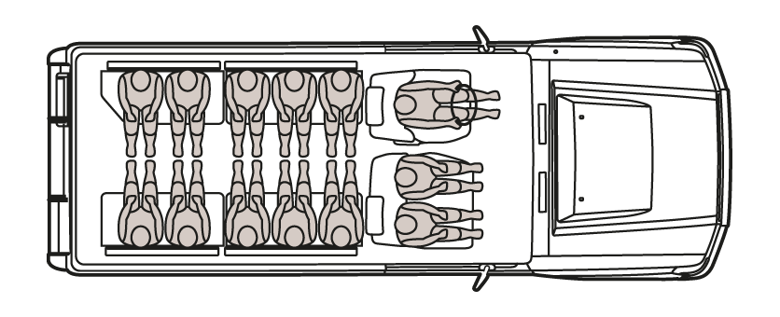
 | Number of seats | 11
 | Front seating arrangement | 1+2
 | Front seating type | Bench
 | Rear seating arrangement | 2x5 Inward facing
 | Rear seating type | Bench
E | WEIGHTS (kg)
 | Kerb weight | 2260
 | Gross Vehicle Weight | 3200
 | Payload | 940
F | DIMENSIONS (mm)
 | Length | 5070
 | Width | 1770
 | Height | 2115
 | Wheelbase | 2980
 | Ground clearance | 235
G | TYRES
 | Front tyres | 7.50R16-8 - Tubed
 | Rear tyres | 7.50R16-8 - Tubed
 | Tyre type | Dunlop, 8 ply 114, Radial
H | INTERIOR FEATURES
 | Air cleaner warning | Odometer: digital
 | Ashtray | Oil pressure warning light
 | Assist grips x 3 | One touch 2-4WD selector (H4 button)
 | Bottle Holder (Front) | Parking brake warning light
 | Brake fluid level warning | Pre-wiring for audio with 2 speakers and antenna
 | Cigarette lighter | Seat belts: front x 3 (2 x 3 point & 1 x 2 point)
 | Clock: digital | Seat belts: rear x 8 (2 point)
 | Dash silencer (interior only) | Speedometer km/h
 | Door ajar warning | Steering column-Tilt & Telescopic & Collapsible
 | Floor mats: rubber (FR: D+P) | Steering wheel lock
 | Floor silencer (around front pedals) | Sub fuel gauge
 | Footrest - Driver | Sub fuel tank switch
 | Fuel gauge | Sun visors D&P
 | Fuel level warning light | Timing belt replacement warning light
 | Glove box: w/o lock | Transfer - 4WD lever & knob
 | Headrests x 2 | Trip Meter
 | Heater: front | Vinyl floor covering
 | Interior lights: front and rear | Voltage meter w/warning light
 | Interior rear-view mirror (day and night) | Water temperature gauge
I | EXTERIOR FEATURES
 | Antenna | Rear step bumper
 | Bumper | Semi-sealed halogen headlamps
 | High/Low 2-speed windshield wipers (Inc. mist) | Side steps
 | Lockable fuel lid | Swing-out type back door
 | Mud guards: front & rear | Towing hook: FR & RR closed
 | Outside rear view mirror - Door | Windshield - green laminated
 | Rear quarter glass - sliding
 | Safety and Security
 | Anti-lock braking system (ABS) | Central door locking - w/remote
 | Deck guard frame | First Aid Kit
 | Spare wheel mounted behind the cabin, lockable | Lockable fuel cap
 | Front Bull Bar | Tool kit
 | Rear step Bumper | Installed Electric winch
 | Side steps
J | MISCELLANEOUS
 | Owner's manual - English | Tool Kit & Jack
 | Parts catalogue: English and French | Repair manual: English

REQUIREMENTS

Price and Currency: The prices shall be in United States Dollars (USD).
NB: The cost should be duty exempted and delivery location is Juba, AAHI Compound.

Submission of Quotes
The quotations shall be submitted in Hard copies in sealed envelopes, for Suppliers within Juba and soft copies for International Companies.

Submission Address

bids shall be submitted to:
AAH-I/UNHCR Logistic Base Juba South Sudan
Near JIT Supermarket, the envelope should be labeled
Read: Motor Vehicle
AAH-I South Sudan.

Registration for submission:
Please ensure that, you register your hand delivered quotation/bid with the Procurement department and drop it in the bid box yourself, before you leave the Procurement department.
Each hand delivered quotation/bid must be registered individually on the bids submission forms which will be available at Procurement department. Unregistered quotation/bid will not be considered even if it is dropped in the tender box.

Request for clarifications

Any request for clarification must be made in writing through the email: procurement.southsudan@actionafricahelp.org strictly and must be received not later than Friday the 26th June, 2020 at 12:00 pm Local Time.

Deadline for the submission of the quotation
The deadline for the submission of the quotes will be strictly on Tuesday the 30th June, 2020, at 12:00 pm Local Time.

Notification of the results
Only the successful and competitive bidder will be notified, and if you do not receive email communication within two weeks after the expiry of the deadline, consider your bid not successful.

Language for the bids

The language for the bids shall be English only.

Disclaimer

This is only a Call for quotations and AAH-I South Sudan reserves the right to either amend or cancel it at any time with or without notice. In such cases, AAH-I South Sudan shall accept no liability whatsoever. The prospective bidder is wholly responsible for any and all costs related to the preparation and submission of their quotations.

The decision of the AAH-I South Sudan Procurement Review Committee shall be final.

