
 Save the
3 February 2026
Re-Job Advertisement
Save the Children is an international non-governmental organization that works for a future of children, their families and communities realize social equity and dignity; have access to their basic physical, emotional and development needs.
SCI is seeking to recruit: -
Job Title: Business Development Manager
Location: Juba
Reports to: Director, Strategic Partnership and Influence
Contract Period: 12 months
CHILD SAFEGUARDING:
Level 3 - the responsibilities of the post may require the post holder to have regular contact with or access to children or young people.
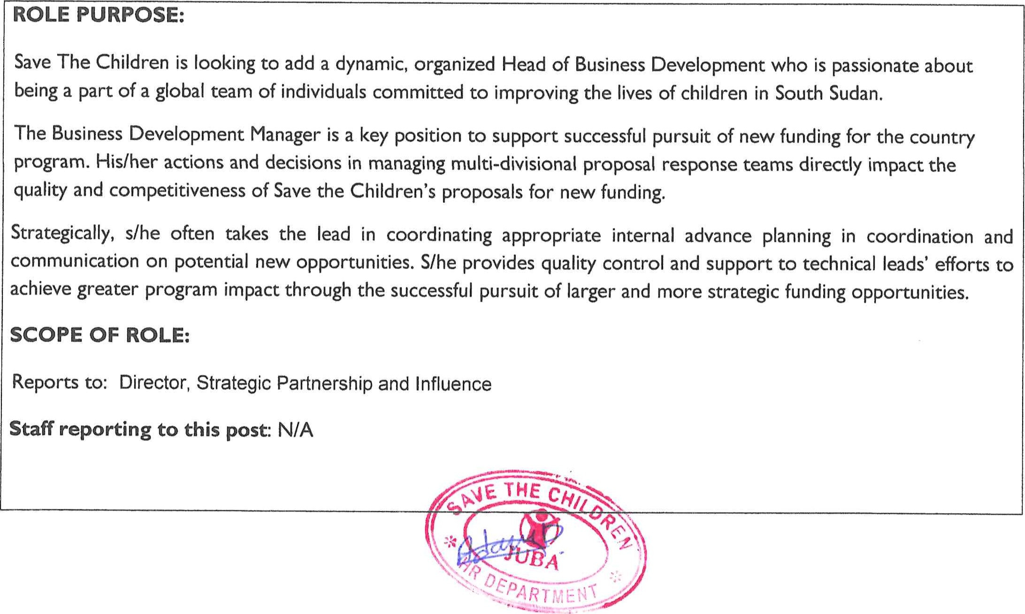

SKILLS AND BEHAVIOURS (SCI Values in Practice)
Accountability:
- Understands and respects the need for procedures, policies and planning for safety and security management in delivering humanitarian assistance o Holds self-accountable for making decisions, managing resources efficiently, achieving and role modelling Save the Children values
Holds the team and partners accountable to deliver on their responsibilities - giving them the freedom to deliver in the best way they see fit, providing the necessary development to improve performance and applying appropriate consequences when results are not achieved o Creates a managerial environment across the team to lead, enable and maintain our culture of child safeguarding Ambition:
- Sets ambitious and challenging goals for themselves (and their team), takes responsibility for their own personal development and encourages others to do the same o Widely shares their personal vision for Save the Children, engages and motivates others Future orientated, thinks strategically Collaboration:
Build and maintains effective relationships, with their team, colleagues, members and external partners and supporters o Values diversity, sees it as a source of competitive strength Approachable, good listener, easy to talk to Creativity:
Develops and encourages new and innovative solutions o Willing to take disciplined risks Integrity:
Honest, encoura es o enness and trans arenc .

QUALIFICATIONS
Essential:
o Master's degree in international development or related field

EXPERIENCE
6-8 years of experience in international development, including at least 5 years of experience in successful proposal development for institutional and corporate donors, including pre-solicitation preparation. Substantive relevant experience in proposal development for other multilateral or bilateral donors may be considered within the years of experience sought.
Experience training staff and creating traypjn dules and materials.
Experience managing a small team. THE
Ex erience in business skills devel , str en ihoods, or enter rise-related ca aci -buildin .

Preference for a candidate with overseas field experience.
Must be willing to travel to field offices offices up to 20%.
Ability to coordinate multiple projects simultaneously, work well under pressure and meet deadlines. Ability to effectively communicate with and coordinate activities of multiple partners, including field-based staff.
Excellent technical skills in writing, editing, formatting, research, negotiation, and verbal communications, and attention to detail required.
Additional job responsibilities
The duties and responsibilities as set out above are not exhaustive and the role holder may be required to carry out additional duties within reasonableness of their level of skills and experience.
Equal Opportunities
The role holder is required to carry out the duties in accordance with the SCI Equal Opportunities and Diversity policies and procedures;
Child Safeguarding:
We need to keep children safe so our selection process, which includes rigorous background checks, reflects our commitment to the protection of children from abuse.
Safeguarding our Staff:
The post holder is required to carry out the duties in accordance with the SCI anti-harassment policy
Humanitarian response
In the event of a major humanitarian emergency, the role holder will be expected to work outside the normal role profile and be able to vary working hours accordingly
Health and Safety
The role holder is required to carry out thsgy.ties-in.ccordance with SCI Health and Safety policies and procedures.
THE 


Application Information:
Please attach a copy of your CV , ID/ Passport and cover letter with your application and include details of your current remuneration and salary expectations. A copy of the full role profile can be found at(SCI Career Site Careers (oraclecloud.com)
Please attach the following documents
Application letter/Cover letter ID/ Passport
Education Qualifications/ Transcript and Certificate.
We need to keep children safe so our selection process, which includes rigorous background checks. reflects our commitment to the protection of children from abuse,
All employees are expected to carry out their duties in accordance with our global anti-harassment policy.
_In case you face difficulty accessing the link, please come to Save the Children International head office Juba Hai Malakal or SCI Field Offices for HR Technical support.
Deadline for submitting applications: 23 ^{rd}, February 2026 4.00 PM) the position will be filled subject to confirmation of the funding from the donor."


