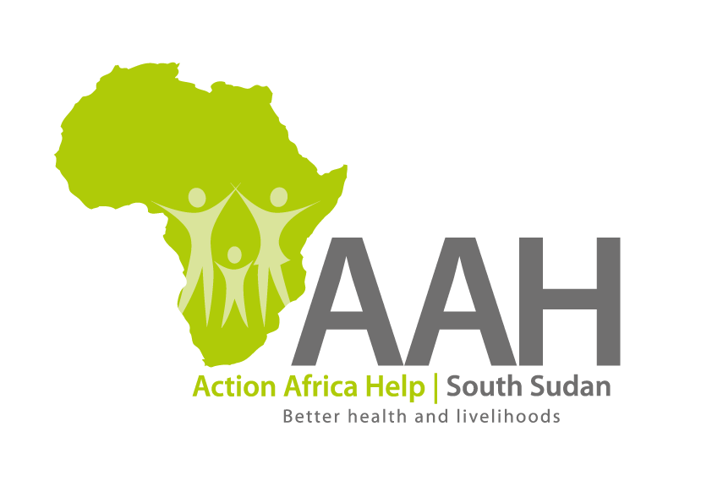
INVITATION TO TENDER – VARIOUS SERVICES

Background
Action Africa Help International (AAH-I) is a nongovernmental Organization and nonprofit making operating in South Sudan with a mission to support disadvantaged Communities to sustainably improve their standard of living through Community empowerment approach in partnership with stake holders. AAH-I implements Primary Health Care, Agriculture, Humanitarian aid projects and Capacity Building.

The organization is calling for quotations from competent and reputable suppliers for Provision of the following services and supply of construction materials with intention of getting into a one year Frame work agreement (2022).

Specific details on each tender should be picked from AAHI/UNHCR Juba Logistics Base during working hours.

 | Description of Goods/Services
1. | Internet Services
2 | Security Services
3. | Cargo Airlifting Services
4. | Road Transport Services
5. | River Transport Services
6. | Assorted Construction materials
7. | Garbage collection
8. | Sewage collection
9. | Supply of drinking water - 20 litres jumbo bottle
10. | Crane services
11. | Property Insurance
12. | Motor vehicle insurance
13. | Money Transfer Services
14. | Cash in premises

REQUIREMENTS

Price and Currency: The prices shall be in United States Dollars (USD).
Submission of Quotes
The quotations shall be submitted in Hard copies in sealed envelopes, and there shall be no submission of quotes in soft copies. The suppliers must adhere to this instruction to avoid inconveniences.

Submission Address
The bids shall be submitted to:

AAH-I/UNHCR Logistic Base Juba South Sudan
Near JIT Supermarket,
AAH-I South Sudan.

The envelope should clearly indicate the service/goods you are applying for.
Registration for submission:
Please ensure that, you register your hand delivered quotation with the Procurement department and drop it in the bid box yourself, before you leave the Procurement department.

Request for clarifications
Any request for clarification must be made in writing through the email: procurement.southsudan@actionafricahelp.org, Strictly and must be received not later than Monday the 15th November, 2021 at 4:00 pm local time.

Deadline for the submission of the quotation
The deadline for the submission of the quotes will be strictly on Monday the 22nd November, 2021 at 12:00 pm local time.

Notification of the results
Only the successful and competitive bidder will be notified, and if you do not receive email communication within two weeks after the expiry of the dead line, consider your bids not successful.

Language for the bids
The language for the bids shall be English only, but no other languages to be used.

Disclaimer
This is only a Call for quotations and AAH South Sudan reserves the right to either amend or cancel it at any time with or without notice. In such cases, AAH South Sudan shall accept no liability whatsoever. The prospective bidder is wholly responsible for any and all costs related to the preparation and submission of their quotations.

The decision of the AAH South Sudan Procurement Review Committee shall be final.

