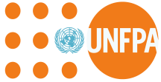
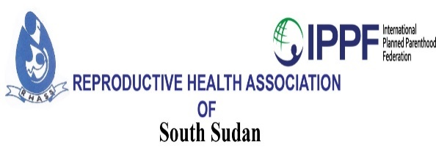

06/09/2019

: Map FP partners and services interventions, and conduct FP analysis of FP utilization data for accountability and decision making
Terms of refence
Introduction
Family planning (FP) reduces the burden of unplanned pregnancies, promotes smaller families, and improves maternal and child survival, household well-being, and women’s participation in development efforts. These benefits notwithstanding, over 225 million women globally who want to avoid pregnancy do not use effective contraception contributing to 85 million unintended pregnancies Yet, effective methods to prevent or postpone pregnancy exist
The drivers of low utilization of family planning services vary across the country the major barriers to family planning include poor livelihoods weak health systems and poorly-trained providers lack of access to quality sexual and reproductive health (SRH) information fears of side effects and weak support by male partners and religious, political and cultural authorities.
Purpose of the consultancy
The Reproductive Health Association of South Sudan seeks to contract the services of a qualified National consultant to carry out in collaboration with local stakeholders and partners mapping of Family planning partners and services intervention and utilization.

The task of the consultant
The consultant is expected to undertake the following;
- To carry out meetings with the Government Health officials, and partners supporting Family planning programs in respective States and Counties with UNFPA support to find out what is happening in their settings.
- The need to get information from the MOH about data on Family planning services utilization, Contraceptive use rates and the level of unmet need if data are available
Objectives
The ultimate goal for these terms of reference is mapping partners providing Family planning services, services interventions locations and FP utilization.
- Identifying FP partners, facilities providing FP services and their locations
- Data on key attributes (types of contraceptives available, Health workers providing FP)
- Knowledge on contraceptives supply and expansion of method mix
- Identifying of hard to reach areas.

Key Deliverables
- A report setting out the approaches in getting the information about Family planning partners, service provision sites and data on FP utilization from Government and stakeholders.
- A tool with information about FP partners. Service sites and data on utilization.

Timeframe
The assignment is expected to take ten (7) days and include meeting with officials from the MOH and partners providing FP.

Qualifications

- Holder of a degree in a relevant discipline (development, social sciences, research, communications)

Duty Location
This assignment will be carried out in Juba.

Consultancy fee
Fee will be in line with the RHASS finance policy (100%) payment on completion of the assignment.
Procedure for submission of express of interest
Interested candidate should send a copy of a one-page expression of interest, your profile with details of your track record relevant to the assignment, CV and a one-page concept note on how you will implement the TOR and send all these documents either by hand to the Reproductive Health Association of South Sudan’s office in Hai Mauna along Gudele road opposite the church complex or by mail to recruitmentrhass@gmail.com by Friday 13th September.

