INVITATION TO TENDER
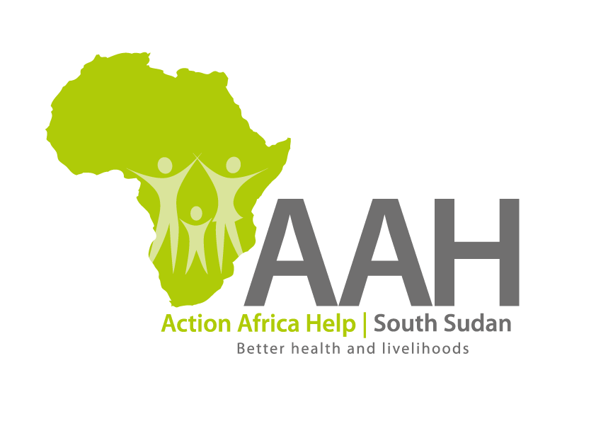
Background
Action Africa Help International (AAH-I) is a nongovernmental and nonprofit making Organization operating in South Sudan with a mission to support disadvantaged Communities to sustainably improve their standard of living through Community empowerment approach in partnership with stakeholders. AAH-I implements Primary Health Care, Agriculture, Humanitarian aid projects and Capacity Building.

The organization is calling for quotations from reputable companies for:

supply of caterpillar equipment’s spare parts and provision of technical services for repair and maintenance of the said equipment. This is with an intention of getting into long term

No. | Description
1 | Provision of technical services for repair and maintenance of caterpillar equipment.
2 | Supply of assorted construction materials
3 | Supply of cylinder GP stick (201-7080)

- Deadline of submission is 3rd June, 2022.

- Detailed tender document to be picked from:

AAH-I/UNHCR Logistic Base, Juba South Sudan
Near JIT Supermarket,
AAH-I South Sudan.

