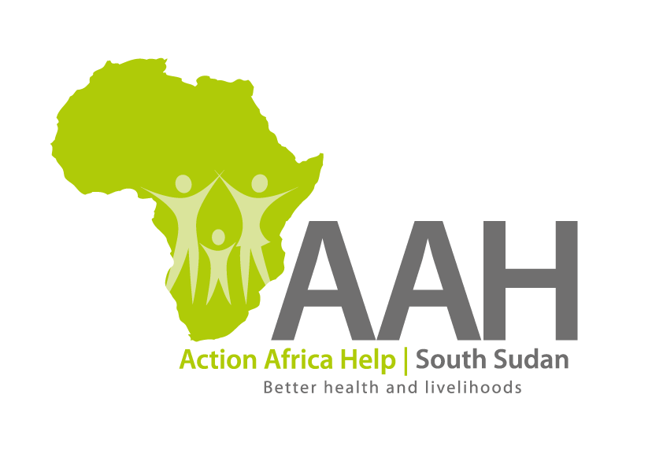
AAH South Sudan
Juba Office: Hai Gabat – Opp JIT Supermarket
Behind South Sudan Customs, Tel: +211 925 478 457
Email: ssudan@actionafricahelp.org
Website: www.actionafricahelp.org

INVITATION TO TENDER - RE-ADVERTISEMENT

Background
Action Africa Help International (AAH-I) is a nongovernmental and nonprofit making Organization operating in South Sudan with a mission to support disadvantaged Communities to sustainably improve their standard of living through Community empowerment approach in partnership with stake holders. AAH-I implements Primary Health Care, Food Security, Humanitarian aid and Public Works Projects.

The organization is inviting for bids from competent and reputable companies for Provision of Technical Services for rehabilitation of a motor grader whose specifications are shown below:

 | DESCRIPTION | UNIT
1. | Rehabilitation of the burnt Motor grader; (RFQ 7003)  Make and Model: CAT Grader 160K/C-7  Serial No: *KHX37726* Pin No: CAT 0160KCSZM00281, YEAR – 2011 | TOR to be picked from  AAHI/UNHCR Juba logistic base

Detailed ITB to be picked from AAHI/UNHCR Juba Logistic base during working hours.

Deadline for submission of the bids will be on 10th May, 2022.

