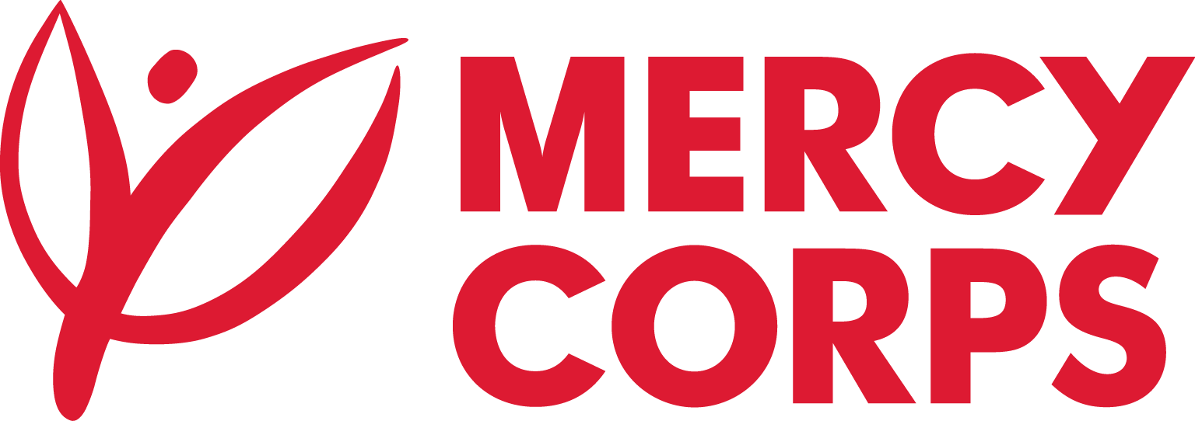
Date: 4th May 2026
References:
- JUB-0113 Construction of Pit Latrine-greater Mundri.
- JUB-0114 Construction of dry slab -greater Mundri.

Tender Notice
Mercy Corps is a non-religious, non-profit and non-governmental international humanitarian organization.

Mercy Corps is seeking to contract a legally registered companies in South Sudan to construction of the following:

- JUB-0113 Construction of Pit Latrine-greater Mundri.
- JUB-0114 Construction of dry slab -greater Mundri.

If your company is dealing in the areas cited above and is interested to compete in the bid, please download the forms from the links provided above, complete the Intent to Bid Form, Supplier Information Form and submit completed forms by email to ss-tender@mercycorps.org not later than May 6th, 2026 by 4:00PM CAT.

- Email must clearly show the Tender Reference number –
JUB-0113 Construction of Pit Latrine-greater Mundri.
JUB-0114 Construction of dry slab -greater Mundri, in the email subject line.

After the closing date of this Tender Notice, the Request for Bid will be sent to the suppliers who submitted Intent to Bid Forms. The Request for Bid will be sent according to the preference you have mentioned in the Intent to Bid Form.

