**Specification for Cargo Tri-motorcycle.**

|  |  |  |
| --- | --- | --- |
| Engine | Brand | Lifan/Zongshen Engine |
|  | Type | one cylinder, 4-stroke, AIR COOLING |
|  | Displacement | 250 cc |
|  | Ignition method | CDI |
|  | Starting method | Electric / Kick |
| Weight | Gross weight | 480kg |
| Load capacity | 1.5 Ton |  |
| Chassis | 2.0 mm thickness tube |  |
| Cargo Box | 2000*1350 mm | |
| Front Shock Absorber | 60mm diameter double Type | |
| Color | Red or Blue | |

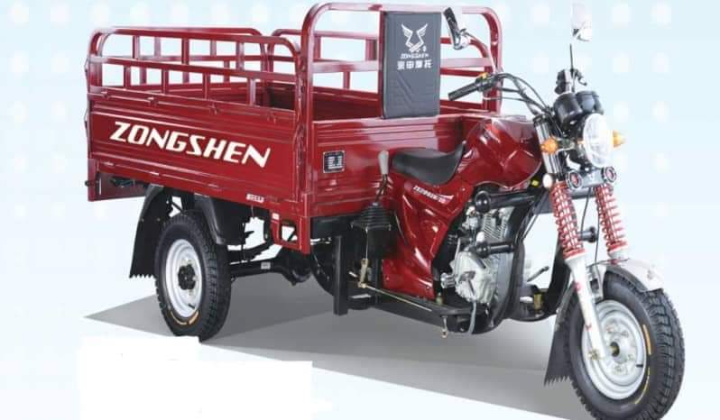

**Note:**

* **A sample must be presented to ForAfrika’s Office for approval by relevant ForAfrika’s staff before final delivery. ForAfrika will not accept any delivery if the sample is not approved.**