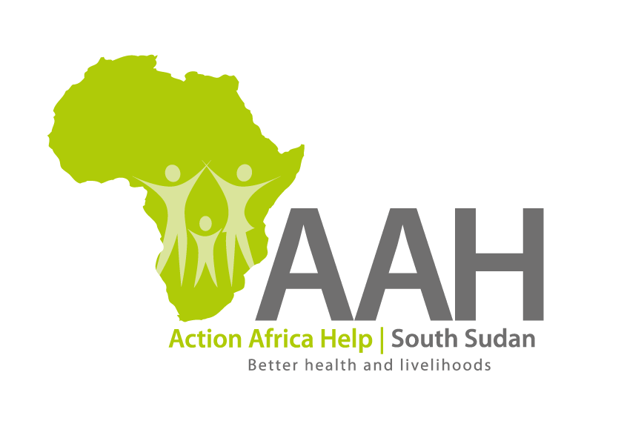
AAH South Sudan
Juba Office: Hai Gabat – Opp JIT Supermarket
Behind South Sudan Customs, Tel: +211 925 478 457
Email: ssudan@actionafricahelp.org
Website: www.actionafricahelp.org

INVITATION TO TENDER

Background
Action Africa Help International (AAH-I) is a nongovernmental and nonprofit making Organization operating in South Sudan with a mission to support disadvantaged Communities to sustainably improve their standard of living through Community empowerment approach in partnership with stakeholders. AAH-I implements Primary Health Care, Agriculture, Humanitarian aid projects and Capacity Building.

The organization is calling for quotations from reputable companies for the Supply of Turbo Charger for Motor grader as per below.

S/N | Description | Part Number | Qty
1 | MOTOR GRADER 160 -RQ -7517
 | Turbo Charger | 352-2396 | 1Pc
REQUIREMENT:

Price and Currency: The monthly rate shall be in United States Dollars (USD).
- Must be a registered company
- Proof of past experience in supplying heavy equipment spare parts
- Delivery period must be clearly indicated

Submission of Quotes
The quotations shall be submitted in Hard copies in sealed envelopes only there will be no submission of quotes in soft copies. Suppliers must adhere to this instruction to avoid inconveniences.

Submission Address

The bids shall be submitted to:
AAH-I/UNHCR Logistic Base Juba South Sudan
Near JIT Supermarket,
The envelope should be labeled: Turbo Charger

Registration for submission:
Please ensure that, you register your hand delivered quotation/bid with the Procurement department and drop it in the bid box yourself, before you leave the Procurement department.
Unregistered quotation/bid will not be considered even if it is dropped in the tender box.

Deadline for the submission of the quotation
The deadline for the submission of the quotes will be strictly on Friday 5th February, 2022, at 10:00 Am Local Time
Notification of the results
Only the successful and competitive bidder will be notified, and if you do not receive email communication within two weeks after the expiry of the deadline, consider your bid not successful.

Language for the bids

The language for the bids shall be English only.

Disclaimer

This is only a Call for quotations and AAH-I South Sudan reserves the right to either amend or cancel it at any time with or without notice. In such cases, AAH-I South Sudan shall accept no liability whatsoever. The prospective bidder is wholly responsible for any and all costs related to the preparation and submission of their quotations.

The decision of the AAH-I South Sudan Procurement Review Committee shall be final.

