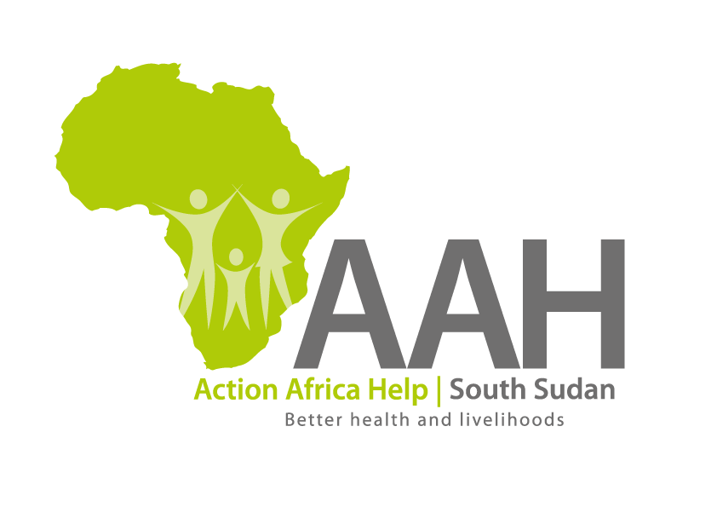
INVITATION TO BID

Background
Action Africa Help International (AAH-I) is a nongovernmental and nonprofit making Organization operating in South Sudan with a mission to support disadvantaged Communities to sustainably improve their standard of living through Community empowerment approach in partnership with stakeholders. AAH-I implements Primary Health Care, Agriculture, Humanitarian aid projects and Capacity Building.

The organization is inviting bids from reputable companies for supply of various supplies as indicated below.

NO | Description | UoM | Quantity
1 | Supply of walking tractor | pieces | 5
2 | Maize huller, diesel engine | pieces | 4
3 | Cassava chippers | pieces | 3
4 | Tarpaulin | pieces | 8
5 | Pallets | pieces | 157
6 | Maize sheller | pieces | 5
7 | Diesel Irrigation Machine | pieces | 4

Interested bidders can collect detailed ITB from AAHI/UNHCR Logistic base OR request through procurement.southsudan@actionafricahelp.org.

The deadline for the submission of the bids is 20th July, 2026 at 12:00pm

