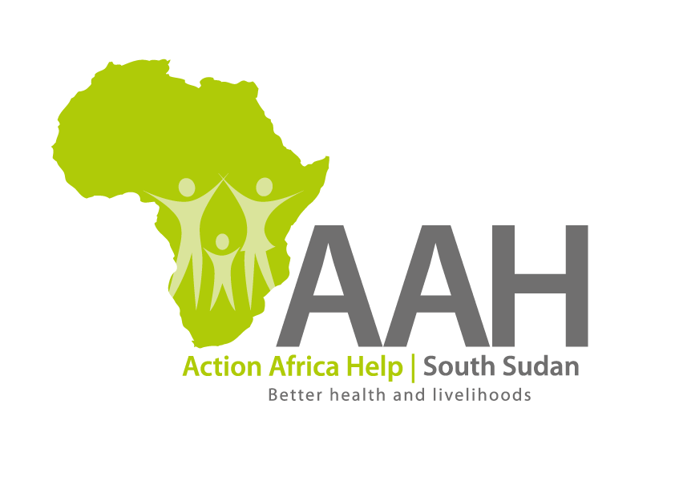
AAH South Sudan
Juba Office: off Munuki Road,
Next to South Sudan Civil Service Commission
Kenya, Somali, South Sudan, Uganda, Zambia

SCOPE OF THE MEDICAL AND GPA/GL COVER
The number of staff to be covered is 265 where each staff will be covered for both medical and GPA/GL Insurance Cover. 60 staff will be covered up to a maximum of 5 dependents while 205 staff will be covered up to a maximum of 3 dependents.

Overall Maximum inpatient Covered Benefit per family per Annum 10,000 USD
Summary of benefits that must be included in the cover are;
Comprehensive and flexible hospitalization (inpatient) cover, which includes the following services:
- Surgical fees, Anesthesia & theatre charges
- Diagnostic tests, Prescription drugs and materials
- In patient Prescribed Physiotherapy
- Prescription drugs on discharge
- Road ambulance evacuation leading to hospitalization
- Air Tickets for urgent referrals to Uganda, Kenya, Ethiopia, Sudan, Rwanda, and Egypt for treatment not available in South Sudan.
- Evacuation –emergency rescue by road or air for Patient
- Pre-existing / chronic conditions on full disclosure at the time of joining & HIV/AIDS and related conditions
- Inpatient Dental treatment (illness related) excluding prostheses & implants
- Illness related maxillofacial surgery
- Psychiatry and psychotherapy
- Oncology/Cancer treatment covered to full cover limit
- Acute Renal Dialysis during hospitalization covered to full cover limit
- Day-care surgery
- Referral Treatment outside South Sudan
- X-ray, CT, MRI and PET scans
- Reconstructive surgery following an accident
- Organ Transplants
- Illness related Reconstructive surgery
- In Patient non accidental Ophthalmology
- International Hospitalization
- Overseas referral
- Congenital and genetic conditions defects
- Maternity – Antenatal & Post-natal
There shall be a maternity benefit of Minimum US$1000.00 for principal members and spouse
per family per annum to cater for all pregnancy and confinement related hospitalization.
- All claims from pre-existing pregnancies to be payable under the maternity benefit above.
Emergency caesarian section to be catered for under the standard inpatient benefits at a minimum sublimit of US$1800 per family per annum.

- Funeral Expenses
Last Expense
Minimum limit US$1000 per family per annum

In the event of death of the insured person during the cover period, on receipt of satisfactory proof of death in writing, the Insurance will be required to pay the amount of Minimum US$1,000 to the policy holder or designated beneficiary within 24 hours upon receipt of proper documentation.

Overall Maximum Outpatient Cover Benefit per family per Annum 2000 USD
The outpatient cover will cater for all routine outpatient services .The minimum proposed benefits for the cover are:
- Outpatient Consultation as per set tariff
- Prescription drugs and Materials
- Prescribed Diagnostic tests (CT Scan and MRI)
- Prescribed Physiotherapy
- Pre-existing / chronic conditions on full disclosure
- HIV/AIDS (Adherence and Nutritional counseling; Follow-up every 3 months; Prevention of mother to child transmission (PMTCT); ARV’s and monitoring; Opportunistic Infections.
- Psychiatry and psychotherapy
- Outpatient Oncology/Cancer
- CT, MRI , Angiography and PET scans
- Congenital and genetic conditions defects
Dental - Stand-alone
Minimum Benefit: US$. 250.00- Per family per annum
The Cost of Dental Consultation resulting in treatment expenses, inclusive of
• Anesthetist’s fees
• Hospital and Operating Theatre cost,
• Fillings
• Extraction
• Root canal
• Scaling necessitated by a medical condition and prescribed by appointed dentist once a year
•Replacement or repair of old dentures bridges and plates unless damage to dentures, bridges and plates becomes necessary as a result of accident

- Optical Services includes frames & lenses
Optical Stand-alone
Minimum Benefit : US$250.00 Per person per annum
• Outpatient ophthalmologists expenses
• Change of lenses by prescription.
• Contact lenses
• Laser correction of eye sight to the full limit
• Photo chromatic and/or antiglare lenses
• Plano lenses
• Optical frames payable to the full optical limit. Members entitled to at least one frame every year.

Medical claims incurred outside the geographical scope and /or the geographical area where no credit facilities are available shall be settled on reimbursement at 100% both inpatient and outpatient limits.

