Malteser International
Country Coordination Office
Plot No. 246, Block 3k 2nd Class Residential
Tongping (behind Indian Embassy)
Juba, South Sudan
20 Jun 2023

Request for Quotation
RFQ_YEI_2023_0112

For supply and delivery of WASH consumables for Malteser International Office in Yei in UNHCR Logistics Compound on Yei Lasu Road.

- Annex 1: Specification of Bidding
- Annex 2: Bill of Quantity

We look forward to receiving your quotations on 23 Jun 2023 at or before 12pm via E-mail to: mb.procurement-juba@malteser-international.org

Thank you for your cooperation.

Sincerely,

Nermin Silajdzic
Country Logistics and Security Coordinator
Plot No. 246 Block 3k South 2nd Class - Behind Indian Embassy, Tong Ping
Central Equitorial State, Juba, South Sudan
M: +211 (0) 911 746 963 · M: +211 (0) 924 767 949
nermin.silajdzic@malteser-international.org · Skype: nsilajdzic
www.malteser-international.org
Malteser International Europe/Malteser Hilfsdienst e. V., County Court Cologne, VR 4726
Executive Board: Karl Prinz zu Löwenstein, Dr. Elmar Pankau,
Douglas Graf Saurma-Jeltsch, Verena Hölken
Legal advice: This communication is for use by the intended recipient and contains information that may be privileged, confidential or copyrighted under applicable law. If you are not the intended recipient, you are hereby formally notified that any use, copying or distribution of this e-mail, in whole or in part, is strictly prohibited. Please notify the sender by return e-mail and delete this e-mail from your systems.
Please consider the environment before printing this email

A. SPECIFICATION OF BIDDING
Related to our advertised RFQ_YEI_2023_0112 Malteser International (MI) herewith calls for quotations for supply and delivery of WASH consumables for Malteser International Office in Yei in UNHCR Logistics Compound on Yei Lasu Road.

Description of the organization and its activities
Malteser International is the international humanitarian relief agency of the Sovereign Order of Malta. For over 60 years we provide relief and recovery for people during and following conflicts and disasters around the world. Christian values and humanitarian principles form the foundations of our work. In over 30 countries in Africa, the Americas, Asia and the Middle East, we support people in need – regardless of their religion, origin or political convictions.
Malteser International has been working in the geographic area of today’s South Sudan since 1996. MI implements a multi-sectoral program including Food & Nutrition Security, Livelihoods, WASH, health and peaceful conflict resolution. This includes activities such as agricultural trainings, cash distributions, food for education and access to water, sanitation and hygiene. The program is aiming to increase its work with local partner organisations in order to optimise its sustainability. Furthermore, MI applies a participatory, gender sensitive and inclusive approach in its programming. As of today, MI maintains its country office in Juba while operating a program office in Wau and project offices in Uyujuku and Yei.
Objective of Request for Quotation: In accordance with the overall targets of above-mentioned operations, MI plans to order WASH consumables for Malteser International Office in Yei in UNHCR Logistics Compound on Yei Lasu Road.
The technical specifications and conditions of the quoting process are described below in the Specification of Quoting and in the Annex 2: Bill of Quantity which are part of this RFQ.
Internet providers are invited to submit quotations complying with the requirements here below specified.

Quotation Presentation
Quotations will be received on 23 Jun 2023 at or before 12pm via E-mail to: mb.procurement-juba@malteser-international.org.
The deadline for the delivery of the quotations is on 23 Jun 2023 at or before 12pm
- The quotation should be valid for 60 days after the deadline
- The format BoQ can be used or a separate one depending on supplier’s choice.

General conditions
- The quotation shall be typed or written and signed on each page by the legal representative of the supplier,
- The winning company might be requested to provide catalogues, pictures, technical descriptions and/or samples of items at the order stage when required,
- The prices of the quotation will be expressed in United States Dollars. The prices must be on unit price basis,
- The prices will be considered fixed whereas MI will not process Tax exemption. No additional change of whatsoever nature and type will be accepted by MI,
- MI reserves the right to accept or reject all quotations depending on prevailing condition at the time.

Validity of quotations
Each company is bound to the quotation submitted for a period of 60 days from the deadline for submission of quotations.

Language of quotations
All quotations, official correspondence between companies and MI, as well as all documents associated with the quotation request will be in English.

Submission of quotations
All quotations must conform to the following conditions:

Each quotation shall be received via E-mail to: mb.procurement-juba@malteser-international.org on 23 June 2023 at or before 12pm

Content of quotations
All submitted quotations must conform to the requirements mentioned in the RFQ. Furthermore, they must include the following documents:
Part 1 - Quotation: A quotation for supply and delivery of WASH consumables for Malteser International Office in Yei in UNHCR Logistics Compound on Yei Lasu Road. The format BoQ can be used or a separate one depending on supplier’s choice. Additional sheets may be attached for further details.
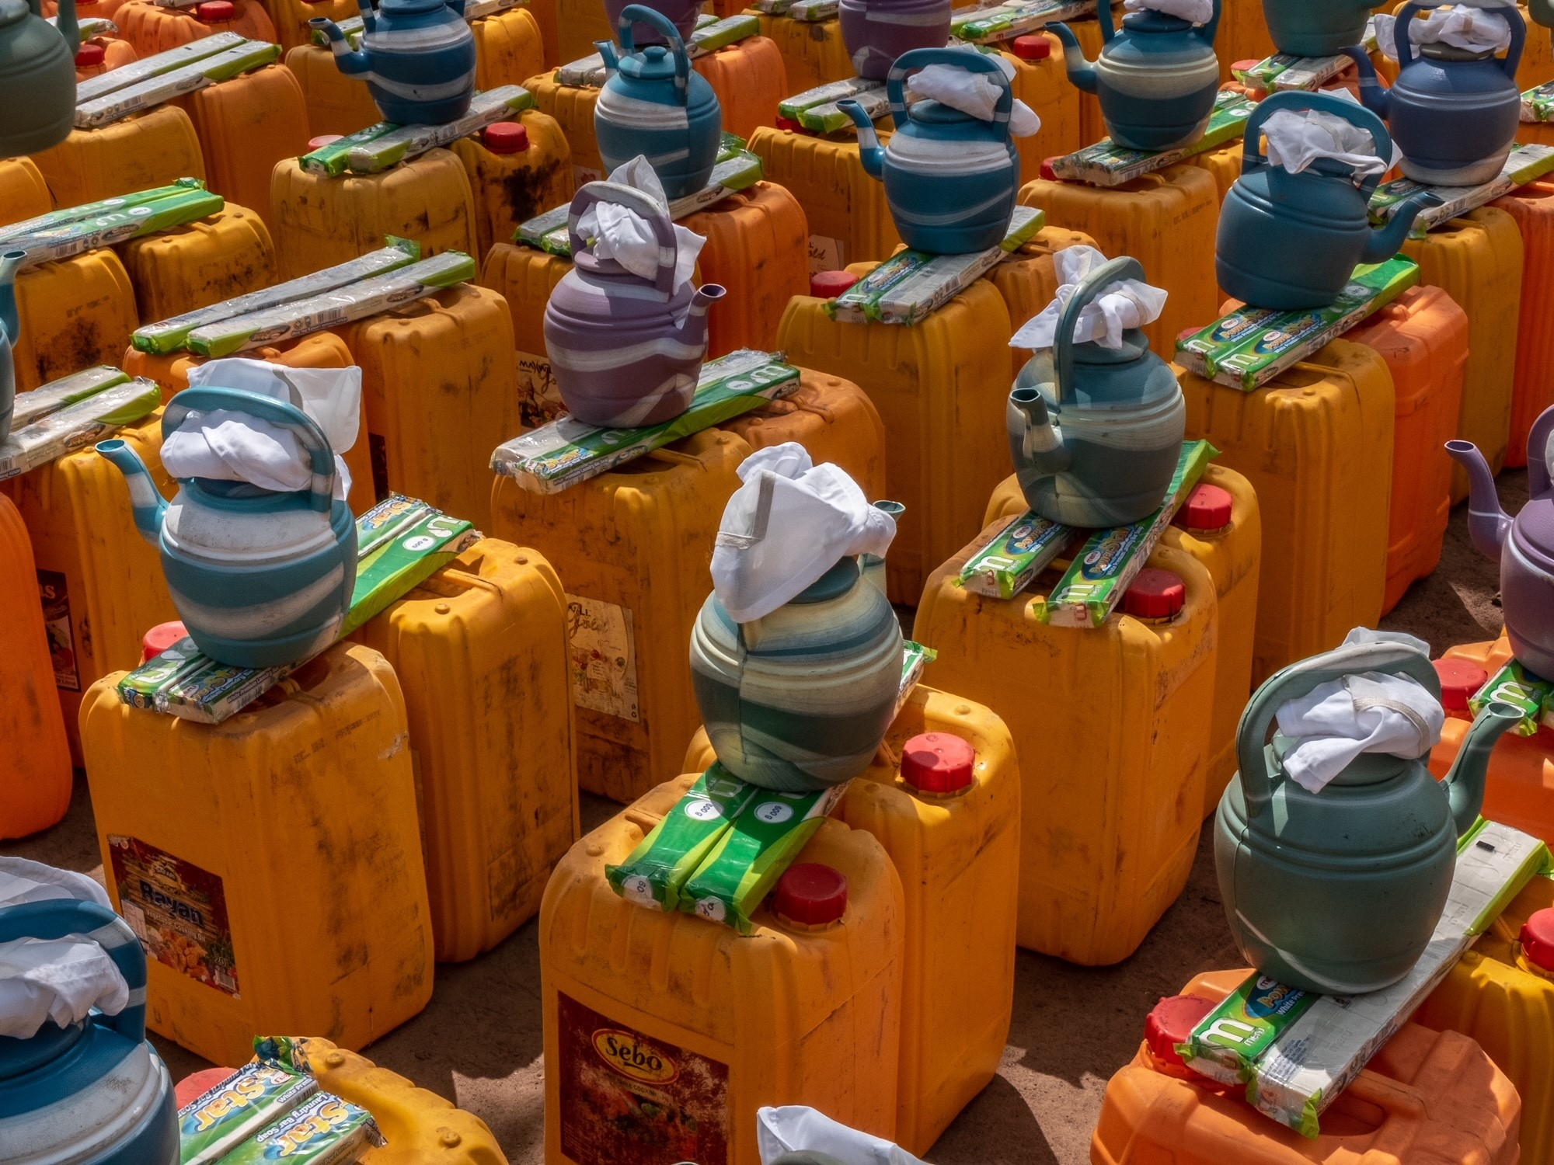

Part 2 - Legal documents
- Copy of the company’s certificate of incorporation,
- Copy of Chamber of Commerce registration,
- Copy Tax Identification Certificate,
- Copy of Certificate of Operation,
- Company’s Bank Statement of last three months,
- Company’s official address,
- Company’s phone numbers,
- Bank account details (where money would be paid),

Ownership of quotations
MI reserves/funds ownership of all quotations received. As a consequence, bidders will not be able to stipulate requirements that their quotations are to be returned.
- Opening of submitted quotations.
The quotation will be opened on 26 Jun 2023 in MI Office in Juba, South Sudan, by the Evaluation Committee. The selection process will be recorded in writing by the Evaluation Committee.

Quotation evaluation
The criteria applied for the evaluation will be the legal conformity, the price, the technical experiences, the compliance with technical specifications and quality of WASH consumables, having their own shops or stores with WASH consumables and the capacity to deliver. The work will be awarded to the winning bidder according to the timetable mentioned above.
- Exclusion criteria
The following are exclusion criteria:
- Not submitted the following company registration documents in South Sudan:
- Copy of the company’s certificate of incorporation,
- Copy of Chamber of Commerce registration,
- Copy Tax Identification Certificate,
- Copy of Certificate of Operation and
- Not bided according to the specification.

- Specific Technical and Financial Evaluation Criteria to standards:
- Comparative Bid Analysis and justification basing on responsiveness of the selected supplier by evaluation committee,
- Framework agreement will directly be issued to the selected supplier upon approval.
- Terms of payment
The payment will be done in United States Dollar by bank transfer or cheque as specified below:
- Payment will be carried out in ten days for previous month upon received invoices from the Contractor.

Annex 2: Bill of Quantity

For supply and delivery of WASH consumables for Malteser International Office in Yei in UNHCR Logistics Compound on Yei Lasu Road

No | Description of WASH consumables | Quantity | Unit | Estimated unit price USD | Sub-total USD
1 | Empty jerry cans 20 liters capacity with lid and preferred color is yellow, plastic | 1,000 | Pcs
2 | Ibriq capacity of 2 liters plastic | 1,000 | Pcs
3 | Soaps weighs roundabout 600g, 24 pieces of soaps in a box | 42 | Boxes
4 | Transport cost from Juba to MI Yei field office | 1 | Trip
 |  |  |  | Total

On behalf of Malteser International:
20 Jun 2023

Sincerely,

Nermin Silajdzic
Country Logistics and Security Coordinator
Plot No. 246 Block 3k South 2nd Class - Behind Indian Embassy, Tong Ping
Central Equitorial State, Juba, South Sudan
M: +211 (0) 911 746 963 · M: +211 (0) 924 767 949
nermin.silajdzic@malteser-international.org · Skype: nsilajdzic
www.malteser-international.org
Malteser International Europe/Malteser Hilfsdienst e. V., County Court Cologne, VR 4726
Executive Board: Karl Prinz zu Löwenstein, Dr. Elmar Pankau,
Douglas Graf Saurma-Jeltsch, Verena Hölken
Legal advice: This communication is for use by the intended recipient and contains information that may be privileged, confidential or copyrighted under applicable law. If you are not the intended recipient, you are hereby formally notified that any use, copying or distribution of this e-mail, in whole or in part, is strictly prohibited. Please notify the sender by return e-mail and delete this e-mail from your systems.
Please consider the environment before printing this email

