**Malteser International**

**Country Coordination Office**

**Plot No: 445 Kololo Road 3k South**

**Tong Ping, Juba Town**

**Juba, South Sudan**

**29th July 2022**

**Request for quotations**

**RFQ_JUB_2022_0255**

For Supply and delivery of Hand washing facilities to MI warehouse Bilpham Road, after Trinity Petrol Station.

1. Annex 1: Specification of Bidding
2. Annex 2: Bill of Quantity

We look forward to receiving your tenders via E-mail to**:** [**mb.procurement-juba@malteser-international.org**](mailto:mb.procurement-juba@malteser-international.org) by or before the submission deadline on **3rd August 2022 at or before 4:00PM**

Please write in the Subject line of your email with tender: **RFQ_JUB_0255, For Supply and delivery of Hand washing facilities to MI warehouse, Bilpham Road.**

|  |  |  |
| --- | --- | --- |
| [Description: Logo Malteser International](http://www.malteser-international.org/) |  | **South Sudan Coordination Office**  *Guya Stephen Thomas, Logistics Assistant*  Plot No. 94, 3K, Tong Ping T: +211 (0) 921 638 992; +211(0) 916 748 468 [Stephen.guya@malteser-international.org](mailto:Stephen.guya@malteser-international.org)  [www.malteser-international.org](http://www.malteser-international.org/) Malteser International Europe/Malteser Hilfsdienst e. V., County Court Cologne, VR 4726 Executive Board: Karl Prinz zu Löwenstein, Dr. Elmar Pankau, Douglas Graf Saurma-Jeltsch, Verena Hölken |
|  |  | [Description: icon facebook](https://www.facebook.com/malteserinternational) [Description: icon youtube](https://www.youtube.com/user/MalteserInt) |

# A. SPECIFICATION OF QUOTING

Related to our advertised Request for quotation **RFQ_JUB-2022-0255**

Malteser International herewith calls Quotations for Supply and delivery of hand washing facilities to Malteser International warehouse Bilpham Road.

Description of the organization and its activities.

Malteser International, the worldwide relief agency of the Sovereign Order of Malta for humanitarian aid, has more than 50 years of experience in humanitarian relief and covers around 100 projects in some 20 countries in Africa, Asia and the Americas, annually. It provides aid in all parts of the world without distinction of religion, race or political persuasion. Christian values and the humanitarian principles of impartiality and independence are the foundation of its work.

In South Sudan, Malteser International operates in Juba, Yei, Wau, and Uyujuku. In these locations, its activities include Health and Nutrition, Food Security and Livelihood, Water Sanitation and Hygiene and Health Programs

**Objective of Request for Quotations:** In accordance with the overall targets of above-mentioned operations, Malteser International plans to order tenders for Supply and delivery of Printers and Tonners to MI Juba Office.

The technical specifications and conditions of the quoting process are described below in the Specification of Quoting and in the Annex 2: Bill of Quantity which are part of this Request for Quotations.

Companies are invited to present tenders complying with the requirements here below specified.

# Tenders Presentation

The tender shall be received via E-mail to**:** [**mb.procurement-juba@malteser-international.org**](mailto:mb.procurement-juba@malteser-international.org) before the submission deadline on **3rd August 2022 at or before 4:00PM.**

* The offer shall be written in English
* If submitted in an envelope it must state the following information:
* Reference to the Bid Number
* Address to which the offer is being submitted (see above)
* Reference to the RFQ number
* Address to which the offer is being submitted
* The offer should be valid for **30 days after the deadline**
* The format BoQ can be used or a separate one depending on supplier’s choice.

# General conditions

* The tender shall be typed or written and signed on each page by the legal representative of the supplier,
* The winning company might be requested to provide the Truck for Inspection of mechanical Condition.
* The prices of the tender will be expressed in United States Dollars. The prices must be on unit price basis,
* The prices will be considered fixed whereas Malteser International will not process Tax exemption. No additional change of whatsoever nature and type will be accepted by Malteser International,
* MI reserves the right to accept or reject all tenders depending on prevailing condition at the time.

# Technical specification

For Supply and delivery of hand washing facilities to Malteser International Warehouse, Bilpham road, after Trinity petrol Station.

|  |  |  |  |  |
| --- | --- | --- | --- | --- |
| No | Supplies | Quantity | Unit | Quality |
|
| 1 | **50 liters handwashing facility (Rotor type) with metallic stand to be branded with Malteser and Donor Logo as per attached example.** | **20** | **Pcs** | **Good** |

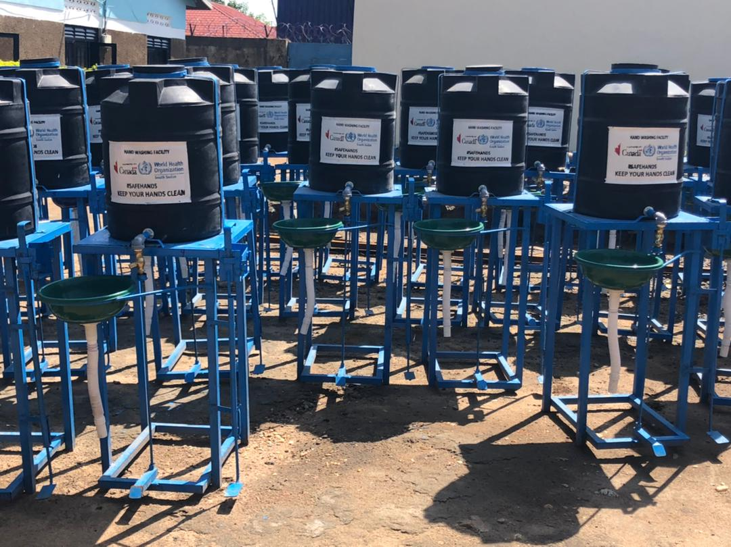

Material schedule for foot pedal operated hand washing station

|  |  |  |  |
| --- | --- | --- | --- |
| No | Item description | Unit | Quantity |
| 1 | 50 Litres Plastic water storage tank (ROTO Type) | Pcs | 1 |
| 2 | Lever/push/pull tap | Pcs | 1 |
| 3 | MS Flat steel plate for tank, basin and soap dispenser base; 5mm thick and 1m2 size plate | Pcs | 1 |
| 4 | Wash basin/bucket c/w wastewater drainage pipe 1”Ø | Pcs | 1 |
| 5 | MS Square hollow tubes: 2”x2” 6m length for the HWS pedestal  (horizontal and vertical members) fabricated on 0.5 - 1m high stand | Pcs | 2 |
| 6 | MS Square rod; 1x1” and 1m long for the HWS foot pedals | Pcs | 2 |
| 7 | Welding rods and other fittings/accessories; coil spring, lubricating grease | Item | 1 |
| 8 | Paint and visibility work | Litres | 1 |
| **2** | **Plastic Bucket with Lids, 20 litres capacity** | **PCS** | **110** |

# 4Validity of tenders

Each company is bound to the tender submitted for a period of 30 days from the deadline for submission of tenders.

# Language of tenders

All tenders, official correspondence between companies and Malteser International, as well as all documents associated with the tender request will be in English.

# Submission of tenders

All tenders must conform to the following conditions:

# Each tender must have received via E-mail to: [mb.procurement-juba@malteser-international.org](mailto:mb.procurement-juba@malteser-international.org) before the submission deadline on 3rd August 2022 at or before 4:00PM

# Content of tender

All submitted tenders must conform to the requirements mentioned in the request for quotation. Furthermore, they must include the following documents:

# Part 1 - Tender:

# For Supply and delivery of Hand washing facilities to MI Warehouse, Bilpham Road.

# The format BoQ can be used or a separate one depending on supplier’s choice. Additional sheets may be attached for further details.

**Part 2 – Documents to submit**

* Copy of the company’s certificate of incorporation,
* Copy of Chamber of Commerce registration,
* Copy Tax Identification Certificate,
* Copy of Certificate of Operation,
* Company’s Bank Statement of last three months,
* Company’s official address,
* Bank account details (where money would be paid),

1. **Exclusion criteria**

**The following are exclusion criteria:**

1. **Not submitted the following company registration documents in South Sudan:**
   * 1. **Copy of the company’s certificate of incorporation,**
     2. **Copy of Chamber of Commerce registration,**
     3. **Copy Tax Identification Certificate,**
     4. **Copy of Certificate of Operation,**
2. **Not bided according to the specification,**
3. **Mathematical error of total bided price >±2 %.**

# Ownership of tenders

MI reserves/funds ownership of all tenders received. As a consequence, bidders will not be able to stipulate requirements that their tenders are to be returned.

1. **Opening of submitted tenders**

The tenders will be opened on 3rd August 2022 in Malteser International Country Coordination Office in Juba by the Evaluation Committee. The selection process will be recorded in writing by the Evaluation Committee.

# Tenders’ evaluation

The criteria applied for the evaluation will be the legal conformity, the price, the technical experiences, the compliance with technical specifications, quality standards, references. The work will be service will be awarded to the winning bidder according to the timetable mentioned above.

1. **Specific Technical and Financial Evaluation Criteria to standards:**

* Comparative Quotation Analysis and justification basing on responsiveness of the selected supplier by internal committee,
* Contract Agreement/ PO will directly be issued to the selected supplier upon approval.

1. **Terms of payment**

The payment will be done in United States Dollar by bank transfer or cheque as specified below:

* Payment will be made in ten working days upon received invoices for month from the Supplier/Contractor.

**15)Bidders, who have not received any notification from MI one month after the deadline of the RFQ, should consider themselves unsuccessful in the procurement process**

**Annex 2: Bill of Quantity**

# For Supply and delivery of Hand washing facilities to MI warehouse, Bilpham Road.

|  |  |  |  |  |  |
| --- | --- | --- | --- | --- | --- |
| No | Description | Quantity | Unit | Unit Price USD | Total USD |
| 1 | **50 liters handwashing facility (Rotor type) with complete accessories on the above attachment.** | 20 | PCS |  |  |
| 2 | **Plastic Bucket with Lids, 20 litres capacity** | 110 | PCS |  |  |
| Total USD |  |

29th July 2022

Regards,

|  |  |  |
| --- | --- | --- |
| [Description: Logo Malteser International](http://www.malteser-international.org/) |  | **South Sudan Coordination Office**  *Guya Stephen Thomas, Logistic Assistant*  Plot No. 94, 3K, Tong Ping T: +211 (0) 921 638 992; +211(0) 916 748 468 [Stephen.guya@malteser-international.org](mailto:Stephen.guya@malteser-international.org)  [www.malteser-international.org](http://www.malteser-international.org/) Malteser International Europe/Malteser Hilfsdienst e. V., County Court Cologne, VR 4726 Executive Board: Karl Prinz zu Löwenstein, Dr. Elmar Pankau, Douglas Graf Saurma-Jeltsch, Verena Hölken |
|  |  | [Description: icon facebook](https://www.facebook.com/malteserinternational) [Description: icon youtube](https://www.youtube.com/user/MalteserInt) |