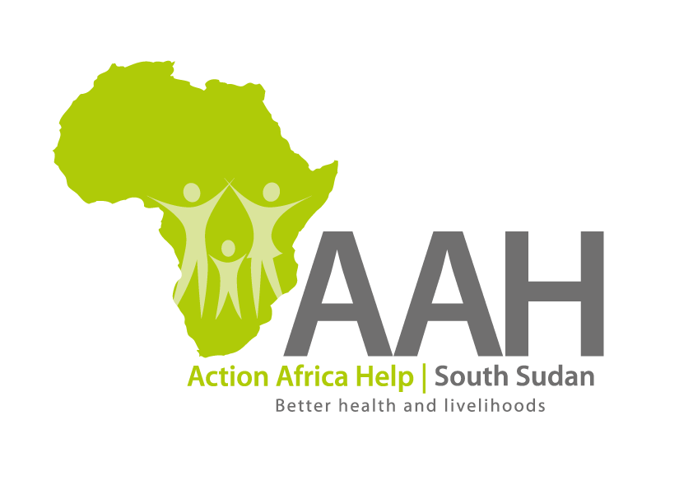**AAH South Sudan**

**Juba Office: Hai Gabat – Opp JIT Supermarket**

**Behind South Sudan Customs, Tel: +211 925 478 457**

**Email: ssudan@actionafricahelp.org**

**Website**[**: www.actionafricahelp.org**](http://www.actionafricahelp.org/)

**INVITATION TO TENDER**

**Background**

Action Africa Help International (AAH-I) is a nongovernmental and nonprofit making Organization operating in South Sudan with a mission to support disadvantaged Communities to sustainably improve their standard of living through Community empowerment approach in partnership with stake holders. AAH-I implements Primary Health Care, Food Security, Humanitarian aid and Public Works Projects.

The organization is inviting for bids from competent and reputable companies for supply of various construction materials. The list of the materials can be picked from AAHI Office in Juba and Jamjang.

Interested bidders should be in a position to supply the said materials at AAHI Jamjang Office by procuring them from Khartoum due to inaccessibility of the road from Juba to Jamjang as well as river condition.

The deadline for submission is **Tuesday** the **20th September, 2022,** at **4:00 pm Local Time.**

More information on the tender to be picked from AAHI/UNHCR Juba logistic base and Jamjang Office.