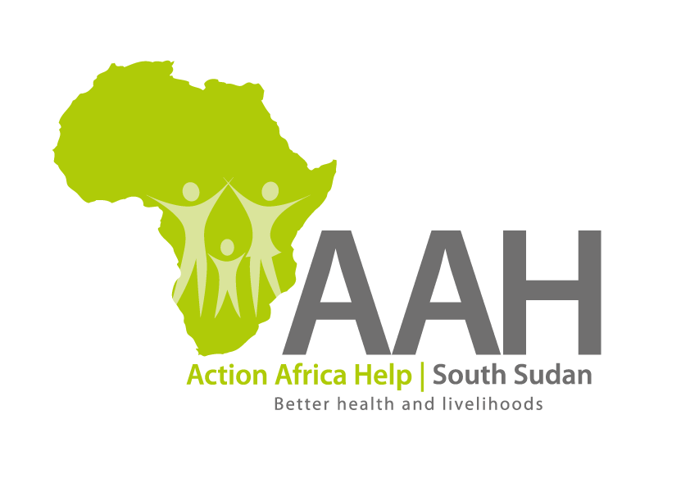
AAH-I South Sudan
Juba Office, off Munuki Road,
Next to South Sudan Civil Service Commission

INVITATION TO TENDER
Background
Action Africa Help International (AAH-I) is a nongovernmental and nonprofit making Organization operating in South Sudan with a mission to support disadvantaged Communities to sustainably improve their standard of living through Community empowerment approach in partnership with stakeholders. AAH-I implements Primary Health Care, Agriculture, Humanitarian aid projects and Capacity Building.

The organization is calling for quotations from reputable companies for provision of the following construction services in Wau.

 | Provision of labour and materials as per the BOQ for  Renovation work at Wau Logistics base | BOQ to be picked from  AAH-I/UNHCR Logistic base in Juba

- REQUIREMENTS

Bidders are required to submit US$2000 bind bond (Bank Guarantee) in the form of pay order in favour of AAHI South Sudan. Pay order will be returned to bidders on completion of evaluation. It should be valid for 60 days. The template should be picked from AAHI/UNHCR Logistic Base. No submission will be accepted without a bind bond.

Administrative Requirement:
Contractors are required to submit the following documents;
- Valid registration Certificate
- Valid Tax compliance certificate
- Operation License
Only registered company will be evaluated.
Technical Requirement
- Company Profile which should contain evidence of past experience
- BOQ
- Work schedule

- Price and Currency: The prices shall be in United States Dollars (USD).

- Quotation should be on Company’s letter head

- Submission of Quotes
The quotations shall be submitted in Hard copies in sealed envelopes on the address indicated below.

Submission Address
bids shall be submitted to:
AAH-I/UNHCR Logistic Base, Juba South Sudan
Near JIT Supermarket,
AAH-I South Sudan.

- Site visit/Inspection
The bidder is strongly advised to visit and examine the site(s) of works and its surrounding and obtain for himself, at his own expense, all information that may be necessary for preparing the tender and entering into contract. The bidder shall be fully responsible for the reliability and accuracy of all information so obtained.

- Registration for submission:
Please ensure that, you register your hand delivered quotation/bid with the Procurement department and drop it in the bid box yourself, before you leave the Procurement department in Juba or Logistics department in Maban. Each hand delivered quotation/bid must be registered individually on the bids submission forms which will be available at Procurement department/Logistics department. Unregistered quotation/bid will not be considered even if it is dropped in the tender box.

- Request for clarifications
Any request for clarification must be made in writing through the email: procurement.southsudan@actionafricahelp.org strictly and must be received not later than Friday the 12th November, 2021 at 4:00 pm Local Time.

- Deadline for submission of the quotation
The deadline for the submission of the quotes will be strictly on Thursday the 18th November, 2021, at 12:00 pm Local Time.

- Evaluation criteria
Evaluation will be based on administrative, technical and financial requirements. Failure to submit any of the documents requested will result to disqualification.

- Notification of the results
Only the successful and competitive bidder will be notified, and if you do not receive email communication within two weeks after the expiry of the deadline, consider your bid not successful.

- Language for the bids

The language for the bids shall be English only.

Disclaimer
This is only a Call for quotations and AAH-I South Sudan reserves the right to either amend or cancel it at any time with or without notice. In such cases, AAH-I South Sudan shall accept no liability whatsoever. The prospective bidder is wholly responsible for any and all costs related to the preparation and submission of their quotations.

The decision of the AAH-I South Sudan Procurement Review Committee shall be final.

