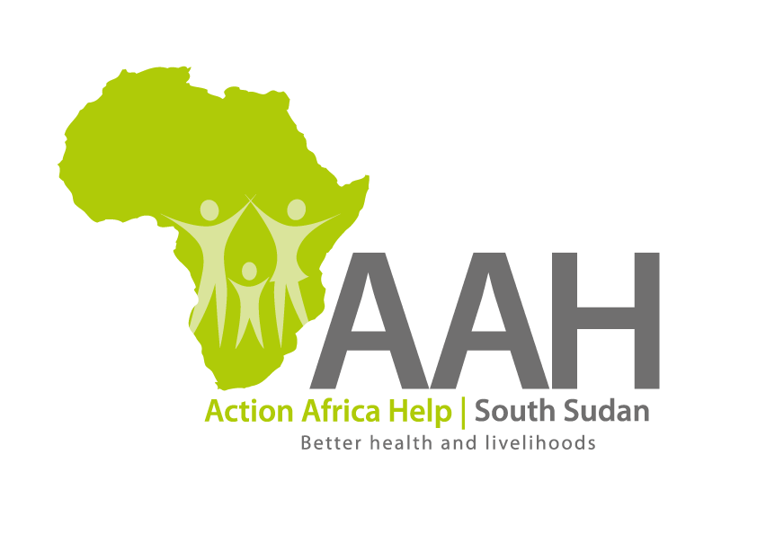
AAHI-South Sudan
Juba Office: Hai Gabat – Opp JIT Supermarket
Behind South Sudan Customs, Tel: +211 925 478 457
Email: ssudan@actionafricahelp.org
Website: www.actionafricahelp.org

INVITATION TO TENDER

Background
Action Africa Help International (AAH-I) is a nongovernmental and nonprofit making Organization operating in South Sudan with a mission to support disadvantaged Communities to sustainably improve their standard of living through Community empowerment approach in partnership with stakeholders. AAH-I implements Primary Health Care, Agriculture, Humanitarian aid projects and Capacity Building.

The organization is inviting for bids from competent and reputable companies for supply of assorted construction materials as follows

S/N | Items description | U o M | Quantity
1 | Hollow section 100x100x3mm 6m long | Pcs | 50
2 | Hollow section 100x50x3mm 6m long | Pcs | 50
3 | Hollow section 40x40x3mm 6m long | pcs | 35

The deadline for submission is Friday the 19th August, 2022, at 12:00 pm Local Time.

More information on the tender to be picked from AAHI/UNHCR Juba logistic base

