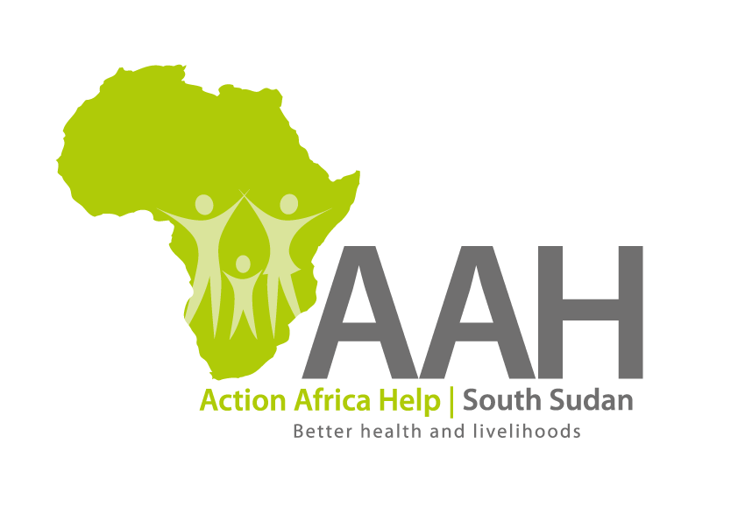

|  |
| --- |
| **INVITATION FOR TENDER** |

**Background**

Action Africa Help International (AAH-I) is a nongovernmental and nonprofit making Organization operating in South Sudan with a mission to support disadvantaged Communities to sustainably improve their standard of living through Community empowerment approach in partnership with stakeholders. AAH-I implements Primary Health Care, Agriculture, Humanitarian aid projects and Capacity Building.

The organization is inviting quotations from reputable companies for supply and installation of a solar system in an office in Pariang.

|  |  |  |
| --- | --- | --- |
| **No** | **Description** | **Comment** |
| 1 | Supply and Installation of a complete 1000 watts solar system in Pariang | BOQ to be picked from AAHI Juba Logistics Base or AAHI Jamjang Logistics base. |

Detailed ITB to be picked from AAHI/UNHCR Juba Logistic base/Jamjang Logistics Office during working hours (Monday to Friday, 9:00am -12:00pm and 2:00pm to 4:00pm).

Deadline for submission of the bids will be on **9th September, 2024** at **12:00pm.**