Malteser International Europe, Grüner Weg 14, 50825 Cologne, Germany

Malteser International
South Sudan Coordination office
Plot No. 445, Block 3, Kololo - US Embassy Road.
Central Equatorial State, Juba
South Sudan

Date; 01/10/2021

Request for Quotations for Supply of safety boots and security Items to MI Juba Office
RFQ-WAU-2021-0239.

For Safety Boots and security items to MI Juba Office, Central Equatorial State.

Annex 2: Bill of Quantity

Malteser International MI, Coordination Office in Juba South Sudan is requesting for quotation for Supply of safety boots and security Items to MI Juba Office, Under Project 1357-WAU-2021.
We look forward to receiving your tenders by or before the submission deadline on
06/10/2021, before 4:00 PM via E-mail to:mb.procurement-juba@malteser-international.org

Kindly Indicate in the Subject line of your email with tender: Request for Quotations for Supply of safety boots and security Items to MI Juba Office.

Kind Regards,

South Sudan Coordination Office
Guya Stephen Thomas, Logistics Assistant.
Plot No. 94, 3K, Tong Ping
T: +211 (0) 921 638 992; +211(0) 916 748 468
Stephen.guya@malteser-international.org
www.malteser-international.org
Malteser International Europe/Malteser Hilfsdienst e. V., County Court Cologne, VR 4726
Executive Board: Karl Prinz zu Löwenstein, Dr. Elmar Pankau,
Douglas Graf Saurma-Jeltsch, Verena Hölken

Legal advice: This communication is for use by the intended recipient and contains information that may be privileged, confidential or copyrighted under applicable law. If you are not the intended recipient, you are hereby formally notified that any use, copying or distribution of this e-mail, in whole or in part, is strictly prohibited. Please notify the sender by return e-mail and delete this e-mail from your systems.
 please consider the environment before printing this email

A SPECIFICATION OF THE TENDERS
Related to our request for Supply of safety boots and security Items to MI Juba Office, Under Project 1357-WAU-2021.

Description of the organization and its activities
MI is a worldwide humanitarian relief service of the Sovereign Order of Malta and legally a division of Malteser Hilfsdienst e. V. based in Cologne, Germany. MI is a charitable organization recognize as a relief organization according to the Geneva Convention. In South Sudan, MI is running basic health care programs, a sleeping sickness control program and supporting people affected by leprosy. The activities implemented in Wau area focusing on food security, livelihood, and WASH.
Objective of the RFQ:
In accordance with the overall targets of the above-mentioned operations, MI requests quotations for Supply of safety boots and security Items to MI Juba Office.

The technical specifications and conditions of the tender is fully described in Annex 2:
Competent and qualified companies are therefore invited to present bids complying with the requirements specified.

Tender Presentation.
The tender shall be sent via E-mail to: mb.procurement-juba@malteser-international.org
With the Subject Line RFQ/WAU/2021/0239, Supply of safety boots and security Items to MI Juba Office.

The deadline for the submission of the tender is 06/10/2021/before 4:00 PM
- The tender shall be written in English
- The tender should be valid for 30 days after the deadline
- The formatted BOQ can be used or a clear separate one depending on supplier’s choice.

General conditions
- The tender shall be typed or written and signed on each page by the legal representative of the supplier,
- The winning company might be requested to provide catalogues, pictures, technical descriptions and/or samples of items at the order stage when required,
- The prices of the tender will be expressed in United States Dollars. The prices must be on unit price and total basis.
- The prices will be considered fixed whereas MI will not process Tax exemption. No additional change of whatsoever nature and type will be accepted by MI,
- MI reserves the right to accept or reject all tenders depending on prevailing condition at the time,

Technical specification
S/N | Description | Unit | Quantity | Quality
1 | Safety boots ( similar to keen man water proof safety boot brand) assorted sizes. | Pairs | 10 | Good
2 | Protective and safety work clothing (overall with reflector, fabric excel brand) different sizes. | Pcs | 3 | Good
3 | Rain Coat ( synthetic Assorted size) | Pcs | 3 | Good
4 | Gumboots, good Quality black colour | Pcs | 3 | Good
5 | Security Mirror for main gate (Diameter 36 inches) with mounting flange for fixing on a wall | Pair | 1 | Good
6 | Fire extinguisher powder 10kgs S HI SA-ABC | container | 2 | Good
7 | Fire extinguisher powder 5kgs S HI SA-ABC | Container | 2 | Good

Pictures for Required Safety Boots and Security items.
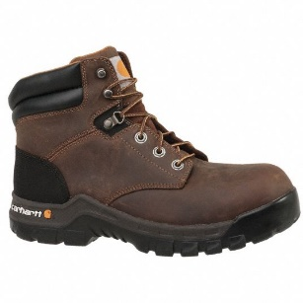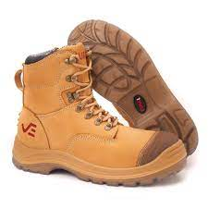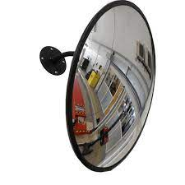
Safety Boots (Size 10-1/2) Security Mirrow (Diameter 36 inches)

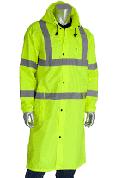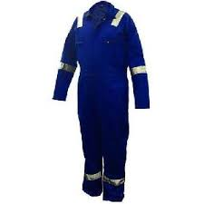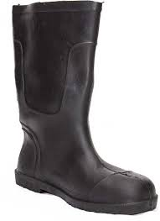
Rain Coat Protective and Safety Work Cloth (Fabric excel Brand) Gumboots

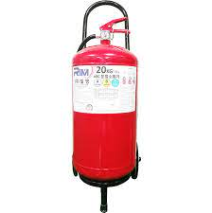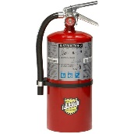
Fire Extinguisher CO2 Powder 10 kgs Fire Extinguisher CO2 Powder 5 Kgs

Activities | Date | Time*
Deadline for submission of tenders | 06/10/2021 | 4:00 PM
Opening of submitted tenders | 7/10/2021
Notification of award to the successful tenderers | 8/10/2021
Signature of Contract Agreement / PO | 11/10/2021

Validity of tenders
Each company is bound to the tender submitted for a period of 30 days from the deadline for submission of bids.

Language of tender
All tenders, official correspondence between companies and Malteser International, as well as all documents associated with the tender request will be in English.

Submission of tenders
All tenders must conform to the following conditions:

Each tender must be sent to mb.procurement-juba@malteser-international.org

within the deadline on 06/10/2021 before 4:00 PM.

Content of tender
All submitted tenders must conform to the requirements mentioned in the RFQ. Furthermore, they must include the following documents:

Part 1 - Tender: A tender

The formatted BoQ can be used or a separate one depending on supplier’s choice. Additional sheets may be attached for further details.
Part 2 - Legal documents
- Copy of the company’s certificate of incorporation,
- Copy of Chamber of Commerce registration,
- Copy of Tax Identification Certificate,
- Copy of Certificate of Operation,
- Company’s Bank Statement of last three months,
- Company’s official address,
- Bank account details (where money would be paid)

Ownership of tenders
Malteser International reserves/funds ownership of all tenders received. Consequently, tenderers will not be able to stipulate requirements that their bids are to be returned.
- Opening of submitted tenders
The Evaluation Committee will evaluate the tenders on 8/10/2021 in Malteser International Juba office MI Office in Juba, South Sudan and the tenderers will not attend the evaluation. The Evaluation Committee will record the selection process in writing indoor.

Tender evaluation
The criteria applied for the evaluation will be the legal conformity, the price, the technical experiences, the compliance with technical specifications and quality standards, and the capacity to deliver, delivery time and meet timeframes as specified. The Services will be awarded to the winning tenderer according to the timetable mentioned above.
- Specific Technical and Financial Evaluation Criteria to standards:
Comparative bid analysis and justification basing on responsiveness of the selected supplier by evaluation committee.
Contract Agreement/ PO will be issued to the selected supplier upon approval.

Terms of payment
The payment would be under project 1357-WAU-2021, In United States Dollar by bank transfer or cheque as specified below:
Payment will be done after 30 working days upon completion of work and submission of Invoice.

Annex 2: Bill of Quantity.

S/N | Description of items | unity | Quantity | Unit Price (USD) | Total price (USD)
1 | Safety boots ( similar to keen man water proof safety boot brand) assorted sizes. | Pairs | 10
2 | Protective and safety work clothing (overall with reflector, fabric excel brand) different sizes. | Pairs | 3
3 | Rain Coat ( synthetic Assorted size) | Pcs | 3
4 | Gumboots, good Quality black colour | Pairs | 3
5 | Security Mirror for main gate Concealed brand (Diameter 36 inches) with mounting flange for fixing on a wall. | pair | 1
6 | Fire extinguisher powder 10kgs S HI SA-ABC | Pcs | 2
7 | Fire extinguisher powder 5kgs S HI SA-ABC | pcs | 2
 |  |  |  | Grand Total, USD

Date: 1/Oct/2021.
Kind Regards,

South Sudan Coordination Office
Guya Stephen Thomas, Logistics Assistant.
Plot No. 94, 3K, Tong Ping
T: +211 (0) 921 638 992; +211(0) 916 748 468
Stephen.guya@malteser-international.org
www.malteser-international.org
Malteser International Europe/Malteser Hilfsdienst e. V., County Court Cologne, VR 4726
Executive Board: Karl Prinz zu Löwenstein, Dr. Elmar Pankau,
Douglas Graf Saurma-Jeltsch, Verena Hölken
Legal advice: This communication is for use by the intended recipient and contains information that may be privileged, confidential or copyrighted under applicable law. If you are not the intended recipient, you are hereby formally notified that any use, copying or distribution of this e-mail, in whole or in part, is strictly prohibited. Please notify the sender by return e-mail and delete this e-mail from your systems.
 please consider the environment before printing this email

