

# **INVITATION TO TENDER FOR SUPPLY (2024 MODEL TOYOTA LAND CRUISER 13-SEATER HARDTOP) UNDER FRAMEWORK AGREEMENT**

|  |  |
| --- | --- |
| **Date of Issue** | **Sept 11,9/2024** |
| **Tender No** | **061014** |
| **Contract Title** | **Supply** **(**2024 Model Toyota Land Cruiser 13-seater Hardtop**)** |
| **Closing date** | **10th October 2024** |
| **Tender opening place** | **Juba** |
|  |  |

The Healthcare Foundation Organization (HFO) is looking to enter into a contract with a qualified and legally recognised service provider (Company) to provide supply services for a 13-seater hardtop 2024 model Toyota Land Cruiser Hardtop. These services are required explicitly in Juba and our field offices in various parts of South Sudan.

Interested vendors are invited to submit their bids in a sealed envelope to the following address:

HEALTHCARE FOUNDATION ORGANIZATION - HFO

Address: Tongping behind Catholic University

City: Juba, South Sudan

Telephone: 0921444481

We appreciate your attention to this matter and look forward to receiving your proposals.

Thank you. Email: [logp.healthcarefoundation.org@gmail.com](mailto:logp.healthcarefoundation.org@gmail.com)

CC. [opm.healthcarefoundation.org@gmail.com](mailto:opm.healthcarefoundation.org@gmail.com)

Please make sure to remember the following important information:

NOTE: All prices should include applicable government taxes, transportation, and delivery (Duty delivery paid quote).

The service provider is expected to offer fixed prices for a contract period of 12 months starting from the initial date of signing the contract, with the option for renewal up to a maximum of 24 months, subject to satisfactory performance.

Bid Submission:

1. Bidders must hand-deliver their bids to the tender box at the HFO office at the specified location. Upon bid submission, the bidder must register in the tender submission book, which is available with the HFO receptionist at the main gate.

2. All bids (sealed) must be submitted in English only and delivered to the office mentioned by 10:00 AM-50:00 PM on 10th October 2024. Bid documents must be marked as "invitation to tender: Supply (2024 Model Toyota Land Cruiser 13-seater Hardtop)

3. Any queries related to this tender should be directed to **logp.healthcarefoundation.org@gmail**.com on or before 10 October 2024.

4. the procurement committee will reject unsealed and incorrectly marked envelopes during the tender opening.

Supporting Documentation to be Submitted with Each Bid:

Copies of the following supporting documentation must accompany each Bid:

* Valid Certificate of Incorporation
* Valid Membership Certificate
* Valid Operations Licenses
* Valid Trading License
* Tax Identification Number (TIN)
* Valid Tax Clearance Certificate
* Valid Imports and Exporters Registration Certificate
* Valid Letter of No Objection
* Relevant Certification from the Ministry of Petroleum and Energy.
* Company Profile
* Financial Audit Reports for the years 2020-2022

Evaluation Criteria**:**

**TBD**HFO will evaluate bids that meet the minimum technical requirements based on the following:

|  |  |  |  |
| --- | --- | --- | --- |
| **No.** | **Criteria** | **Scoring** | **Weight** |
|  | Meet Technical Specification | 25% | Comparison between the total quality specifications meets—5 points for each. |
|  | Price | 50% | The lowest bidders will receive a total score of 50%. 10 points for each |
|  | Lead Time | 10% | Comparison for short delivery lead time. 5 points each. |
|  | Past Performance | 10% | Max of 5 signed contracts plus signed delivery notes of fuel. |
|  | Other Factors | 5% | Five points concerning staff and vendor offices/deports in field locations will be given. |

The award is anticipated to be made based on a best-value analysis. However, HFO reserves the right to negotiate with and request clarifications from any vendor before awarding or changing the evaluation criteria scoring/weighting at any time.

**Section 2 –Supplier Information Form**

**1. Business Profile**

|  |  |
| --- | --- |
| Name of Company: |  |
| Physical Address: |  |
| Postal Address: |  |
| Telephone Number: |  |
| Email, if applicable: |  |
| Contact Name, Telephone Number and Title |  |
| Type of business (plc/limited company/partnership etc…) |  |
| Years in operation: |  |
| Are you Juba-based? |  |
| Do you have agents, outlets, or franchises in the above locations? |  |
| Do you have agents, outlets, or franchises in the above locations? |  |
| Provide information on your relationships with IMA World Health staff, such as friends, family, business partners, etc. |  |

**2. Bank Details:**

|  |  |
| --- | --- |
| Bank Name: |  |
| Bank Address: |  |
| Bank Account Name: |  |
| Bank Account Number: |  |
| How long has this account been open? |  |

**3. Payment Terms:**

|  |  |
| --- | --- |
| Orders accepted on receipt of an LPO: Y/N |  |
| Number of days credit provided, if applicable: |  |
| Details of any discounts that apply: |  |
| Preferred payment method: (cash/cheque/electronic payment) |  |

**4. Product Information:**

|  |  |
| --- | --- |
| Does your company test the fuel before delivery? If so, please describe how the fuel is tested. |  |
| Does your company have measuring facilities to record the quantity delivered on your trucks? If so, what are they? For example, a Gauge or dip Stick. |  |
| What capacity are your trucks? |  |
| Will you deliver to the above-mentioned field locations (double check that this is the correct spelling) |  |
| Where do you source your fuel from? Can you verify the source? |  |
| Do you provide both petrol and diesel? |  |

**Section 3: Price SPECIFICATIONS - Vehicle Supply - Toyota Land Cruise**

|  |  |  |  |  |  |  |
| --- | --- | --- | --- | --- | --- | --- |
| No | Item Description |  | Specifications | Unit | Qty | Qty |

Vehicle

|  |  |  |  |  |  |
| --- | --- | --- | --- | --- | --- |
|  | 2024 Model Toyota Land Cruiser 13-seater Hardtop | 13-Seater - 4x4 LHD, Model: HZJ78L-RJMRS (2024 Model) - Including delivery to the HFO Juba office WARRANTY PERIOD AND WARRANTY TERMS | vehicle and accessories | 1 | All accessories are to be finally fitted, where applicable, before delivery. |
|  | ARB Recovery Kit | ARB | kit | 1 |  |
|  | Manual Winch and Cable | T-Max 3200 brand | Pcs | 1 |  |
|  | ARB-portable 12V air compressor Ki | ARB | kit | 1 |  |
|  | Heavy-duty Jump leads | TMJ/ARB | kit | 1 |  |
|  | Tyre lever 60cm long | TJM/ARB | Pcs | 4 |  |
|  | An airbag compatible Bull bar (Land Cruiser 70 series), | SKU/Part#/Specs | pcs | 1 |  |
|  | Tool kit (Complete) 88 pcs of items | Britoil or Craftsman brand | set | 1 |  |
|  | Rubber Floor Mats, Front 2 per vehicle |  | pcs | 1 |  |
|  | Nato Swivel Hitch for towing (To be Fitted) |  | pcs | 1 |  |
|  | Toyota Factory Roof Rack (For hardtops) | Robs Magic or TJM | pcs | 1 |  |
|  | Spare wheel carrier on top of roof rack (To be fitted) 2 per vehicle | Robs Magic | pcs | 1 |  |
|  | Replace rear bumper bar, Inc. Hi-Lift jacking points (To be Fitted) | Robs Magic | pcs | 1 |  |
|  | High Lift Jack (including mounting clamps) (To be Fitted) | T-MAX | pcs | 1 |  |
|  | Warning Triangle |  | pcs | 1 |  |
|  | Fire Extinguisher (Fitted on Vehicle |  | ABC type, 2kg | 1 |  |
|  | Heavy-duty canvas seat covers for front and rear. |  | set | 1 |  |
|  | Vehicle reinforcement metal pick at the front of the vehicle |  | pcs | 1 |  |
|  | Radio code |  | set | 1 |  |

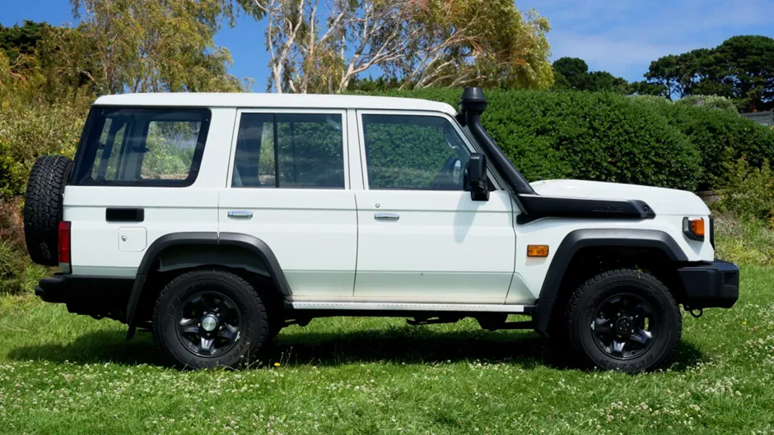

**Section 4 – Inspections and Site Visit**

HFO reserves the right to visit and inspect the quality and confirm the availability of the stock samples as part of the bid evaluation process.

I do, at this moment, confirm that the prices quoted are valid for three months.

Name: .......................................................................

Signature: ................................................................

Date: ........................................................................

Official stamp