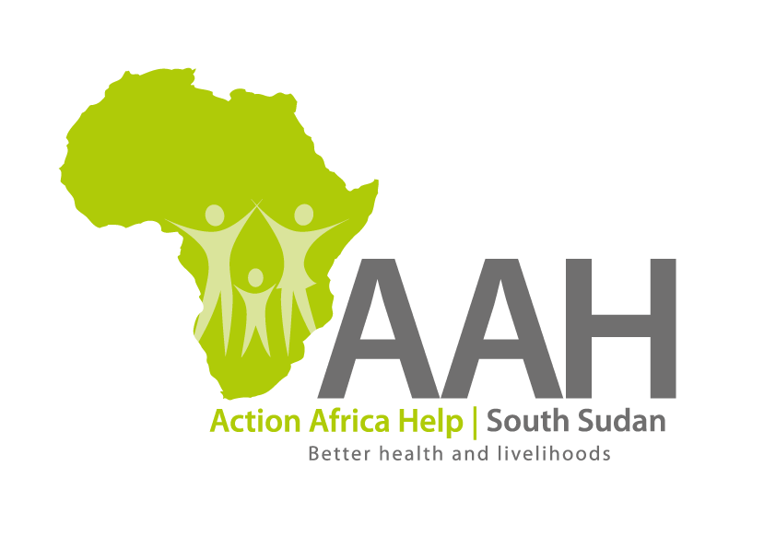
AAHI-South Sudan
Juba Office: Hai Gabat – Opp JIT Supermarket
Behind South Sudan Customs, Tel: +211 925 478 457
Email: ssudan@actionafricahelp.org
Website: www.actionafricahelp.org

INVITATION TO TENDER

Background
Action Africa Help International (AAH-I) is a nongovernmental and nonprofit making Organization operating in South Sudan with a mission to support disadvantaged Communities to sustainably improve their standard of living through Community empowerment approach in partnership with stakeholders. AAH-I implements Primary Health Care, Agriculture, Humanitarian aid projects and Capacity Building.

The organization is inviting bids from reputable companies for the Supply of Toyota spare parts, Agriculture tools and Isuzu spare parts.

s/n | Tender details | Reference
1 | Toyota spare parts | Prequo2361 | Detail tender to be pick from AAH Juba logistic base
2 | Isuzu spare parts | Prequo2371 | Detail tender to be pick from AAH Juba logistic base.
3 | Agriculture totals | Prequo2333 | Detail tender to be pick from AAH juba logistic base.

More details on the said tenders can be picked from AAHI/UNHCR Juba Logistics base during working hours (Monday to Friday, 9:00am to 11.30am and 2:00pm to 4.00pm)

Deadline for submission of the bids will be on 12 April, 2024 at 12:00pm.

