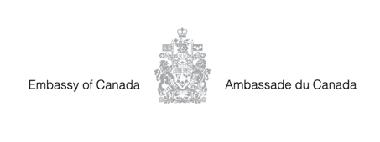

**The Embassy of Canada is Hiring!**

The Embassy of Canada to South Sudan is seeking qualified candidates for the position of Executive Assistant to the Ambassador.

* **Application Deadline:** Monday, March 3rd, 2025
* **Detailed information about this job:** <https://staffing-les.international.gc.ca/en/careers/senior-executive-assistant-to-the-ambassador-juba-203117-en>



 *@CanSouthSudan*

*https://www.facebook.com/CanadainSouthSudan/*

*The Government of Canada is an equal opportunities employer and welcomes applications from diverse sections of the community. Candidates will be considered based on merit. Our organization offers an inclusive workplace where respect, teamwork, and collaboration are part of our culture. Canada’s missions abroad are committed to promoting and supporting an environment free from harassment and discrimination, as well as encouraging and supporting employees to learn and develop their skills and competencies.*

