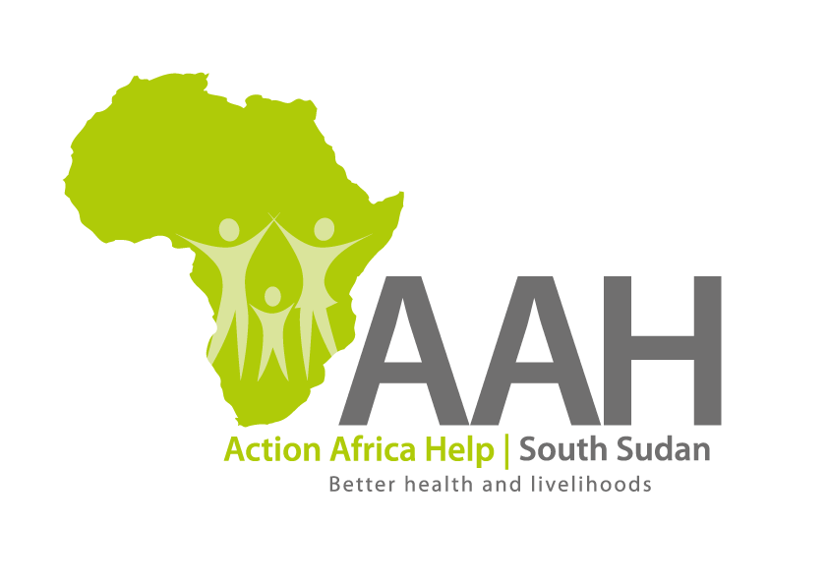
AAH-I South Sudan
Juba Office, off Munuki Road,
Next to South Sudan Civil Service Commission

Call for Pre-qualification of Suppliers for the year 2023
- Introduction

The Action Africa Help International (AAH-I) South Sudan is calling for applications for pre-qualification from competent and qualified suppliers for the provision of various categories of goods and services for the year 2023. The pre-qualification will be followed by a Request for Quotations (RFQ), Invitation to Bid (ITB) and/or Request for Proposal (RFP) which may result in Long Term Agreements with the successful bidders.

Companies that wish to participate in the process are required to complete the application forms indicating the categories for which the applications are being submitted. In addition to requirements in the pre-qualification application form, the interested applicants must provide the following documents/information:

- Mandatory documentation and information:

- Certificate of registration of business (in Country where company was registered)
- Revenue Authority Tax Registration Certificate (Indicating TIN)
- Tax Clearance Certificate (Must be Valid for the period ending 30th June 2022,
or later).
- Certificate of registration with South Sudanese Chamber of Commerce (for South
Sudan registered companies)
- Valid Operation and/or Trading Licence (whichever is applicable)
- Articles and Memorandum of Association (it is mandatory that you submit the
entire document)
- Audited Accounts for at least the last three years indicating the annual turnover (in
case of a Joint Venture or Partnership, Audited Accounts of one of the principles
partners will suffice)
- Official Business physical, postal, telephone and email addresses
- Twelve Months Certified Bank Statement for the period ended 30th June, 2022
- Reference and recommendations from at least 5 present and 5 past clients with whom your firm has done business for the category being bided for
- Proof of substantial contracts/orders completed in the last 18 months for the specific category you are bidding for
- Fully and satisfactorily completed Prequalification Form specifying the category your firm is bidding for

- Address for submission of applications:
AAH-I/UNHCR Logistics Base,
Hai Ghabat,
Juba Town, (Near JIT Super Market)
South Sudan

Note: Any submission made through any other address or means respectively, shall not be honoured and AAH-I South Sudan shall not accept any responsibility whatsoever.

- Labelling and marking of submissions:
Submissions MUST be contained in a Single large Envelope clearly labelled “Application for pre-qualification as a Supplier/Service provider (whichever is applicable)” and MUST indicate the category for which you are applying.

- Deadline for request for clarification and submission of documentation:
Any requests for clarifications should be made in writing only and addressed to the Procurement Coordinator at the following address: procurement.southsudan@actionafricahelp.org and MUST be received before or not later than 25th September, 2022, 16:00pm.

The closing date for submitting a complete pre-qualification application is 5th October, 2022, 1600hrs, Central Africa Time.

- Accessing the prequalification forms and details:

Detailed pre-qualification application forms are available at the following website: www.actionafricahelp.org and South Sudan NGO Forum.

- Selection criteria:

ONLY companies that fully and satisfactorily meet the requirements listed in Section 2 above (Mandatory information and documentation), the Vendor Prequalification Form and any other criteria which the Procurement Review Committee shall deem necessary for this purpose, shall be pre-qualified and shall be invited to participate in the subsequent bidding process.

Specifically, bidder submissions will be evaluated and scored on the following criteria (to be determined from requirements listed in Section 2 above):

- Satisfactory proof of legality of company existence 30 marks
(Section 2.1; 2, 4; 2, 5; 2.6 and 2.8)
- Satisfactory proof of tax compliance 20 marks
(Section 2.2; and 2.3)
- Satisfactory proof of adequate financial capacity 30 marks
(Section 2.7 and 2.9)
- Satisfactory proof of bidder’s business worthiness 20 marks
(Section 2.10; 2.11 and 2.12)
Note: Only bidders whose submissions score a minimum of 80 marks from the evaluation will be pre-qualified.

- Feedback to successful/unsuccessful applicants:

A list of successful applicants will be drawn and posted on the AAH-I website (www.actionafricahelp.org) and at AAH-I South Sudan Offices in South Sudan and successful applicants will be advised by email within two (2) weeks from date of closure of receipt of applications.

In case you submit an application form for pre-qualification but don’t hear from us 4 weeks after the closing date, please consider your application unsuccessful; no separate or individual communication shall be made by AAH-I South Sudan to the unsuccessful bidder(s).

- Disclaimer:

9.1 This is only an invitation for prequalification and Action Africa Help International South Sudan may cancel the process at any time without notice. Submission of application does not result in any contractual relationship between the bidder and Action Africa Help International South Sudan

9.2 Action Africa Help International South Sudan is under no obligation whatsoever to prequalify any bidder but the decision of the evaluation committee guided by the advised criteria shall be final

9.3 The bidder is fully liable for any cost incurred in the preparation and submission of their application.

