Franklin Graham President

REQUEST FOR QUOTE NOTICE

Deadline for submission of bids June 28th, 2024

From: Samaritan’s Purse.
South Sudan, Hai Cinema next to
Quality Hotel, Old Juba Town Road.
E-mail: SouthSudanSealedBid@samaritan.org
Date: June 19th 2024

Subject: PR MWJB-2024-079 QUADBIKES AND ACCESSORIES
Samaritan’s Purse wishes to contract a legally recognized service provider (company) for the Supply quadbikes and accessories
Item # | Unit | UoM | Part # | Item Description | Unit Cost (USD) | Total Cost (USD) | Remarks
1 | 3 | Pcs |  | Quad Bikes; Yamaha 350 Grizzly ATV; 4x4WD; Preferred color Green and Blue |  | 0.00
2 | 3 | Pcs |  | Riding helmets - full face |  | 0.00
3 | 3 | Pairs |  | Riding Gloves |  | 0.00
4 | 3 | pcs |  | Foot Pumps |  | 0.00

Manner of Submission:
Please submit your tender in accordance with the requirements detailed below,
Either
By hand delivery to Samaritan’s Purse Juba office, HAI CINEMA NEXT TO QUALITY HOTEL, JUBA TOWN ROAD in sealed enveloped clearly marked PR MWJB-2024-079 QUADBIKES AND ACCESSORIES
OR
By Email to the following address (Tender committee email): SouthSudanSealedBid@samaritan.org with formal bid & additional supporting documentation indicated below. The subject line should be PR MWJB-2024-079 QUADBIKES AND ACCESSORIES
Sealing and Marking of Bids
The Bidder shall enclose the bid in a plain envelope securely sealed, the envelope shall:
- Be addressed to the tender committee (see above e-mail address), Juba office.
- Bear the bid reference number PR MWJB-2024-079 QUADBIKES AND ACCESSORIES as the subject of the bid.
- No other markings should be on the envelope.
- The bidder will drop the envelope into a tender box at the Samaritan’s Purse office reception and shall register the company and name of the person dropping the envelope. If all envelopes are not sealed and marked as required, the tender committee will reject the bid during the review time.
Bidders with questions regarding this notice should send them in writing to the email address:
Copying SouthSudanSealedBid@samaritan.org Responses will be shared through the same email address.

Your bid should clearly indicate the following:
- Detailed specifications (if different from stipulated specifications):
- Limitations.
- Mode of payment, terms & conditions.

Bid Disqualification Criteria:
- Any Supplier that fails to attach the following documentation with bid will be disqualified immediately;
- Copy of valid tax clearance certificate.
- Copy of company incorporation certificate (Renewed). Make sure to submit both sides & stamped.
- The bid should have at least 3 months’ quote validity with clear delivery lead time.
- The currency of offer should be USD with clear payment terms.
- Sign and stamp Samaritan’s Purse tender code of conduct and return it alongside quotations.
- Copy of a minimum of three purchase orders or contracts with stamp and acknowledgment that reflect delivering the same category of Quadbikes to other organizations since 2020 – 2023.

Conditions of bidding:
- Payment terms will be within 15-30 business days after receipt of goods and invoice, by Electronic bank transfer/checks.
- Business Contact details including President/Owners of the company.
- Samaritan’s Purse is not subject to VAT; therefore, all offers should be exclusive of VAT costs.
- NB: No tender documents are to be requested from the office. You only need to submit your quotation as instructed above.
- Should be legally registered company.
- With a track record or experience of Quadbikes.
- Ability and capacity to supply the specified work to Samaritan’s Purse Juba office SP field Office.
- If submitting in an EMAIL format, only bids submitted solely to SouthSudanSealedBid@samaritan.org will be accepted.
  - Emailed Bids will be REJECTED if:
    - Another Samaritan’s Purse email is in copy
    - Submitted separately to any other party.
    - Any coercive behaviour is suspected.
    - Failure to meet selection criteria indicated below (Marked Red)

Terms & Conditions:
- SAMARITAN’S PURSE accepts no responsibility and is under no obligation to reimburse applicants for the costs associated with preparation of their applications;
- Time of delivery of service is very important; the service provider should therefore indicate a reasonable time for supply upon receiving of Purchase Order (PO) otherwise delay penalties will be strictly implemented and no time extension would be granted unless for reasons beyond the contractor’s control.
- SAMARITAN’S PURSE reserves the right to award the most qualified service provider (contractor) regardless of the lowest price submitted;
- SAMARITAN’S PURSE reserves the right to award to more than one bidder or to reject all applicants and cancel the solicitation at any time.

Hai
1 | 2
Cinema next to Quality Hotel
3 | 4
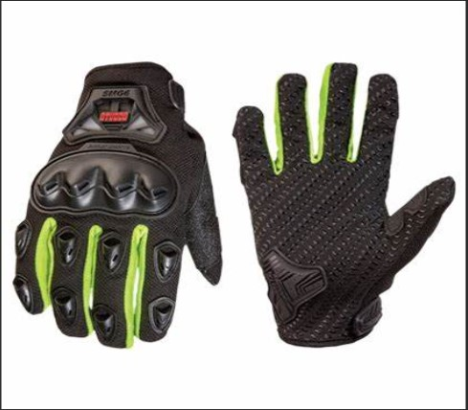 | 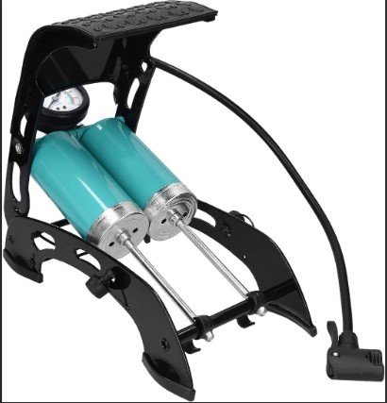
Juba, South Sudan
"All we have comes from God and we give it out of His hand.”
- 1 Chronicles 29:14b, Dutch Paraphrase

www.samaritanspurse.org

