INVITATION TO TENDER
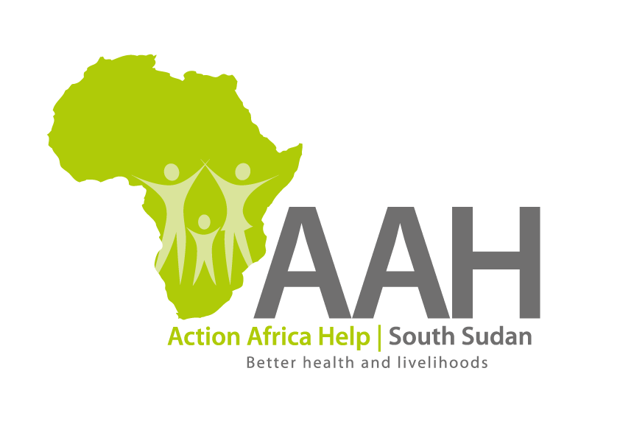
Background
Action Africa Help International (AAH-I) is a nongovernmental and nonprofit making Organization operating in South Sudan with a mission to support disadvantaged Communities to sustainably improve their standard of living through Community empowerment approach in partnership with stakeholders. AAH-I implements Primary Health Care, Agriculture, Humanitarian aid projects and Capacity Building.

The organization is inviting bids from reputable companies for supply of the following agricultural Equipment.

S/No: | Description: | specifications: | Unit: | Qty.
01 | Grinding Mill for maize flour, diesel engine, battery and stand | 50 - 40, CF40M, N75 | Set | 1
02 | Maize huller, diesel engine, battery, stand | 6NF15.8, CF40M, N75 | Set | 1
03 | Maize Sheller | Manual Maize Shellers (Made in India) | Pieces | 3

More details on the said tenders can be picked from AAHI/UNHCR Juba Logistics base during working hours (Monday to Friday, 9:00am to 11.30am and 2:00pm to 4.00pm)

Deadline for submission of the bids will be on 1st December, 2023 at 12:00pm.

