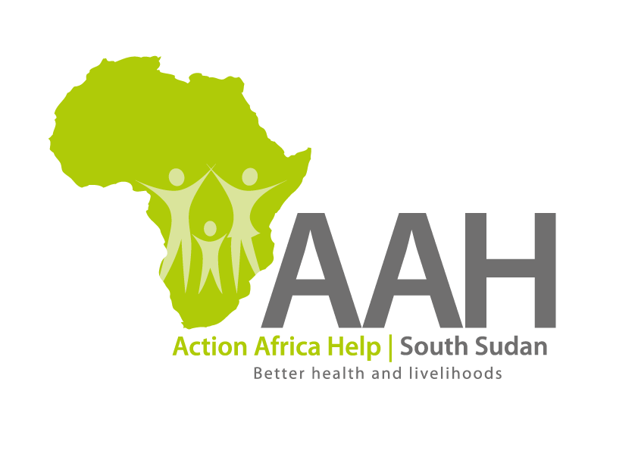
AAHI-South Sudan
Juba Office: Hai Gabat – Opp JIT Supermarket
Behind South Sudan Customs, Tel: +211 925 478 457
Email: ssudan@actionafricahelp.org
Website: www.actionafricahelp.org

INVITATION TO TENDER

Background
Action Africa Help International (AAH-I) is a nongovernmental and nonprofit making Organization operating in South Sudan with a mission to support disadvantaged Communities to sustainably improve their standard of living through Community empowerment approach in partnership with stakeholders. AAH-I implements Primary Health Care, Agriculture, Humanitarian aid projects and Capacity Building.

The organization is inviting bids from reputable companies for supply of vehicles Tyres.

S/n | Item description | Part number | U oM | Quantity
1 | Tyres Good year | 13R-22.5 | Pcs | 10
2 | Tyres Michelin radial with tubes | 12.00-R24 | Pcs | 30
3 | Tyres Michelin Radial Tubeless. | 295/80R22.5 | pcs | 10

More details on the said tenders can be picked from AAHI/UNHCR Juba Logistics base during working hours (Monday to Friday, 9:00am to 11.30am and 2:00pm to 4.00pm)

Deadline for submission of the bids will be on 29th March, 2024 at 12:00pm.

