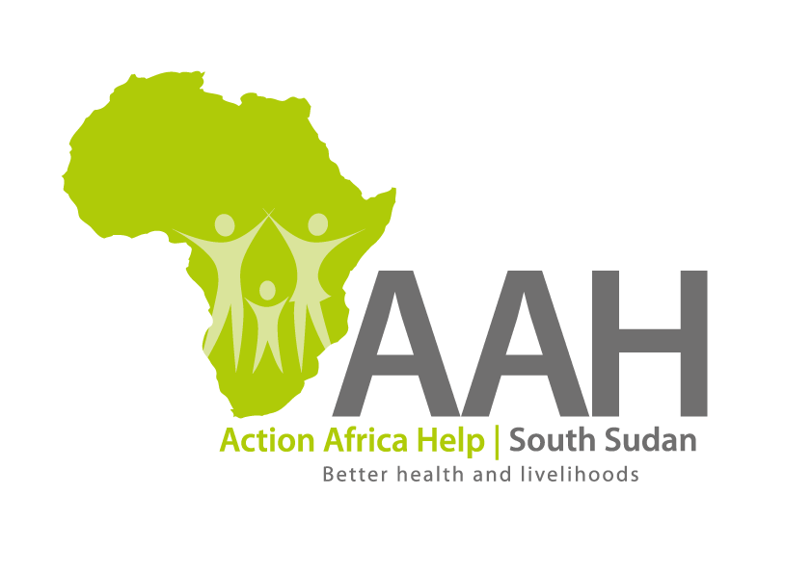AAHI-South Sudan

Juba Office: **Hai Gabat – Opp JIT Supermarket**

**Behind South Sudan Customs, Tel: +211 925 478 457**

**Email:** [**ssudan@actionafricahelp.org**](mailto:ssudan@actionafricahelp.org)

**Website:** [**www.actionafricahelp.org**](http://www.actionafricahelp.org)

|  |
| --- |
| **INVITATION TO TENDER** |

**Background**

Action Africa Help International (AAH-I) is a nongovernmental and nonprofit making Organization operating in South Sudan with a mission to support disadvantaged Communities to sustainably improve their standard of living through Community empowerment approach in partnership with stakeholders. AAH-I implements Primary Health Care, Agriculture, Humanitarian aid projects and Capacity Building.

The organization is inviting bids from reputable companies for the assessment and Repair of cold chain storage

at AAHI Warehouse and supply of assorted spare parts.

|  |  |  |
| --- | --- | --- |
| **S/N** | **Description** |  |
| 1 | Supply of spare parts PREQ2973 | More details on the said tenders can be picked from AAHI/UNHCR Juba Logistics |
| 2 | Supply of spare parts PREQ 2969 | More details on the said tenders can be picked from AAHI/UNHCR Juba Logistics |
| 3 | Assessment and repair of cold chain storage in Jebel Warehouse. | More details on the said tenders can be picked from AAHI/UNHCR Juba Logistics |

More details on the said tenders can be picked from AAHI/UNHCR Juba Logistics base during working hours (Monday to Friday, 9:00am to 11.30am and 2:00pm to 4.00pm)

Deadline for submission of the bids will be on **8th October, 2024 at 2:00pm**.