INVITATION TO TENDER.
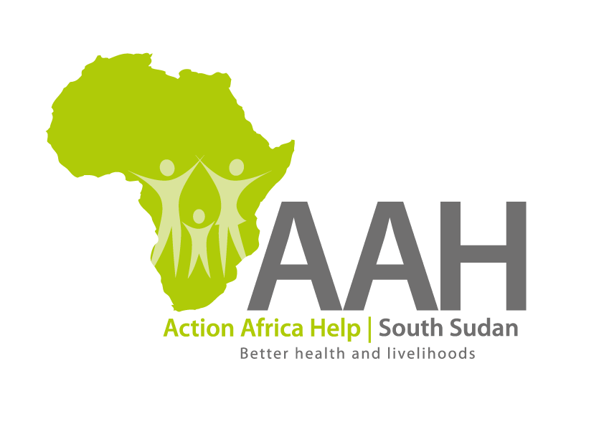
Background
Action Africa Help International (AAH-I) is a nongovernmental Organization and nonprofit making operating in South Sudan with a mission to support disadvantaged Communities to sustainably improve their standard of living through Community empowerment approach in partnership with stake holders. AAH-I implements Primary Health Care, Agriculture, Humanitarian aid projects and Capacity Building.

The organization is inviting bids from competent and reputable construction companies for provision of labor for construction of 2 classroom block in Kandaka and 4 stance VIP latrine in Napata primary school.

 | Description
1. | PROVISION OF LABOUR FOR CONSTRUCTION OF 2 CLASSROOMS BLOCK AT KANDAKA PRIMARY SCHOOL
2 | PROVISION OF LABOUR FOR CONSTRUCTION OF 4 STANCE VIP LATRINE AT NAPATA PRIMARY SCHOOL

More details on the said tenders can be picked from AAHI/UNHCR Juba Logistics base and JAMJANG AAH/UNHCR log base during working hours (Monday to Friday, 9:00am to 11.30am and 2:00pm to 4.00pm)

Deadline for submission of the bids will be on 14nd JULY, 2023 at 12:00pm.

