Code: HZJ76-RKMRS

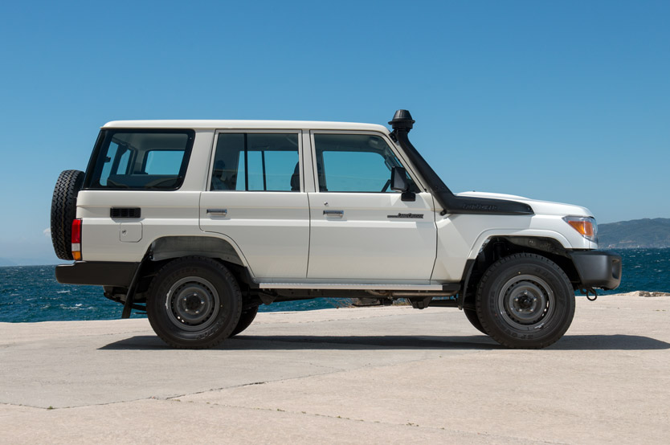
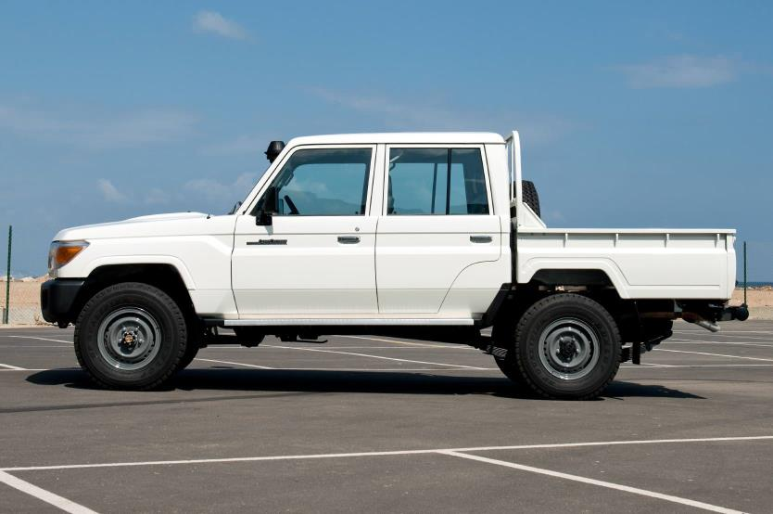

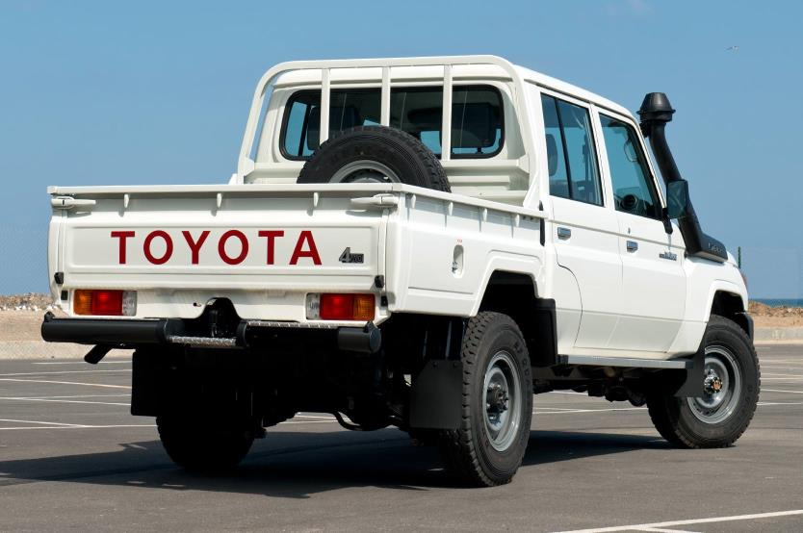
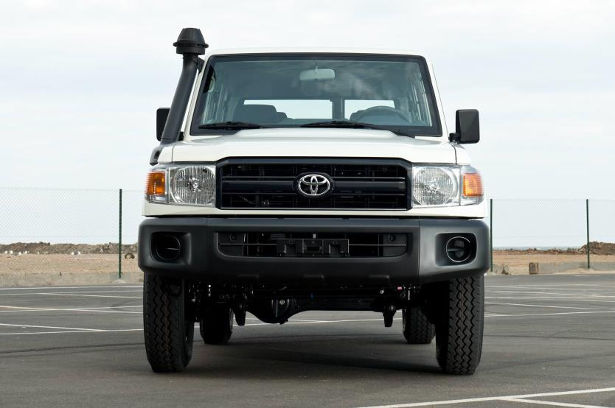

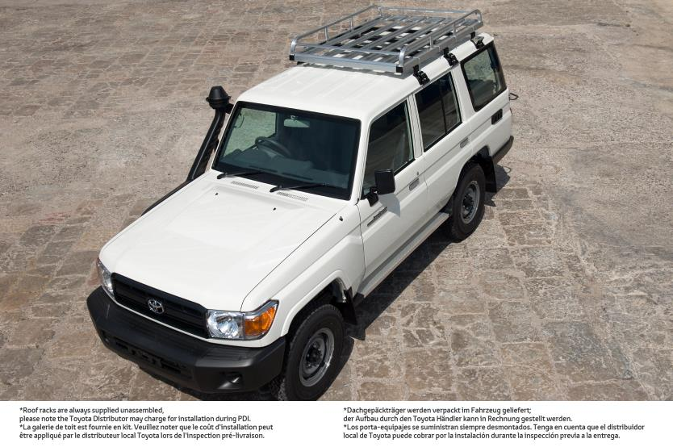

Overview
Model code HZJ76-RKMRS
Drive 4x4
Transmission Manual
Speed 5
Front suspension Coil
Rear suspension Leaf
Front brakes Disc
Rear brakes Drum
Number of doors 5
Number of seats 10
Seat material Vinyl
Colour White

Engine and Chassis
Engine model 1HZ
Displacement 4164
Number of cylinders 6
Maximum power (kw/rpm) 96/3800
Maximum power (bhp/rpm): 129/3800
Maximum torque (Nm/rpm) 285/2200
Electrics (volts) 12
Fuel Type Diesel
Fuel tank capacity (Litres) 130
Engine related standard features
Air Cleaner: cyclone with snorkel Fuel pump
Battery: 80D26 (12V) Fuel sedimenter w/warning buzzer
Brake control valve (Load Sensing Pressure Valve) High altitude compensator
Differential - front 4.300 2P Power steering
Differential - rear 4.300 4P Stabiliser bar - front & rear
Engine oil cooler Transfer - BF1B 2-4 selector
Engine under body protection Transfer box protection
Fuel filter Washer fluid - Methanol full fill

Seating Arrangement
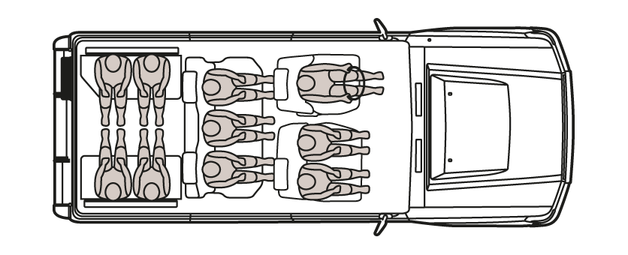

Weights & Dimensions
Weights (kg)
Kerb weight 2190
Gross Vehicle Weight 3060
Payload 870
Dimensions (mm)
Length 4720
Width 1770
Height 1955
Wheelbase 2730
Ground clearance 230

Tyres
Front tyres 7.50R16-8 5.50F - Tubed
Rear tyres 7.50R16-8 5.50F - Tubed
Tyre type Radial

Interior Features
Air conditioning Interior rear view mirror (day and night)
Ashtray Light reminder warning with buzzer
Assist grips Meter illumination control
Bottle Holder (Front) Oil pressure warning light
Brake fluid level warning One touch 2-4WD selector (H4 button)
Cigarette lighter Parking brake warning light
Clock: digital Pre-wiring for audio with 2 speakers and antenna
Dash silencer (interior only) Room Lamp
Door ajar warning Seat belts: front x 3 (2 x 3 point & 1 x 2 point)
Door armrests: front & rear Seat belts: rear x 3 (2 x 3 point & 1 x 2 point)
Floor mats: rubber (FR+RR) Speedometer km/h
Floor silencer (around front pedals) Steering column-Tilt & Telescopic & Collapsible
Footrest - Driver Sun visors D&P
Fuel gauge Timing belt replacement warning light
Fuel level warning light Transfer - 4WD lever & knob
Fuel lid opener Ventilation louvre (outlet)
Glove box: w/o lock Vinyl floor covering
Headrests x 2 Voltage meter w/warning light
Headrests: rear x 2 Water temperature gauge
Heater: front

Exterior Features
Antenna - manual Outside rear view mirror - manual, (black)
Body rust protection - specified region Rear quarter glass - swing
Bumper: front - extension 136mm Rear step bumper
Bumper: rear - black painted + RR reflector Roof rack
Clearance lamp Side steps
Headlamp: Halogen Swing-out type back door
High/Low 2-speed windshield wipers (inc. mist) Towing hook: front and rear, closed
Mud guards: front & rear Windshield - green laminated
Bull Bar

Safety and Security
Air Bag System: D+P(driver and passenger) Child lock (rear doors)
Anti-lock braking system (ABS) Horn
Central door locking - w/remote

Miscellaneous

Owner's manual - English Tool Kit & Jack

