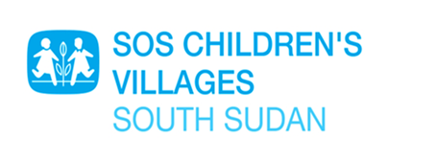

URGENT!

Terms of reference for PROVISIONING OF INTERNET SERVICE WITH DEDICATED BANDWIDTH

- Introduction
SOS Children Villages, South Sudan is an affiliate member of SOS Children’s Villages International, a federation of 137 national associations, working together with a single mission: to ensure that every child grows with love, respect and security. We take action for children as an independent nongovernmental social development organization. We work for children who are orphaned, abandoned or whose families are unable to care for them. We give these children the opportunity to build lasting relationships within a family

- Overall Objective

The main objective is to engage Internet Service Provider (ISP) to provide full TCP/IP internet service with dedicated bandwidth to SOS Children Village Juba facility. The service is expected to be of high quality, reliable and stable with overall uptime of not less than 99%.

- Technical requirements
  - Speed requirement is dedicated 4.0 Mbps symmetrical bandwidth at each Programme Location
  - Provisioning of static IP addresses for the Program Location
  - Connection preference is – fiber optic starting from the ISP to the internet backbone
  - All necessary hardware, cabling and software (if required for Internet service) should be provided and set up by the provider.
  - ISP must be able to manage the Customer Premises Equipment (CPE)
  - No limitations on traffic/ports; bandwidth capacity should be ensured through direct IP connection.
  - Data confidentiality guarantee; internet service provider may not scan traffic
  - Seven days a week,24 hours per day and 365 days per year coverage for technical assistance and/or helpdesk facilities.
  - Any problem should be resolved within a maximum of 2 hours after the notification.
  - It’s preferable if the ISP has a physical presence, including availability of technical support, in the location of SOS Children Village.
  - The ISP must have a Network Monitoring System (NMS) supported by engineers/technical support team.
  - ISP should provide a clear alternate or fallback options when their backbone providers are disconnected from Internet
  - Free and unlimited technical support

- Submission of Internet Proposal

Deadline for submission of quotations is 30th.01.2023

- Contact Details

Yei Road Falcon Company Compound 1500 Meters from UNMISS or electronically in PDF format through email to Taban.Gabriel@sos-southsudan.org and isaac.james@sos-southsudan.org

