INVITATION TO TENDER
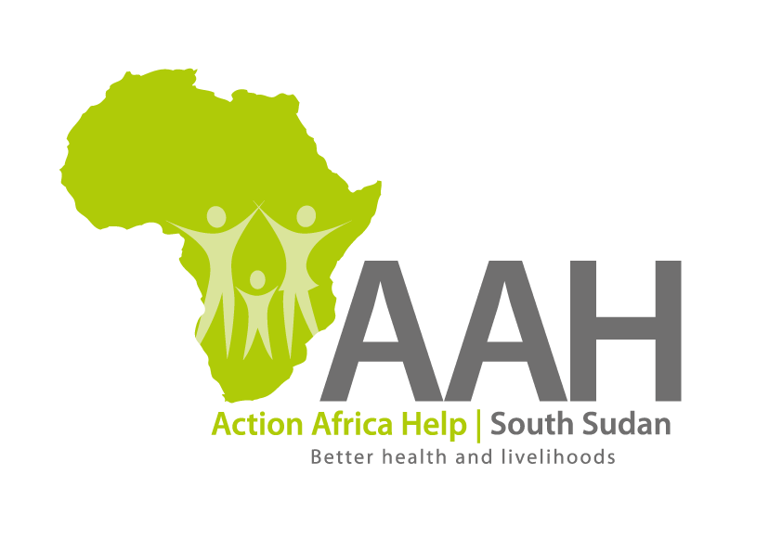
Background
Action Africa Help International (AAH-I) is a nongovernmental Organization and nonprofit making operating in South Sudan with a mission to support disadvantaged Communities to sustainably improve their standard of living through Community empowerment approach in partnership with stake holders. AAH-I implements Primary Health Care, Agriculture, Humanitarian aid projects and Capacity Building.

The organization is inviting bids from competent and reputable Companies for provision of labour and materials for the construction of workshop and parking pavement using interlocking Cabro Blocks at AAH-I log-base.

S/N | Description of Goods/Services
1 | PROVISION OF LABOUR AND MATERIALS FOR THE CONSTRUCTION OF WORKSHOP AND PARKING PAVEMENT USING INTERLOCKING CABRO BLOCKS AT AAH-I LOG-BASE.

More details on the said tenders can be picked from AAHI/UNHCR Juba Logistics base during working hours (Monday to Friday, 9:00am to 11.30am and 2:00pm to 4.00pm)

Deadline for submission of the bids will be on Monday 16th June, 2023 at 12:00pm.

