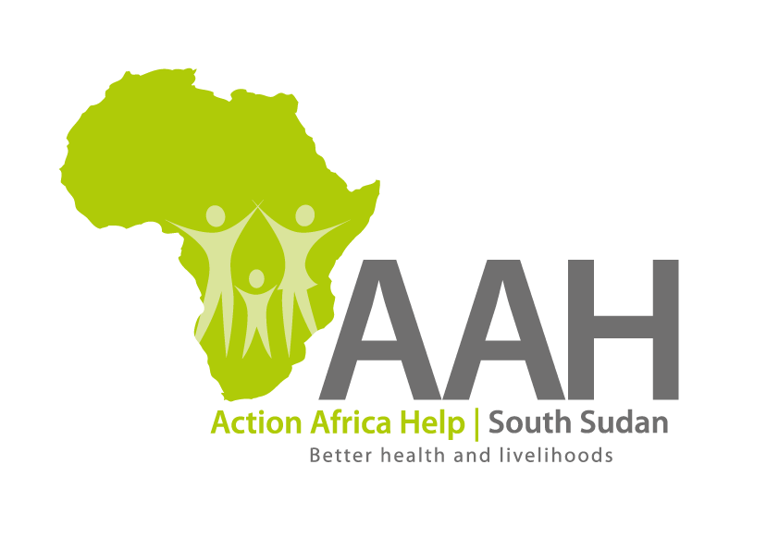
AAH-I South Sudan
Juba Office, off Munuki Road,
Next to South Sudan Civil Service Commission

INVITATION TO TENDER

Background
Action Africa Help International (AAH-I) is a nongovernmental and nonprofit making Organization operating in South Sudan with a mission to support disadvantaged Communities to sustainably improve their standard of living through Community empowerment approach in partnership with stakeholders. AAH-I implements Primary Health Care, Agriculture, Humanitarian aid projects and Capacity Building.

The organization is calling for quotations from reputable companies for provision of supply of the following supplies:

No | Description | Request No | Comment
1 | Supply of generator Kipor 5.5KVA with 20m cable | 10732 | Details to be picked from AAHI Office in Juba Town
2 | Provision of boats on hire – capacity of 15 to 20 people)  To operate in Ulang, Fashoda, Nasir and Malakal | 10738 | Details to be picked from AAHI Office in Juba Town
3 | Provision of landcruisers on hire  8 – 3 doors landcruisers and  4 - pickups  To operate in Upper Nile and Unity States | 10740 | Details to be picked from AAHI Office in Juba Town
4 | 100 sitter capacity tents | 10736 | Details to be picked from AAHI Office in Juba Town
5 | Sleeping tents with rain cover, capacity of 2 to 3 people | 10736 | Details to be picked from AAHI Office in Juba Town

Details of the tender to be picked from AAHI office in Juba town near JIT Supermarket behind Juba Customs office. The tender can be picked from Monday to Friday between 9:00am to 11:30am and 2:00pm to 3:30pm.

The deadline for submission is 12th March, 2024 at 12:00pm.

