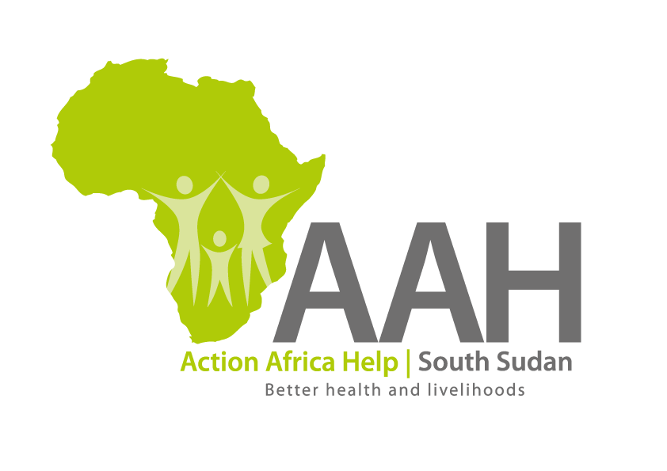
AAHI-South Sudan
Juba Office: Hai Gabat – Opp JIT Supermarket
Behind South Sudan Customs, Tel: +211 925 478 457
Email: ssudan@actionafricahelp.org
Website: www.actionafricahelp.org

INVITATION TO BID

Background
Action Africa Help International (AAH-I) is a nongovernmental and nonprofit making Organization operating in South Sudan with a mission to support disadvantaged Communities to sustainably improve their standard of living through Community empowerment approach in partnership with stakeholders. AAH-I implements Primary Health Care, Agriculture, Humanitarian aid projects and Capacity Building.

The organization is inviting bids from reputable transport companies for provision of:

DESCRIPTION | QUANTITY | UoM | Rate Per trip | Total Cost
Provision of tipper trucks (18m³ ) on hire for transportation of marram from kaya borrow pit to Gendressa agricultural land access road (15km distance). | 1000 | Trip
Provision of tipper trucks (18m³ ) on hire for transportation of marram from kaya borrow pit to Doro agricultural land access road (36km distance). | 2500 | Trip

Detailed ITB should be requested through the following email: procurement.southsudan@actionafricahelp.org

Deadline for submission is 27th April, 2026 at 10:00am.

