Malteser International
Country Coordination Office
Plot No: 445 Kololo Road 3k South
Tong Ping
Juba, South Sudan
13 December 2021
SOB_JUB_2021_0196

Specification of Bidding (SOB) for solarizing two boreholes in Kator Town Block Council and Munuki Town Block Council.
- Annex 1: Specification of Tendering
- Annex 2: Bill of Quantity
- Annex 3 attached to this SOB_JUB_2021_0196: Construction of hand washing facility for schools and maintenance work for
- Giyada school for boys,
- Giyada school for girls,
- Giyada kinder garden and
- St. Kizito school
We look forward to receiving your tenders before the submission deadline on 21 January 2022 at or before 4:00 pm via E-mail to: mb.procurement-juba@malteser-international.org.

Please write in the Subject line of your email with tender: SOB_JUB_2021_0196 for solarisation

Thank you for your cooperation.

Sincerely Yours,

South Sudan Coordination Office
Nermin Silajdzic. Country Logistics and Security Coordinator – South Sudan
Plot No. 445, Block 3, Kololo - US Embassy Road.
Central Equitorial State, Juba.
M: +211 (0) 911 746 963 · M: +211 (0) 924 767 949
nermin.silajdzic@malteser-international.org · Skype: nsilajdzic
www.malteser-international.org
Malteser International Europe/Malteser Hilfsdienst e. V., County Court Cologne, VR 4726
Executive Board: Karl Prinz zu Löwenstein, Dr. Elmar Pankau,
Douglas Graf Saurma-Jeltsch, Verena Hölken
Legal advice: This communication is for use by the intended recipient and contains information that may be privileged, confidential or copyrighted under applicable law. If you are not the intended recipient, you are hereby formally notified that any use, copying or distribution of this e-mail, in whole or in part, is strictly prohibited. Please notify the sender by return e-mail and delete this e-mail from your systems.

 please consider the environment before printing this email

1. SPECIFICATION OF BIIDING

Related to our advertised SOB_JUB_-2021_0196 for solarizing two boreholes in Kator Town Block Council and Munuki Town Block Council.
Under the following reference number: Donor project numbers: 1345-JUB

Description of the organization and its activities
Malteser International, the worldwide relief agency of the Sovereign Order of Malta for humanitarian aid, has more than 50 years of experience in humanitarian relief and covers around 100 projects in some 20 countries in Africa, Asia and the Americas, annually. It provides aid in all parts of the world without distinction of religion, race or political persuasion. Christian values and the humanitarian principles of impartiality and independence are the foundation of its work.
In South Sudan, Malteser International operates in Juba, Yei, Wau and Uyujuku. In these locations, it’s activities include Health and Nutrition, Food Security and Livelihood, Water Sanitation and Hygiene and Health Programs
Objective of SOB: In accordance with the overall targets of above-mentioned operations, MI plans to order solarizing two boreholes in Kator Town Block Council and Munuki Town Block Council.
The technical specifications and conditions of the tendering process are described below in the Specification of Tendering and in the Annex 2: Bill of Quantity which are part of this SOB.
Suppliers are invited to present tenders complying with the requirements here below specified.

Tenders Presentation
- The tender shall be via E-mail to: mb.procurement-juba@malteser-international.org.

The deadline for the delivery of the tenders is: 21 January 2022 at or before 4:00pm
- The tender shall be written in English
- The tender should be valid for 60 days after the deadline
- The format BoQ can be used or a separate one depending on supplier’s choice.

General conditions
- The tender shall be typed or written and signed on each page by the legal representative of the supplier,
- The winning supplier might be requested to provide catalogues, pictures, technical descriptions and/or samples of items at the order stage when required,
- The prices of the tender will be expressed in United States Dollars. The prices must be on unit price basis as well as by totals,
- The prices will be considered fixed. No additional change of whatsoever nature and type will be accepted by Malteser International,
- Malteser International reserves the right to accept or reject all tenders depending on prevailing condition at the time.

Technical specification
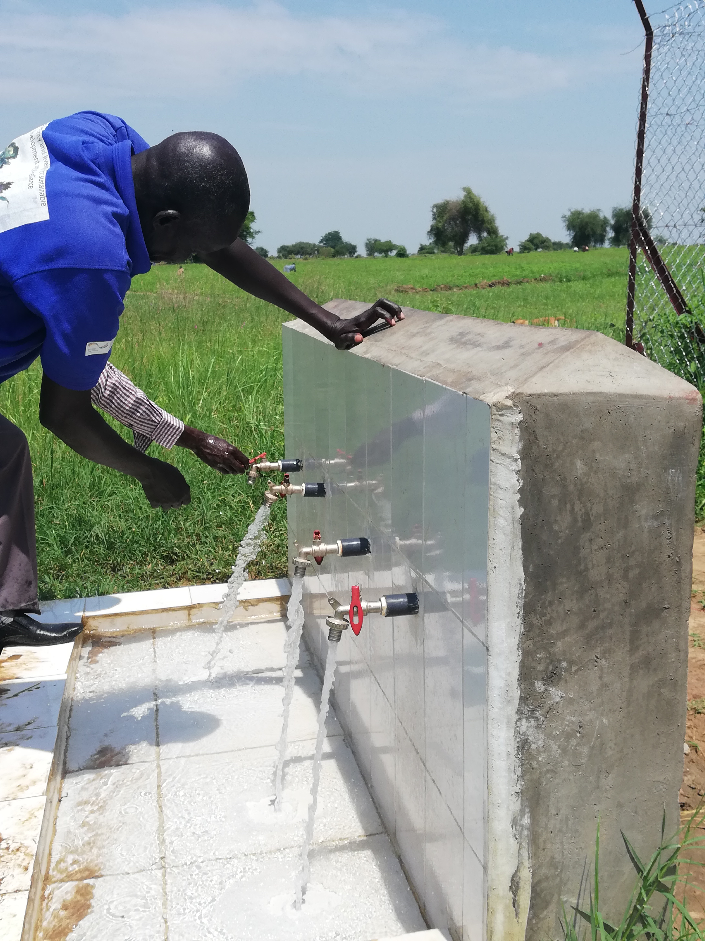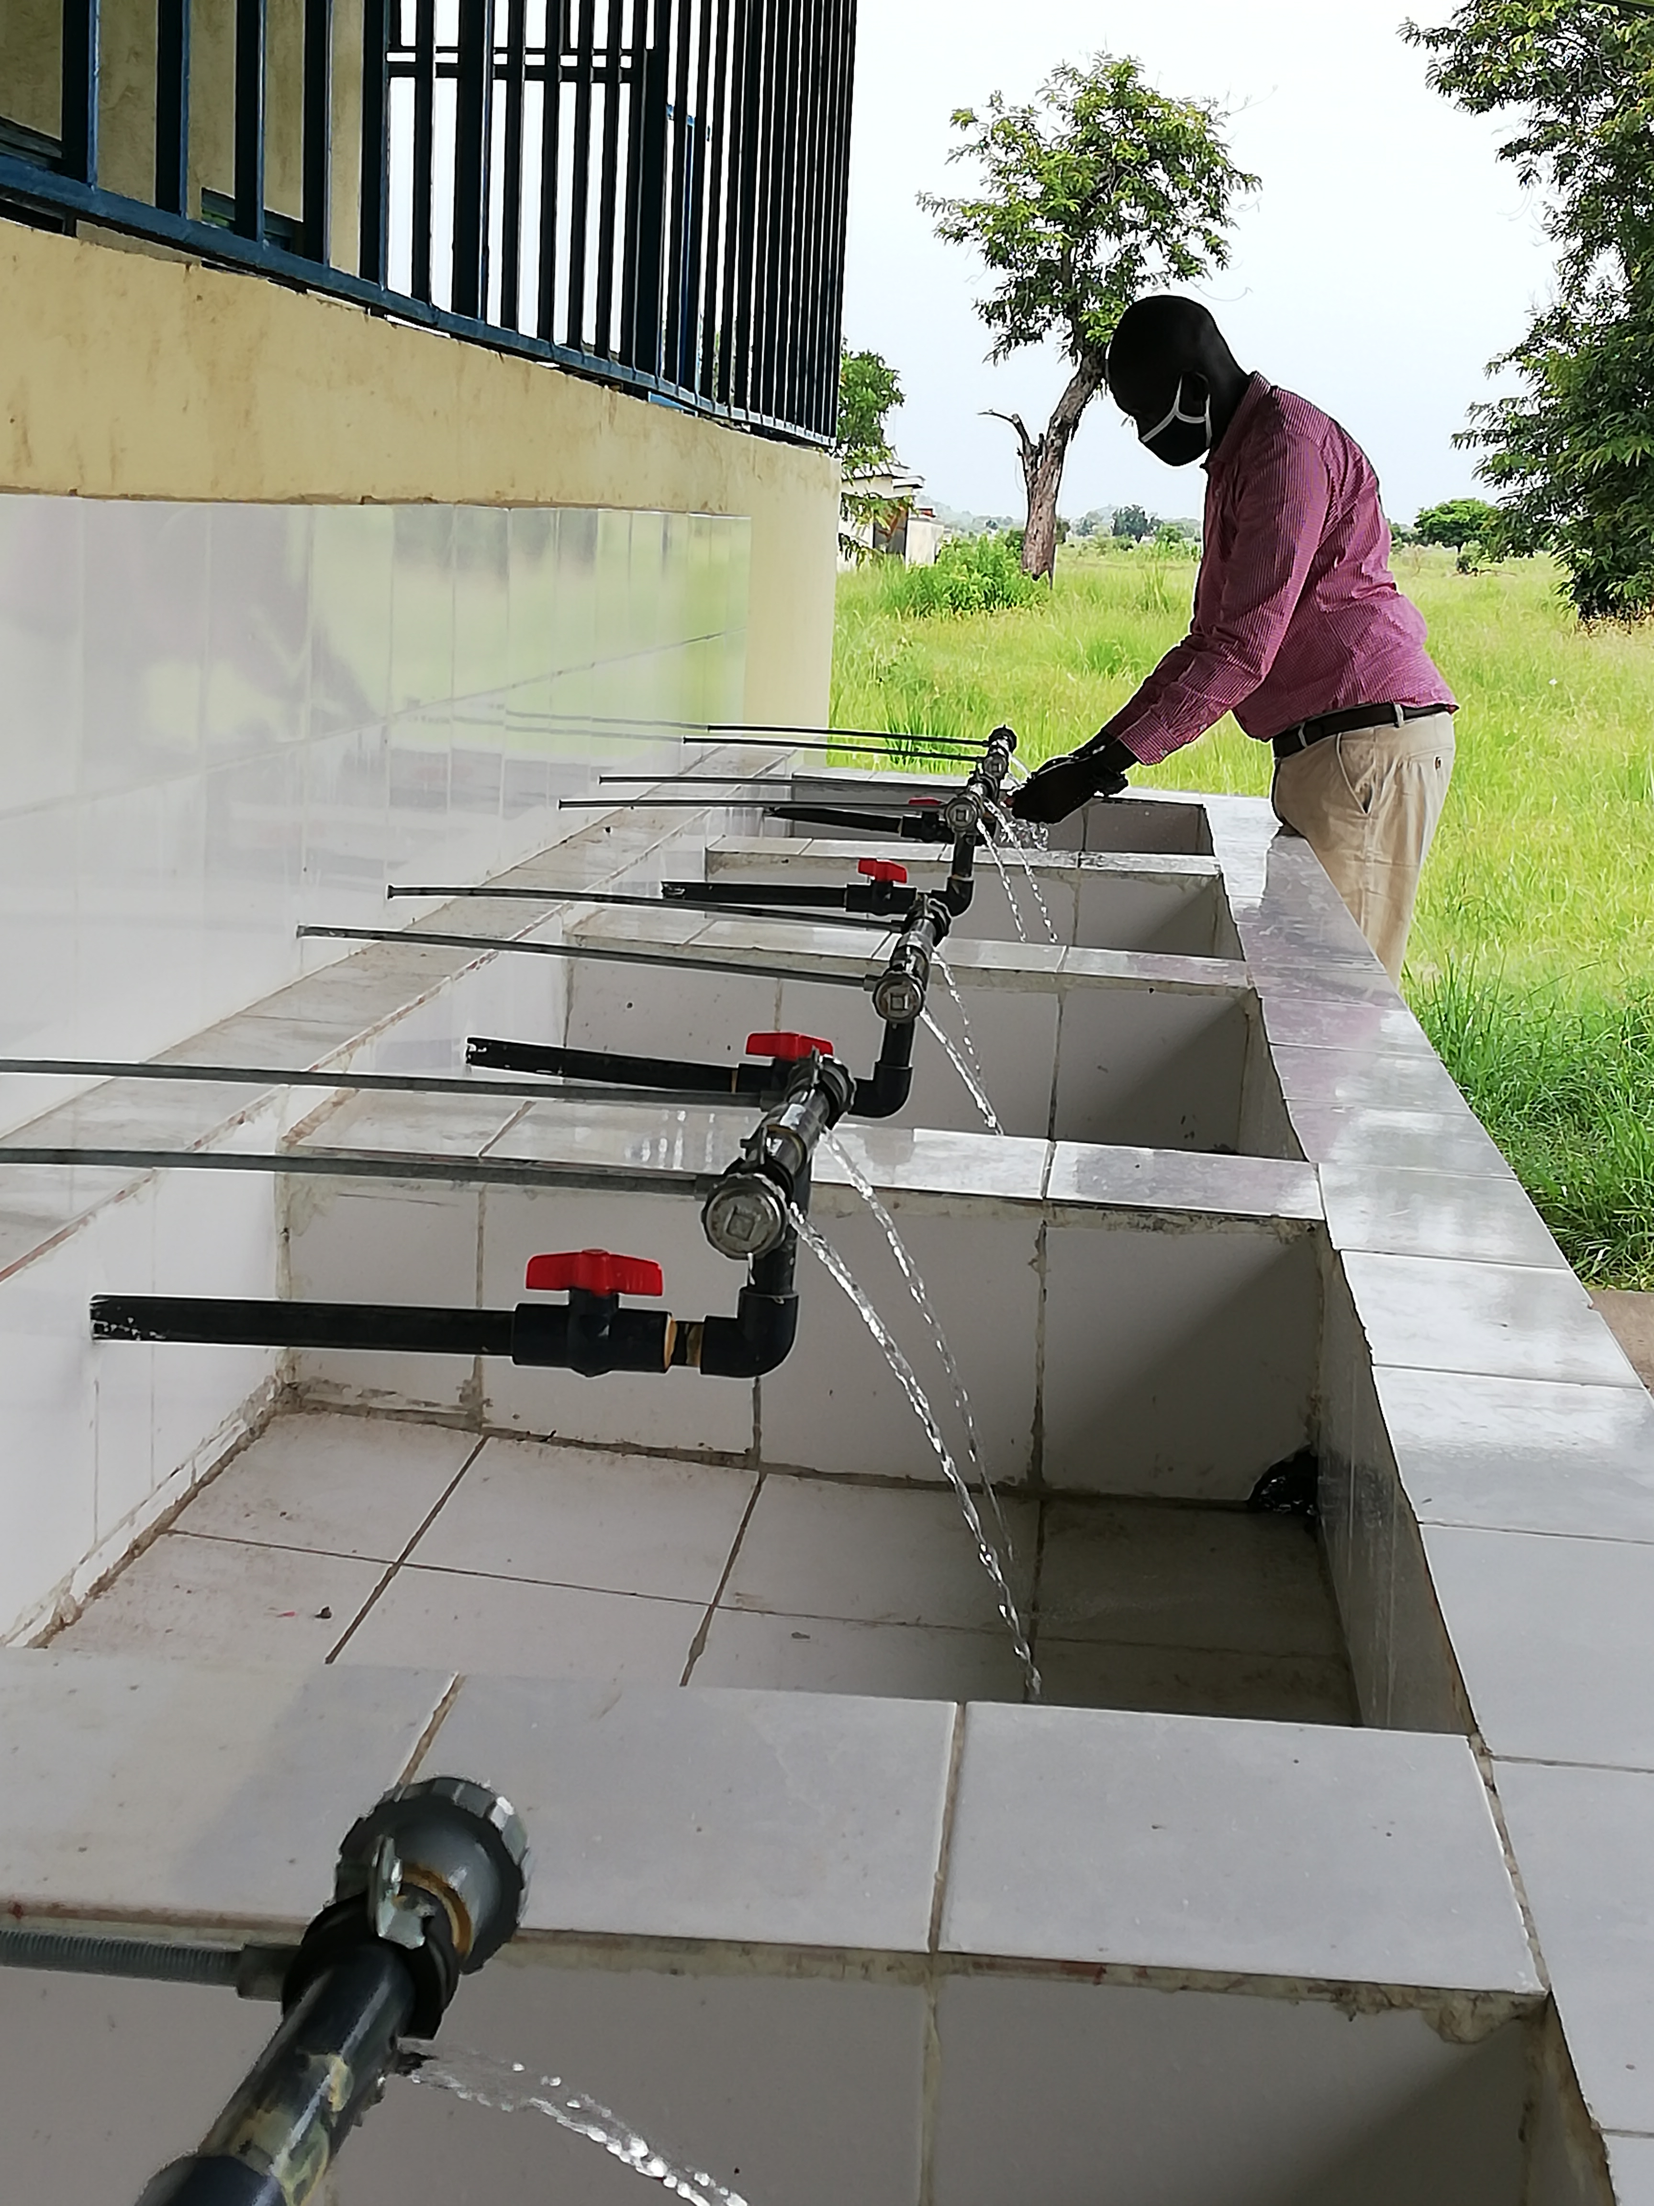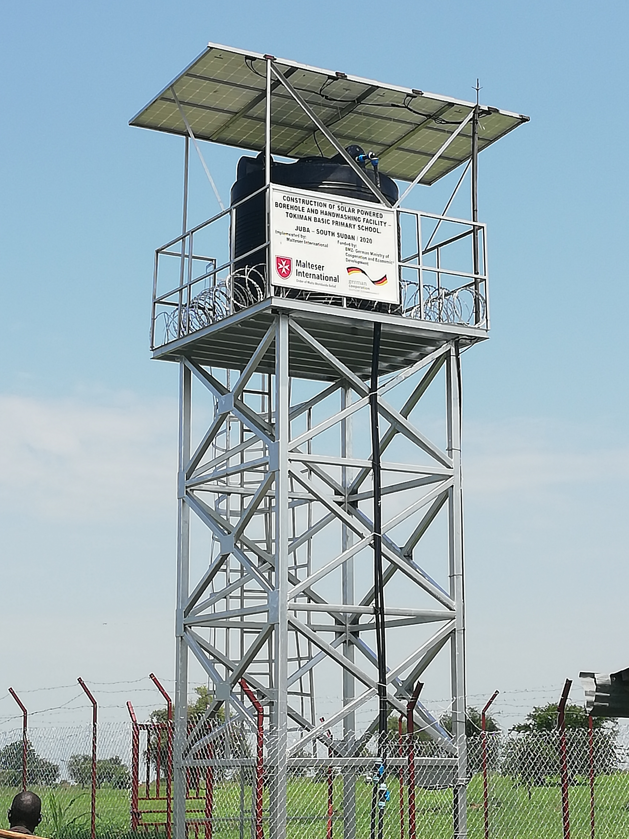

Timetable
Activities | DATE | TIME*
Deadline for submission of tenders | 21 January 2022 | 04:00 pm
Opening of submitted tenders | 25 January 2022 | -
Notification of award to the successful contractor | 8 February 2022 | -
Signature of contract agreement | 9 February 2022 | -
* All times are local time in Juba, South Sudan

Validity of tenders
Each company is bound to the tender submitted for a period of 60 days from the deadline for submission of tenders.

Language of tender
All tenders, official correspondence between companies and MI, as well as all documents associated with the tender request will be in English.

Submission of tender

Each tender shall be submitted via E-mail to: mb.procurement-juba@malteser-international.org on 21 January 2022, at or before 04:00 pm (local Juba time).

Content of tender
All submitted tenders must conform to the requirements mentioned in the SOB. Furthermore, they must include the following documents:
Part 1 - Tender: A tender for solarizing two boreholes in Kator Town Block Council and Munuki Town Block Council. The format BoQ can be used or a separate one depending on supplier’s choice. Additional sheets may be attached for further details.
Part 2 - Legal documents
- Copy of the company’s certificate of incorporation,
- Copy of Chamber of Commerce registration,
- Copy Tax Identification Certificate,
- Copy of Certificate of Operation,
- Company’s Bank Statement of last three months,
- Questionnaire for tender,
- Company’s official address,
- Bank account details (where money would be paid),

Ownership of tenders
MI reserves/funds ownership of all tenders received. As a consequence, bidders will not be able to stipulate requirements that their tenders are to be returned.
- Opening of submitted tenders
The tenders will be opened on 25 January 2022 in MI Country Coordination Office in Juba, South Sudan, by the Evaluation committee. The selection process will be recorded in writing by the committee.

Tenders’ evaluation
Technical resources and experience
- Work schedule,
- Proposed staff details and CVs of Construction manager and Site Engineer,
- Demonstrate how the works will be progressed in a safe manner,
- Experiences and Works References and information required includes: provide for project name, value, brief description of scope of works and location of any 2 recent similar projects completed; Provide completion certificate of Works as proof of evidence and provide Referees for recently completed projects mentioned above (Name of contact person, Title and contact details– Telephone & Email),
- Plant and Equipment: Provide lists of relevant plants and equipment owned or leased to be used for the Works. Provided list of key equipment and
- Preliminary Health and Safety Plan,
Financial selection criteria
- Letter of tender containing the Bidder’s lump sum financial proposal,
- The Bill of Quantity received with this document shall not be modified,
- Financial Situation of the Company and Information required includes: Adequacy of Working Capital for Works USD and Average turnover for the past 2 years in USD (construction and solar only),
- Specific Technical and Financial Evaluation Criteria to standards:
- Comparative Bid Analysis and justification basing on responsiveness of the selected supplier by evaluation committee
- Contract agreement will directly be issued to the selected supplier upon approval.
- Terms of payment
The payment will be done in United States Dollar by bank transfer or cheque as specified below:
- Payment terms will be within 10 business days after receipt of goods and invoice, by electronic bank transfer.

Annex 2: Bill of Quantity

BOQ for upgrading borehole hand pump, construction of hand washing facility and Water Collection Points with drainage system and1 block of latrine manner maintenance work at St. Kizito PHCC- Munuki Town Block Council
S/n | Description | Unit | Quantity | Unit rate (USD) | Amount (USD)
1.00 | Site preparation, setting out, cleaning mobilization and demolishment
1.01 | Pre- construction, survey, and cleaning of the top soil 20cm depth | L-S | 1
 | Sub-Total 1
2.00 | Earth works
2.01 | Excavate in ordinary soil for foundation footings adv. Depth of 2.0m and pipelines at adv. depth of 0.5m. | Cu-m | 40
2.02 | Backfill and well compact with marram around all foundations, footings, Handwashing facilities and drinking water points | Cu-m | 18
2.03 | Supply and level a coarse aggregate at the floor of the water tower with a thickness of 15 cm | Cu-m | 2.4
 | Sub-Total 2
3.00 | Concrete, rebar and construction works
3.01 | Cast a concrete M15 for the footing base, Short column(40x40cm), beam(35X25), floor slab at (15cm thickness) for the water tower, Water Collection Point (WCP) and its floor (10cm thickness), Handwashing facilities and at the bottom of the chain link fence 40x30cm including all the formworks | Cu-m | 5.5
3.02 | Reinforced concrete for footing, short column and platform of the WCP and Handwashing facilities in @ mixed ratio M20 filled in the form works and vibrated around rod reinforcement including all the formwork | Cu-m | 7.1
3.03 | Use a high tensile steel bars (12mm and 8mm) including cutting bending tying, hooking and fixing. 32No.Y12@15cm c'c for basement and column reinforcement bar 8NoY12@13cm c'c per column | Kg | 110
3.04 | Install a set of dia. 18mm anchor bolts (4pcs) and a metal plate (35x35cm & 8 mm thick) accurately in position for the steel tower columns complete with all its necessary accessories | pcs | 4
 | Sub- Total 3
4.00 | Installation of the Metallic Structures and the Tank Segments
4.01 | Mounting, fabrication and Painting of Metal members for Water Tower. Refer and follow Technical Specification, Scope of work and approved work Drawings | L-S | 1
4.02 | Supply and place plastic water storage of 10,000 litres plastic water storage on the metal water Tower with inlet, outlet, washout and overflow access in the tank will be designed in supervision of the site engineer | L-S | 1
4.03 | Fabricate and Install a metal ladder to the tank top as specs | L-S | 1
 | Sub- Total 4
5.00 | Piping, Water distribution network, well cover, Valves and taps
5.01 | Supply and installation of (HDPE flexible) PE 100 pipe OD63 PN10 wall thickness 5.8mm as a riser from the pump to surface including all necessary fittings with consideration of turdity is less than 5 | M | 40
5.02 | Supply and installation of UPVC pipe (2.0)as a riser(column)from the ground surface to elevated water Storage Tank including all necessary fittings for inlet and outlet such as water flow meter, and well cover | M | 12
5.03 | Supply and installation of (HDPE flexible) PE 100 pipe OD63 PN10 wall thick 3mm (1.0)as main distribution line with a value at the joint which leads to the three community water point and washout access and other necessary requirements at an average depth of 50cm | M | 150
 | Sub -Total 5
6.00 | Solar and water pump installation
6.01 | Dismantle the existing hand pump and assembly using ground fos submersible pump SQF 3A- 10 capacity well head protection, and pump controller cu- 200 in metallic box with padlock including all necessary requirements as such sensor for water control | pcs | 1
6.02 | Supply and install a solar panel of 335 watts welded on (40x40x2mm)angle bar on the top of the water tank and one independent security solar light 35 watts | pcs | 4
6.03 | Use electrical flat cable 4mm With Lightening arrester from the solar panels to the water pump with all necessary requirements | M | 50
 | Sub-Total 6
7.00 | Fencing for the Water Tower and Water Collection Points
7.01 | Fabricate and paint and plotted in concrete an angle bar of (50x50x4mm) at the height of 2.0m@2c'c V- shape at the top and sheltered with chain link wire and an entry gate of 1.0m single shutter using Hollow section metal of 9No.40x40x4mm and considering barbed wire on top including all necessary requirements pad locks in and outside | M | 34
 | Sub-Total 7
8.00 | Construction Hand washing facility with at shelter, Water Collection Platform, Grease trape and 2 two Soakaway pits
8.01 | Excavate in ordinary soil for a strip foundation of Handwashing facility and ramp, WCPs, Soak way pit and a grease trap | Cu-m | 5
8.01 | Cast a concrete @ mixed ratio of M20 at handwashing facility, water collections points and grease trap | Cu-m | 4
8.02 | Construct 200mm brick wall for the excavated foundations, Walls, ramp, washing facilities and a sink at MHM room in well burnt clay bricks bedded and jointed 1:4 cement sand mortar | Sq. m | 30
8.03 | Cast 100mm reinforced concrete of M15 mix for top slab of hand washing facility, metallic angle bar for manhole, for grease trap the manhole is supported with an angle bar and WCP taps including formworks | Cu-m | 1.5
8.04 | 13mm thick cement sand (1:4) plaster interior wall handwashing facilities , Manholes, water platform rendered in cement mortar | Sq. m | 15
8.05 | Tiling walls for hand washing facility, WCP floor and wall and MHM room up to window level, @cement sand 1:4 ratio where all edges are supported by tile trims. | Sq. m | 20
8.06 | Extending roof of the latrine with corrugated iron sheet G28 nailed at a metal of 30x30x1.2mm as purlin and 40x40x2mm as rafter and 100x100x4mm as pole including fabrication, installation and painting | Sq. m | 15
8.07 | Backfill the soak ways excavated pits with a suitable materials, place a pvc material and properly covered | no | 4
 | Sub Total 8
9.00 | Plumping works for 2 Hand Washing Facility and 2 Water Collection point
9.01 | Use UPVC pipe of 3/4'' connected to 8 taps on GI Pipe for handwashing facilities and 4 taps with each WCP and Handwashing facility 1 control flage valve for with GI pipe fabricated metal of on the wall, waste water is directed to soak away pit via grease trap | no | 2
 | Sub Total 9
10.00 | Manner Maintained Work for 1 block latrine at the School
10.01 | Supply and installing of metal doors including fabrication and painting; in square (20X20) and rectangular hollow section metal with proper in and out locking system including big size 2 padlocks | No | 6
10.02 | Re-Cast plain 100mm concrete for the on corridor, Ramp at both entry | Cu-m | 1.5
10.03 | Re-Designing foot resting, drop hole and floor per standard and rendering smooth cement mortar with red oxide on concrete floor (Smoothing). | Sq. m | 14.2
10.04 | Fabricate, paint and install hollow section metal of 30x30x1.2 mm at the spacing of 100m c/c above the curtain wall as showing in the drawing | M | 10
10.05 | Repair the existing doors of the latrine block | No | 4
10.06 | Extend the existing roof of latrine to the curtain wall using hard timber of 2x4 rafter and 2x3 purline nailed at metallic wall plate | Sq. m | 39
10.07 | Re- Painting and Fixing cracks Prepare surface smooth with white cement , apply primer coats and three coats of plastic emulsion paint to exterior and interior walls. | Sq. m | 76.2
 | Sub Total 10
 | Grand Total

Important Note:
1,00 Rehabilitation of 1 block of latrine at School
2.00 Solarizing 1 well at the PHCC with water Tower and extends the water pipeline to the school
3.00 Construction of 2 Water Collection Points for PHCC and nearby (St. Kizito School) each
with its grease trap and soak ways
4.00 Construction of Hand washing facility at school with its grease trap and hand washing facility

BOQ For Upgrading borehole hand pump, construction of hand washing facility and Water Collection Points and latrine manner maintenance work at Giyada primary School- Kator Town Block Council

S/n | Description | Unit | Quantity | Unit rate (USD) | Amount (USD)
1.00 | Site preparation, setting out , cleaning mobilization and demolization
1.01 | Pre- construction, survey, and cleaning of the top soil 20 cm depth | L-S | 1
 | Sub-Total 1
2.00 | Earth works
2.01 | Excavate in ordinary soil for foundation footings adv. Depth of 2.0m and pipelines at adv. depth of 0.5m. | Cu-m | 55
2.02 | Backfill and well compact with marram around all foundations, footings, Handwashing facilities and drinking water points | Cu-m | 25
2.03 | Supply and level a coarse aggregate at the floor of the water tower with a thickness of 15 cm | Cu-m | 2.4
 | Sub-Total 2
3.00 | Concrete, rebar and construction works
3.01 | Cast a concrete M15 for the footing base, Short column(40x40cm), beam(35X25), floor slab at (15cm thickness) for the water tower, Water Collection Point (WCP) and its floor (10cm thickness), Handwashing facilities and at the bottom of the chain link fence 40x30cm including all the formworks | Cu-m | 15
3.02 | Reinforced concrete for footing, short column and plateform of the WCP and Handwashing facilities in @ mixed ratio M20 filled in the form works and vibrated around rod reinforcement including all the formwork | Cu-m | 10
3.03 | Use a high tensile steel bars (12mm and 8mm) including cutting bending tying, hooking and fixing. 32No.Y12@15cm c'c for basement and cloumn reinforcement bar 8NoY12@13cm c'c per column | Kg | 110
3.04 | Install a set of dia. 18mm anchor bolts (4pcs) casted in concrete and a metal plate (35x35cm & 8mm thick) accurately in position for the steel tower columns complete with all its necessary accessories | set | 4
 | Sub- Total 3
4.00 | Installation of the Metallic Structures and the Tank Segments
4.01 | Mounting, fabrication and Painting of Metal members for Water Tower. Refer and follow Technical Specification, Scope of work and approved work Drawings | L-S | 1
4.02 | Supply and place plastic water storage of 10,000 liters plastic water storage on the metal water Tower with inlet, outlet, washout and overflow acess in the tank will be designed in supervision of the site engineer | L-S | 1
4.03 | Fabricate and Install a metal ladder to the tank top as specs | L-S | 1
 | Sub- Total 4
5.00 | Piping, Water distribution network, well cover, Valves and taps
5.01 | Supply and installation of (HDPE flexible) PE 100 pipe OD63 PN10 wall thickness 5.8mm as a riser from the pump to surface including all necessary fittings with consideration of turdity is less than 5 | M | 40 | 0 | 0
5.02 | Supply and installation of UPVC pipe (2.0)as a riser(column)from the ground surface to elevated water Storage Tank including all necessary fittings for inlet and outlet such as water flow meter and well cover | M | 12
5.03 | Supply and installation of (HDPE flexible) PE 100 pipe OD63 PN10 wall thicks 3mm (1.0)as main distribution line with a value at the joint which leads to the three community water point and washout access and other necessary requirements at an average depth of 50cm | M | 300
 | Sub -Total 5
6.00 | Solar and water pump installation
6.01 | Dismantle the existing hand pump and assembly using ground fos submersible pump SQF 3A- 10 capacity well head protection, and pump controller cu- 200 in metallic box with padlock including all necessary requirements as such sensor for water control | pcs | 1
6.02 | Supply and install a solar panel of 335 watts welded on (40x40x2mm)angle bar on the top of the water tank and one independent security solar light 35 watts | pcs | 4
6.03 | Use electrical flat cable 4mm With Lightening arrester from the solar panels to the water pump with all necessary requirements | M | 50
 | Sub-Total 6
7.00 | Fencing for the Water Tower and Water Collection Points
7.01 | Fabricate and paint and plotted in concrete an angle bar of (50x50x4mm) at the hieght of 2.0m@2c'c V- shape at the top and sheltered with chain link wire and an entry gate of 1.0m single shutter using Hollow section metal of 9No.40x40x4mm and considering barbed wire on top including all necessary requirements pad locks in and outside | M | 50
 | Sub-Total 7
8.00 | Construction Hand washing facility with a shelter, Water Collection Platform, Grease trape and Soak way pits
8.01 | Excavate in ordinary soil a strip foundation of Handwashing facility and ramp, WCPS, Soak way pit and a grease trap | Cu-m | 5
8.01 | Cast a concrete @ mixed ratio of M20 at handwashing facility, water collections points and grease trap | Cu-m | 4
8.02 | Construct 200mm brick wall for the excavated foundations, Walls, ramp, washing facilities and a sink at MHM room in well burnt clay bricks bedded and jointed 1:4 cement sand mortar | Sq. m | 37
8.03 | Cast 100mm reinforced concrete of M15 mix for top slab of hand washing facility, metallic angle bar for manhole, for grease trap the manhole is supported with an angle bar and WCP taps including formworks | Cu-m | 1.5
8.04 | 13mm thick cement sand (1:4) plaster interior wall handwashing facilities , Manholes, water platform rendered in cement mortar | Sq. m | 20
8.05 | Tiling walls for hand washing facility, WCP floor and wall and MHM room up to window level, @cement sand 1:4 ratio where all edges are supported by tile trims. | Sq. m | 25
8.06 | Extending roof of the latrine with corrugated iron sheet G28 nailed at a metal of 30x30x1.2mm as purline and 40x40x2mm as rafter and 100x100x4mm as pole including fabrication, installation and painting | Sq. m | 21
8.07 | backfill the soak ways excavated pits with a suitable materials, place a pvc material and properly covered | no | 7
8.08 | provide a fence at the hand washing facilities ue 40x40x2mm hollow section metal at the spacing of 0.1c/c and a door on 2.0x 1.0 using with in and out locking system at the handwashing facilities | M | 21
 | Sub Total 8
9.00 | Plumping works for Hand Washing Facility and four Water collection points
9.01 | Use UPVC pipe of 3/4'' connected to 8 taps on GI Pipe for handwashing facilities and 4 taps with each WCP and Handwashing facility 1 control flage valve for with GI pipe fabricated metal of on the wall, waste water is directed to soak away pit via grease trap | No | 4
 | Sub Total 9
10.00 | Manner Maintained Work at the 3 latrine blocks
10.01 | Supply and installing of metal doors including fabrication and painting; in square (20X20) and rectangular hollow section metal with proper in and out locking system including big size 2 padlocks | No | 7
10.02 | Re-Cast plain 100mm concrete for the on corridor, Ramp at both entry | Cu-m | 2
10.03 | Re-Desigining foot resting, drop hole and floor per standard and rendering smooth cement mortar with red oxide on concrete floor (Smoothing). | Sq. m | 63
10.04 | Fabricate, paint and install hollow section metal of 30x30x1.2 mm at the spacing of 100m c/c above the curtain wall as showing in the drawing | M | 27
10.05 | Repair the broken doors of the existing latrine blocks | No | 2
10.07 | Rought cast plastering for the exterior wall of all the three latrine blocks | Sq. m | 121.2
10.08 | Extend the existing roof of latrine to the curtain wall using hard timber of 2x4 rafter and 2x3 purline nailed at metallic wall plate | Sq. m | 39
10.09 | Re- Painting and Fixing cracks Prepare surface smooth with white cement , apply primer coats and three coats of plastic emulsion paint to exterior and interior walls. | Sq. m | 121.2
 | Sub Total 10
Grand Total

Important notes:
1.00 | Rehabilitation of 3 block of latrine at School for Kindergade, Girls, and Boys
2.00 | Solarizing 1 well at the center of the school with water Tower and extends the water pipeline to the each of the schools and community taps
3.00 | Construction of 4 Water Collection Points each with well fence and has its grease trap and soak ways
4.00 | Construction of Hand washing facility at 3 schools with its grease trap and hand washing facility

On behalf of Malteser International: 13 December 2021

Sincerely,

South Sudan Coordination Office
Nermin Silajdzic. Country Logistics & Security Coordinator – South Sudan
Plot No. 445, Block 3, Kololo - US Embassy Road.
Central Equitorial State, Juba.
M: +211 (0) 911 746 963 · M: +211 (0) 924 767 949
nermin.silajdzic@malteser-international.org · Skype: nsilajdzic
www.malteser-international.org
Malteser International Europe/Malteser Hilfsdienst e. V., County Court Cologne, VR 4726
Executive Board: Karl Prinz zu Löwenstein, Dr. Elmar Pankau,
Douglas Graf Saurma-Jeltsch, Verena Hölken
Legal advice: This communication is for use by the intended recipient and contains information that may be privileged, confidential or copyrighted under applicable law. If you are not the intended recipient, you are hereby formally notified that any use, copying or distribution of this e-mail, in whole or in part, is strictly prohibited. Please notify the sender by return e-mail and delete this e-mail from your systems.
 please consider the environment before printing this email

