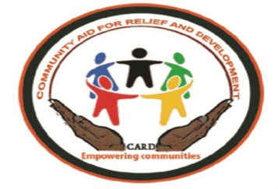

Community Aid for Relief and Development

CARD-SOUTH SUDAN

AIC/ICCO Compound, Hai Tarawa, Juba

Email,cardsouthsudanprogram@gmail.com

Date: 28th-^{st} September 2021

Vacancy/Job Advertisement

Position | Human Resource Officer
Reports to | Human Resource Manager
Location | Juba
Duration | 9 months
Deadline for submission | 14th October 2022

CARD Background
CARD was legally registered by the Ministry of Justice and South Sudan Relief and Rehabilitation Commission (SSRRC) in 2011. We are a leading National Humanitarian and Development Organization dedicated to fighting ill health, poverty, injustice and reducing human suffering in South Sudan through community mobilization, capacity building advocacy and empowering them at the grass root level.

Job brief
We are looking for a skilled HR Officer to recruit as part of our team to support through developing policies and managing procedures. s/he will be responsible for administrative tasks and s/he contribute to making the Organization a better place to work.

Main purpose
- Supporting the development and implementation of HR initiatives and systems
- Providing counseling on policies and procedures
- Being actively involved in recruitment by preparing job descriptions, posting ads and managing the hiring process
- The goal will be to provide excellent assistance and support to employees and managers

Role and Responsibilities
- Support the development and implementation of HR initiatives and systems
- Provide counseling on policies and procedures
- Be actively involved in recruitment by preparing job descriptions, posting ads and managing the hiring process
- Create and implement effective onboarding plans
- Develop training and development programs
- Assist in performance management processes
- Support the management of disciplinary and grievance issues
- Maintain employee records (attendance, EEO data etc.) according to policy and legal requirements
- Review employment and working conditions to ensure legal compliance

Requirements and skills
- Proven experience as HR officer, administrator or other HR position
- Knowledge of HR functions (pay & benefits, recruitment, training & development etc.)
- Understanding of labor laws and disciplinary procedures
- Proficient in MS Office; knowledge of HRMS is a plus
- Outstanding organizational and time-management abilities
- Excellent communication and interpersonal skills
- Problem-solving and decision-making aptitude
- Strong ethics and reliability
- BSc/BA in business administration, social studies or relevant field; further training will be a plus
- HR Credentials (e.g. PHR from the HR Certification Institute)
NB: Female candidates are strong encouraged to apply. Because of the urgent need of the position me may recruit before the deadline.
How to Apply
All applicants should include CV, all relevant copies of official documents and should be submitted by Email at: community cardsouthsudanprogram@gmail.com

