- Technical Specifications & Requirements

Specifications for office desks, office chairs, conference tables, stackable chairs, steel filling cabinets and waiting room chairs.

Bidders must meet the specifications listed in Section 1.1.
# | Item description | Specification | UoM | Quantity | Image
1 | Executive Office desks and chair with lockable drawers and Side Drawers | 140cm(L)x80cm(W) x  75cm (H)top, with wooden frame | Set | 1 | 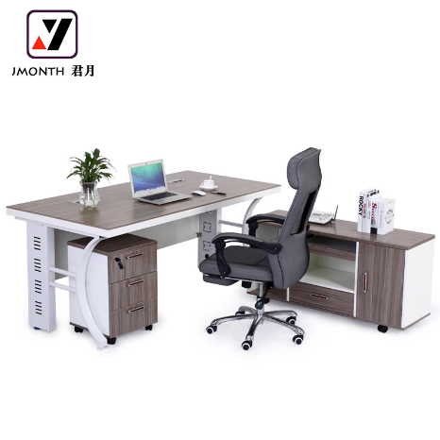
2 | Office Workstation Table,  280cm x240cm | 2-seater, with 4 or 3 lockable drawers, curved design | Set | 3 | 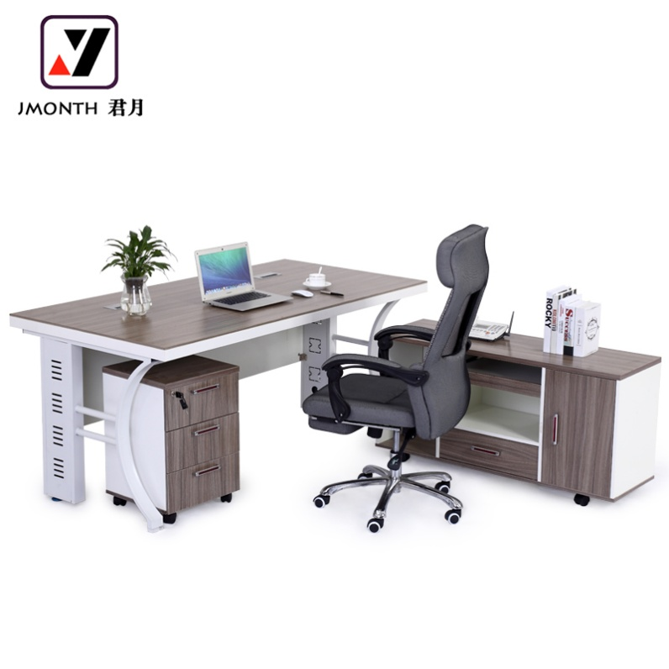  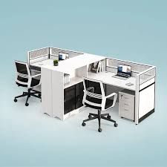
3 | Office chairs with adjustable height and back, high back and  armrest | High back revolving hydraulic, With strong casters/wheels, black or blue fabric material | Pieces | 10 | 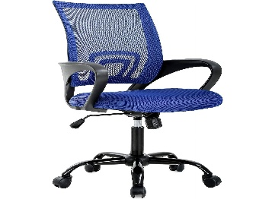
4 | Conference round table and chairs | 8 Seater Conference table and chair- Specs/:  Armrest and square base, lever for adjusting height, black fabric  material chairs with casters/wheels and  Conference table Specs.  DIMENSIONS: L280xW100xH76 cm | Piece | 1 set | 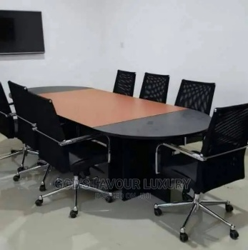
5 | Waiting room joined chairs | 1)Size:L1800*W670*H790mm  2)Seat: 1.5mm thickness metal steel after sliver powder coated .  3)Arms/legs: 1.2mm thickness metal steel after chrome electroplating .  4)Beam: 1.8mm thickness 80*40mm square steel tube  5)leather: PU leather | Pieces | 1 | 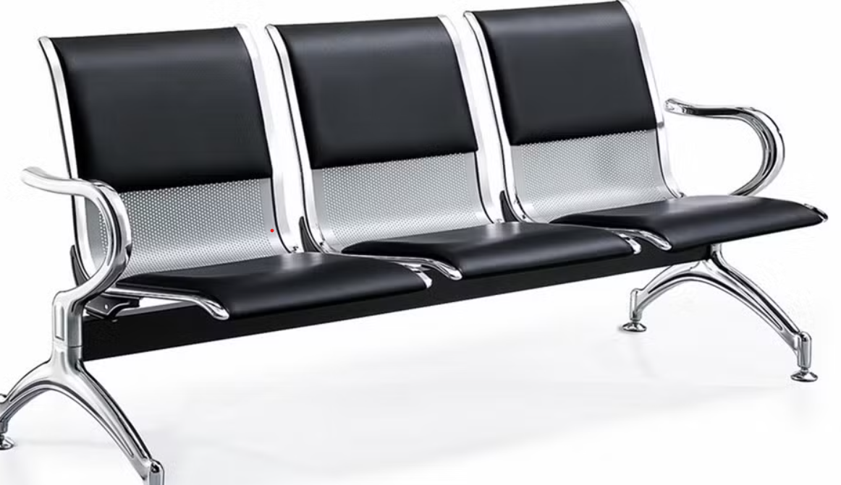

6 | Leteya Steel filling cabinet | Letaya File Cabinets,4 Drawer Metal Lateral Filing Organization Storage Cabinets with Lock, Home Office for Hanging Files Letter/Legal/F4/A4 Size (Require Assembly)  2 ft by 1.8 ft by 4.5 ft | Pieces | 2 | 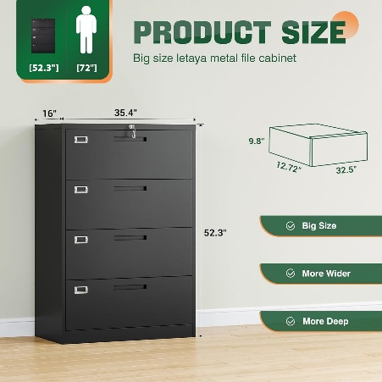
7 | Executive Office Cub board | Modern Front Glass 3 Doors Office File Cabinet· Size: Size: 1200Wx400Dx2000H.mm, Color, grey or black or silver. | Pieces | 3 | 