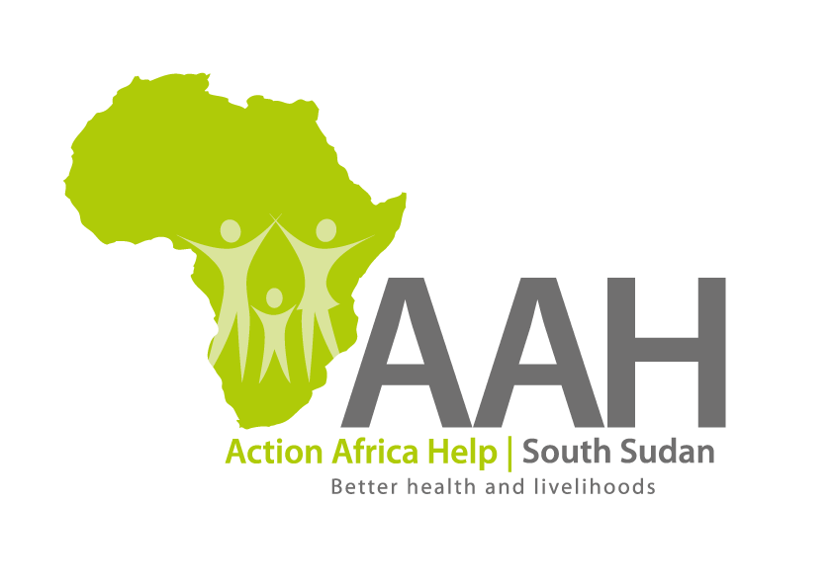
AAHI-South Sudan
Juba Office: Hai Gabat – Opp JIT Supermarket
Behind South Sudan Customs, Tel: +211 925 478 457
Email: ssudan@actionafricahelp.org
Website: www.actionafricahelp.org

RE-INVITATION TO TENDER

Background
Action Africa Help International (AAH-I) is a nongovernmental and nonprofit making Organization operating in South Sudan with a mission to support disadvantaged Communities to sustainably improve their standard of living through Community empowerment approach in partnership with stakeholders. AAH-I implements Primary Health Care, Agriculture, Humanitarian aid projects and Capacity Building.

The organization is calling for quotations from reputable companies for the Provision of Labor and Materials for the construction of Septic Tank at AAH-I Log Base.

 | DETAILS | DETAILED TENDER TO BE PICKED FROM
1 | Provision of labour and Materials for the construction of Septic tank at AAH-I Logistics Base | AAHI/UNHCR Juba Logistic base

The deadline for submission is Friday the 25th November, 2022, at 10:00 Am Local Time.

More information on the tender to be picked from AAHI/UNHCR Juba logistics base

