**Malteser International**

**Country Coordination Office**

**Plot No. 246, Block 3k 2nd Class Residential**

**Tongping (behind Indian Embassy)**

**Central Equatoria State, Juba, South Sudan.**

**23 February 2024**

**Malteser International Request for Quotation**

**RFQ_JUB_2024_0004_2nd round**

For supply and delivery of delivery of agriculture tools to Malteser International (MI) warehouse on Bilipam Road in Juba in South Sudan.

1. Annex 1: Specification of Bidding
2. Annex 2: Bill of Quantity

We look forward to receiving your quotations on **1 March 2024 at or before 12pm** via E-mail to**:** [**mb.procurement-juba@malteser-international.org**](mailto:mb.procurement-juba@malteser-international.org).

Please write in the Subject line of your email with quotation: “**RFQ_JUB_2024_0004_2nd round for supply and delivery of agriculture Tools**”.

Thank you for your cooperation.

With regards,

|  |  |  |
| --- | --- | --- |
|  |  | Nermin Silajdzic  Country Logistics Coordinator Plot No. 246 Block 3k South 2nd Class- Behind Indian Embassy, Tong Ping  Central Equitorial State, Juba, South Sudan M: +211 (0) 911 746 963 · M: +211 (0) 924 767 949 [nermin.silajdzic@malteser-international.org](mailto:nermin.silajdzic@malteser-international.org) · Skype: nsilajdzic [www.malteser-international.org](http://www.malteser-international.org/) Malteser International Europe/Malteser Hilfsdienst e. V., County Court Cologne, VR 4726 Executive Board: Karl Prinz zu Löwenstein, Dr. Elmar Pankau, Douglas Graf Saurma-Jeltsch, Verena Hölken |
| Legal advice: This communication is for use by the intended recipient and contains information that may be privileged, confidential or copyrighted under applicable law. If you are not the intended recipient, you are hereby formally notified that any use, copying or distribution of this e-mail, in whole or in part, is strictly prohibited. Please notify the sender by return e-mail and delete this e-mail from your systems. | | |

**Please consider the environment before printing this email**

# A. SPECIFICATION OF BIDING

Related to our advertised Request for Quotation RFQ_JUB_2024_0004_2nd round MI herewith calls for quotations concerning supply and delivery of agriculture tools to MI warehouse on Bilipam Road in Juba in South Sudan.

Under the following reference number:

Donor project numbers: 1345-JUB

MI project number: 13

# Description of the organization and its activities

Malteser International is the international humanitarian relief agency of the Sovereign Order of Malta. For over 60 years we provide relief and recovery for people during and following conflicts and disasters around the world. Christian values and humanitarian principles form the foundations of our work. In over 30 countries in Africa, the Americas, Asia and the Middle East, we support people in need – regardless of their religion, origin or political convictions.

Malteser International has been working in the geographic area of today’s South Sudan since 1996. MI implements a multi-sectoral program including Food & Nutrition Security, Livelihoods, WASH, health and peaceful conflict resolution. This includes activities such as agricultural trainings, cash distributions, food for education and access to water, sanitation and hygiene. The program is aiming to increase its work with local partner organisations in order to optimise its sustainability. Furthermore, MI applies a participatory, gender sensitive and inclusive approach in its programming. As of today, MI maintains its country office in Juba while operating a program office in Wau and project offices in Uyujuku and Yei.

**Objective of Request for Quotation:**

In accordance with the overall targets of above-mentioned operations, MI plans to procure agriculture tools to Malteser International warehouse on Bilpam Road in Juba in South Sudan.

The technical specifications and conditions of the bidding process are described below in the Specification of bidding and in the Annex 2: Bill of Quantity which are part of this Request for Quotation.

Suppliers are invited to present a quotation complying with the requirements here below specified.

# Quotation Presentation

The quotation shall be received via E-mail to**:** [**mb.procurement-juba@malteser-international.org**](mailto:mb.procurement-juba@malteser-international.org) on **1 March 2024 at or before 12pm**

* The quotation shall be written in English.
* The quotation should be valid for **60 days after the deadline.**

# General conditions

* The quotation shall be typed or written and signed on each page by the legal representative of the supplier,
* The winning supplier might be requested to provide catalogues, pictures, technical descriptions and/or samples of items at the order stage when required,
* The prices of the quotation will be expressed in United States Dollars. The prices must be on unit price basis as well as by totals,
* The prices will be considered fixed whereas MI will not process Tax exemption. No additional change of whatsoever nature and type will be accepted by MI,
* MI reserves the right to accept or reject all quotations depending on prevailing condition at the time.

# Technical specification

For supply and delivery of agriculture tools to MI warehouse on Bilpam Road in Juba in South Sudan

|  |  |  |  |  |
| --- | --- | --- | --- | --- |
| **No** | **Dignity kits** | **Quantity** | **Unit** | **Quality** |
| 1 | Tines Rail Steel Garden Hoe | 2,000 | Pcs | Good quality to be determined by physical visit |

# 

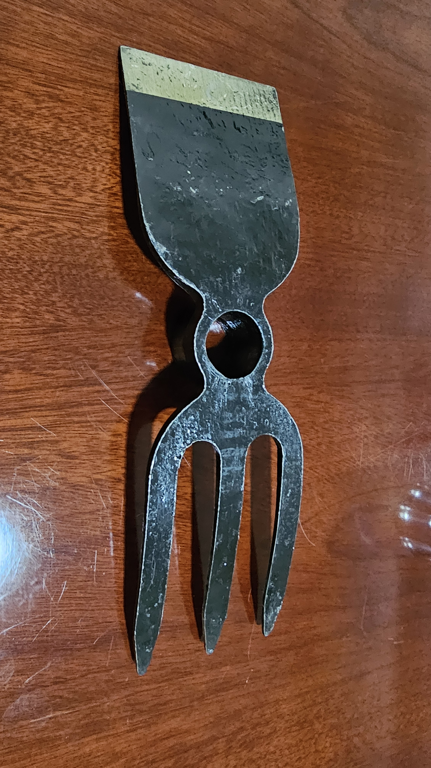

# Validity of quotations

Each company is bound to the quotation submitted for a period of 60 days from the deadline for submission of quotations.

# Language of quotations

All quotations, official correspondence between companies and MI, as well as all documents associated with the quotation’s request will be in English.

# Submission of quotations

# Each quotation must have received via E-mail to: [mb.procurement-juba@malteser-international.org](mailto:mb.procurement-juba@malteser-international.orga) on 1 March 2024 at or before 12pm

# Content of quotation

All submitted quotations must conform to the requirements mentioned in the RFQ. Furthermore, they must include the following documents:

**Part 1 - Quotation:**

A quotation for supply and delivery of farming tools to MI warehouse on Bilipam Road in Juba in South Sudan.

The format BoQ can be used or a separate one depending on supplier’s choice. Additional sheets may be attached for further details as requested above.

**Part 2 - Legal documents of company registered in South Sudan**

* Copy of the company’s certificate of incorporation,
* Copy of Chamber of Commerce registration,
* Copy Tax Identification Certificate,
* Copy of Certificate of Operation,
* Average turnover in the last 2 years for 2022 and 2023,
* Company’s Bank Statement of last three months (November and December 2023 and January 2024),
* Company’s official address,
* Bank account details (where money would be paid),

# Ownership of quotations

MI reserves/funds ownership of all quotations received. Therefore, bidders will not be able to stipulate requirements that their quotations are to be returned.

1. **Opening of submitted quotations.**

Quotations will be opened on 1 March 2024 in MI Office in Juba by the Evaluation committee.

The selection process will be recorded in writing by the evaluation committee.

# Quotation’ evaluation

**Technical resources and experience**

* Delivery time
* The technical experiences,
* Quality standards of farming tools and
* Capacity to deliver.

**Financial selection criteria**

* Bided price,
* Average turnover in the last 2 years for 2022 and 2023,
* Company’s Bank Statement of last three months (November, December 2023 and January 2024),

1. **Evaluation Method**

Quotations shall be evaluated according to the following procedure:

Firstly, quotations shall be evaluated for technical compliance based on:

* Delivery time,
* Previous experience in similar project and
* Quality of farming tools and
* Capacity to deliver.

Secondly, quotations that are found to be technically compliant shall be evaluated based on price and value for money, analysing all relevant costs, risks, and benefits of each bid throughout the whole life cycle of the works and in the context of the project. The evaluation shall be in accordance with the provisions of this RFQs and in accordance with the following weighting:

* The set criteria shall be used to determine the most economically advantageous quotation for contract agreement award,
* The Bidder’s initial proposal should contain the offer’s best terms from a cost or price and technical standpoint,
* If quotations are determined to be equivalent based on the technical criteria, price will then become the deciding criterion for award,
* Bidders are forewarned that an acceptable proposal with the lowest price may not be selected if award to a higher-priced proposal affords MI a greater overall benefit,
* The MI will favourably evaluate a schedule, which shows earlier completion than the MI’s required time limit. The Bidder's innovative approaches to accomplish early completion are encouraged.

1. **Specific Technical and Financial Evaluation Criteria to standards:**

* Comparative Bid Analysis and justification basing on responsiveness of the selected supplier by internal committee.
* Contract agreement will directly be issued to the selected supplier upon approval.

1. **Terms of payment**

The payment will be done in United States Dollar by bank transfer or cheque after delivery as specified below:

* 100% of shall be paid by Malteser International within 10 working days’ delivery of farming tools and receiving invoice from by the Contractor.

**B. Annex 2: Bill of Quantity**

For supply and delivery of agriculture tools to MI warehouse on Bilipam Road in Juba in South Sudan.

|  |  |  |  |  |  |
| --- | --- | --- | --- | --- | --- |
| **No** | **Dignity kits** | **Quantity** | **Unit** | **Unit price USD** | **Total USD** |
| 1 | Tines Rail Steel Garden Hoe | 2,000 | Pcs |  |  |

On behalf of Malteser International: `

23 February 2024

Thank you for your cooperation.

With regards,

|  |  |  |
| --- | --- | --- |
|  |  | Nermin Silajdzic  Country Logistics Coordinator Plot No. 246 Block 3k South 2nd Class- Behind Indian Embassy, Tong Ping  Central Equitorial State, Juba, South Sudan M: +211 (0) 911 746 963 · M: +211 (0) 924 767 949 [nermin.silajdzic@malteser-international.org](mailto:nermin.silajdzic@malteser-international.org) · Skype: nsilajdzic [www.malteser-international.org](http://www.malteser-international.org/) Malteser International Europe/Malteser Hilfsdienst e. V., County Court Cologne, VR 4726 Executive Board: Karl Prinz zu Löwenstein, Dr. Elmar Pankau, Douglas Graf Saurma-Jeltsch, Verena Hölken |
| Legal advice: This communication is for use by the intended recipient and contains information that may be privileged, confidential or copyrighted under applicable law. If you are not the intended recipient, you are hereby formally notified that any use, copying or distribution of this e-mail, in whole or in part, is strictly prohibited. Please notify the sender by return e-mail and delete this e-mail from your systems. | | |

**Please consider the environment before printing this email**