TERMS OF REFERENCE (TOR) MAYENDIT/THAKER SECURITY PROVIDER
- OBJECTIVE

Samaritan’s Purse (SP) Mayendit/Thaker warehouse considers that a secured and safe work environment will contribute to a more productive workforce that will result to an efficient and effective delivery of programs and services. The ministry has only two locations in Mayendit/Thaker that must be secured from burglary, robbery, theft, sabotage, fire, vandalism, unruly rallies and other unlawful acts. Samaritan’s Purse (SP) Mayendit/Thaker warehouse is obliged to have Security Services to safeguard the warehouse and facilities that are off limits to the public. Thus, Samaritan’s Purse Mayendit/Thaker warehouse requires the services of a Security Service Provider that will secure its personnel, properties and facilities.

- APPROVED BUDGETARY REQUIREMENTS

The term of this contract shall be effective for the calendar year 2024 starting 01 January 2024 until such a time that the client will submit an end of contract notification. The contract will spell out the terms and conditions for all budgetary requirements.

- SCOPE OF WORK

- Ensure 24-hour man guarding service at Samaritan’s Purse Mayendit/Thaker warehouse.
  - Main gate
  - Roving patrol
- Provide 24-hour QRF (Quick Reaction Force) service to respond to any emergency as required.
- Submit Weekly and Monthly Situational Security Summaries for Mayendit/Thaker and Unity State situational security summaries. The service provider will also provide quarterly risk assessments of Mayendit/Thaker and Unity State.
- Ensure that security officials on all sites are always equipped with proper security equipment such as a baton, radios and torch-light etc. (provided by the security provider)
- To comply with Standard Operation Procedures for 2 posts. Mayendit post 1 and Thaker post 2
  - Site specific instructions for access control to address the movement of personnel, vehicles and equipment entering and leaving the premises.
  - Fire detection
  - Action to be taken when confronting a suspect
  - Emergency procedures and action to be taken upon any emergency
  - Monthly re-training - Samaritan’s Purse security team to be present
  - Management and supervision on a daily basis from security provider
  - Replacement of officials due to any reason, and of absentees.
  - Check the removal and movement of incoming/outgoing equipment and items. Keep records of items going out of or coming into the warehouse
  - Verify that all gates are properly locked and those left open inadvertently are properly locked, and reported thereafter.
  - Provide trained, equipped and qualified security supervisors, with reasonable knowledge of an international language (English).
  - Provide a larger alarm system to alert the community of an incident at the warehouses.
  - Adhere to all national and local legislation regarding the legalization of the company, taxes, labour practice and any other regulation relevant to the security industry
  - Conduct ad hoc inspections to ensure that all services are guaranteed by the security guards of the company.
  - Ensure all vehicle on premises are locked and if not report to the SP manager.
  - Control of vehicle access into and out of the warehouse facilities.
  - Ensure timely payment of salaries of the guards posted at the Samaritan’s Purse Mayendit/Thaker warehouse. The ministry reserves the right to impose a penalty to the security contractor should the delay in payment of salaries to the guards result in poor service quality.
  - Ensure that the guards posted at the warehouse are properly dressed in uniforms to portray a good image to visitors.

- REQUIRES SHIFTS for MAYENDIT/THAKER WAREHOUSE

- Shift 1: 06:00am – 18:00pm local time

Post | Monday | Tuesday | Wednesday | Thursday | Friday | Saturday | Sunday
Main Gate | 1 | 1 | 1 | 1 | 1 | 1 | 1
Patrol | 1 | 1 | 1 | 1 | 1 | 1 | 1

- Shift 2: 18:00pm – 06:00am local time

Post | Monday | Tuesday | Wednesday | Thursday | Friday | Saturday | Sunday
Main Gate | 1 | 1 | 1 | 1 | 1 | 1 | 1
Patrol | 2 | 2 | 2 | 2 | 2 | 2 | 2

The service provider must ensure that they adhere to the labor laws of South Sudan when formulating their shift structure and determining the hours each person is to work per 24 hour period.

- Required Personnel
  - One (1) Senior Guard per day shift
  - One (1) Guard during the 1st Shift scheduled from 06:00am to 18:00pm
  - One (1) Senior Guard per night shift
  - One (2) Guard during the 2nd Shift scheduled from 18:00pm to 06:00am
  - There will be five (5) security guards on shift at all times during a 24hour period for the entire term of the contract.

- STATEMENT OF WORK

  - Requirements
- The security company must be fully licensed and have in possession all required legal permits for provision of unarmed security services. Certified copies of these documents will be provided to Samaritan’s Purse.
- All personnel to be provided by the security company for performance of work under this Statement of Work shall be fully qualified as Security Guards, in accordance with the South Sudan legislation.
- The security company shall also be required to provide additional security personnel on an as-and when-required basis, following the receipt of authorised written request from the Country Director or his/her designated representative, at the rates set out in the Contract.

  - Responsibilities of the security company
- Access Control
  - The security company security personnel will be unarmed and tasked to prevent unauthorised personnel or vehicular entry into the Samaritan’s Purse Mayendit/Thaker warehouse controlled areas.
  - There is one employee/visitor entrance or point of entry. At each point of entry, the security company shall maintain a “Visitors’ Book” for non-SP personnel visiting SP for official or social purposes.
  - The security company will be required to maintain pedestrian and/or vehicular traffic records at selected gates. Any violations are to be immediately reported to the CSM and or SPM.
  - Personnel movement in areas identified by Samaritan’s Purse (SP) Mayendit/Thaker warehouse as “restricted” shall be closely controlled and monitored.
  - Patrol Duties. The security company shall patrol the contracted installations, i.e. provide physical security of the exterior of all buildings, monitor compound fence lines and protect SP-Owned Equipment, using continuous roving patrol guards in minimal intervals of 30-45 minutes. There will also be numerous visitors to SP activities, which will necessitate a screening/escorting process.
  - Unauthorised Removal of Property. At each point of entry/exit, the company shall prevent the unauthorised removal of SP-Owned Equipment from the SP premises. This will entail a visual, non-destructive and non-invasive search of vehicles entering and exiting the SP compound when instructed to do so by the Senior Management Team, as well as a search of hand-carried items when instructed to do so.
- First Aid
  - All the security company’s personnel should hold a first-aid certificate, which includes Cardiopulmonary Resuscitation (CPR).
  - SP will not provide the First-Aid Kits to guards. Each guard should have its own first aid kit.
- Coverage
  - The security company shall ensure that all posts are continuously manned throughout the duration of each shift. Security guards will exercise maximum awareness and be fully alert during their shift.
  - Guards will ensure that all entry/exit gates are locked when there are no activities.
- Records and Reports
  - A summary of required reports is listed below. The security company may utilise formats or combine reports for efficiency in preparation, insofar as the basic information is provided within the specified timeframe. All administrative files, including details of security personnel on duty at each location at any given time, complaints, incidents, post and radio logs, shift reports, work schedules, equipment inventories, lost and found property, etc., shall be maintained at the SP warehouse and will be the property of SP.
    - Daily Occurrence Book
    - Visitors’ Log; and
    - Staff Working After Hours Log
- Performance Meetings
  - Regular performance meeting will be held between SP AC/CSM/SPM and the security company or its senior representative, not less than once per month. Written minutes of the meetings shall be prepared by the security company and forwarded to SP within 72hours after the meeting.
- The security company Personnel
  - The security company will ensure that same personal is continuously deployed at the same posts. In cases when designated personal cannot be deployed to its standard deployment post, the security company will consult with the AC/CSM/SPM about adequate replacement minimum twenty four (24) hour prior deploying. In cases when new staff has been deployed to the location without prior approval from the AC/CSM/SPM, services provided for that particular shift will not be compensated. The security company will on its’ own cost provide a file with pictures of all security guards designated to the specific location. This file will be visibly displayed on the main assess point.
- Qualifications
  - The security company shall ensure that all its personnel employed and assigned to perform under the contract meet or exceed the following minimum criteria.
    - Must be at least 20 years of age;
    - be physically able to perform all general patrol duties, functions and activities;
    - be free from all communicable diseases;
    - be well proportioned, as to height and weight;
    - be in good general health, without physical defects or abnormalities which would interfere with the performance of duties;
    - have binocular vision correctable to 20/30; and
    - have adequate colour acuity and be capable of hearing normal conversation at three (3) metres with both ears, without the benefit of a hearing aid.
  - The security company shall conduct pre-hire physical examinations at its own cost and expense, to ensure compliance with the above-mentioned requirements. Any request for waivers must be approved in advance by the CSM in writing
  - All employees shall be literate in English/Arabic to the extent of reading and understanding printed regulations, detailed written orders, training instructions and materials.
  - No employee shall have been terminated from any previous employment other than honourable circumstances.
  - All employees must possess the capacity to acquire a good working knowledge in all aspects of the position requirements of the contracted security force, i.e. post orders. The post orders will be provided by the security company for review by the CSM.
- Personal Appearances
  - The security company shall provide all uniform apparel and equipment to its personnel. Uniformed personnel are expected to keep a clean, neat appearance and present a professional bearing.
  - The security company shall ensure that its personnel are physically capable of standing watch, patrol i.e. not having consumed alcoholic beverages or other types of intoxicants within the previous twelve (18) hours, and are sufficiently rested for minimum of eight (8) hours before each shift. The security company shall ensure that its personnel does not exceed working shift of twelve (12) hours. The security company will make every effort that security guards are replaced on time. SP will not be charged for guard services where guard duty exceeds twelve (12) hours shift.
- Training Requirements
  - Prior to deployment, each of the security company’s security personnel must complete their training programmes and each guars should be qualified. All the security company’s security personnel shall receive no less than eight (8) hours refresher training, for every three-month period, on security matters directly related to the performance under the security company. The security company shall determine subjects and the methods of presentation, with emphasis on problem areas.
  - The security company shall conduct the training in an industry acceptable format and shall ensure assimilation of the subject matter by each of its personnel. Results of all refresher training shall be reported in writing to the AC/CSM/SPM within seven (7) days after completion.

- Employee Conduct
  - The security company shall ensure that its employees maintain satisfactory standards of competency, conduct, appearance and integrity. The security company shall take appropriate actions, as necessary, to ensure compliance with these standards.
  - The security company shall ensure that Unity State legislation for hiring is adhere too.
- Equipment
  - The security company shall provide all equipment and/or supplies necessary to meet the requirements of this Contract, including communications equipment to its staff.
  - Samaritans Purse (SP) will not be responsible to provide any security equipment.
- Disclosure of Information
  - Neither the security company nor any of its personnel is allowed to disclose or cause the dissemination of any information concerning the operations, staff or assets of Samaritan’s Purse Mayendit/Thaker warehouse. All inquiries, comments, or complaints, arising from any matter observed, experienced, or learned of as a result of, or in connection with, the performance of this Contract and the resolution of which may require dissemination of official information, will be directed to the CSM/SPM. Deviations from or violations of any of these provisions may, in addition to all other criminal and civil remedies provided by law, subject to the security company to immediate termination for cause, and/or the individuals involved to a withdrawal of the Samaritan’s Purse acceptance and approval of their employment.
  - The security company will not take any videos or record any SP activities.
- Removal from Duty
  - The CSM/SPM has the authority to direct the security company for immediate removal of any employee from the work site should it be determined that an individual is not suitable to perform the guard duties.

  - Duties and Responsibilities of Security Guards
- The security company’s Security Guard shall perform access control functions on 24/7 basis listed but not limited to below;
  - Control all entry/exit points and ensure adequate security of the organisation’s premises as per issued policies and procedures;
  - Ensure that all staff and visitors are properly screened and registered and when required issue with adequate access passes, (visitors, contractors etc).
  - Ensure that routine patrols are conducted within the SP Mayendit/Thaker warehouse premises and that they are properly documented.
  - Patrol assigned areas; maintain continual surveillance against fire, water leakage and any other action which could damage SP Mayendit/Thaker warehouse premises or injure its personnel.
  - Log all movement of equipment in/out of SP Mayendit/Thaker warehouse premises.
  - Properly screen all items carried into the premises to prevent and deter entrance of dangerous, illegal or suspicious looking materials or items.
  - Report all incidents on the grounds that involve a breach of safety, security procedures, injuries and theft.
  - Intervene personally to resolve problems or refer them immediately to the AC/CSM/SPM.
  - Respond to personnel and telephone enquiries and provide appropriate information or suggest alternative sources of information.
  - Provide emergency assistance and assist staff and visitors during contingencies.
  - Assist staff, visitors and guests on the SP Mayendit/Thaker warehouse premises as a courtesy and service.
  - Report for duty as and when necessary (on call).
  - Perform other related security duties outlined in the contract as required.
  - Open and close buildings, offices etc.
  - Unless prior approval has been given by the SPM, personal mobile phones are to be turned off while on duty.

- INSURANCE AND LOSS (Procurement office to add details)

- COVENANT (Procurement office to add details)

- CONFIDENTIALITY (Procurement office to add details)

- LEGAL (Procurement office to add details)

- FORCE MAJEURE (Procurement office to add details)

- PREVENTING SEXUAL EXPLOITATION AND ABUSE (Procurement office to add details)

- Location Orientation

Location of Thaker warehouse
- GPS Code: 8°23'36.0"N 30°02'58.8"E
- The warehouse has three Rubhall
- The warehouse is fenced with chain link wire with its gates facing the airstrip

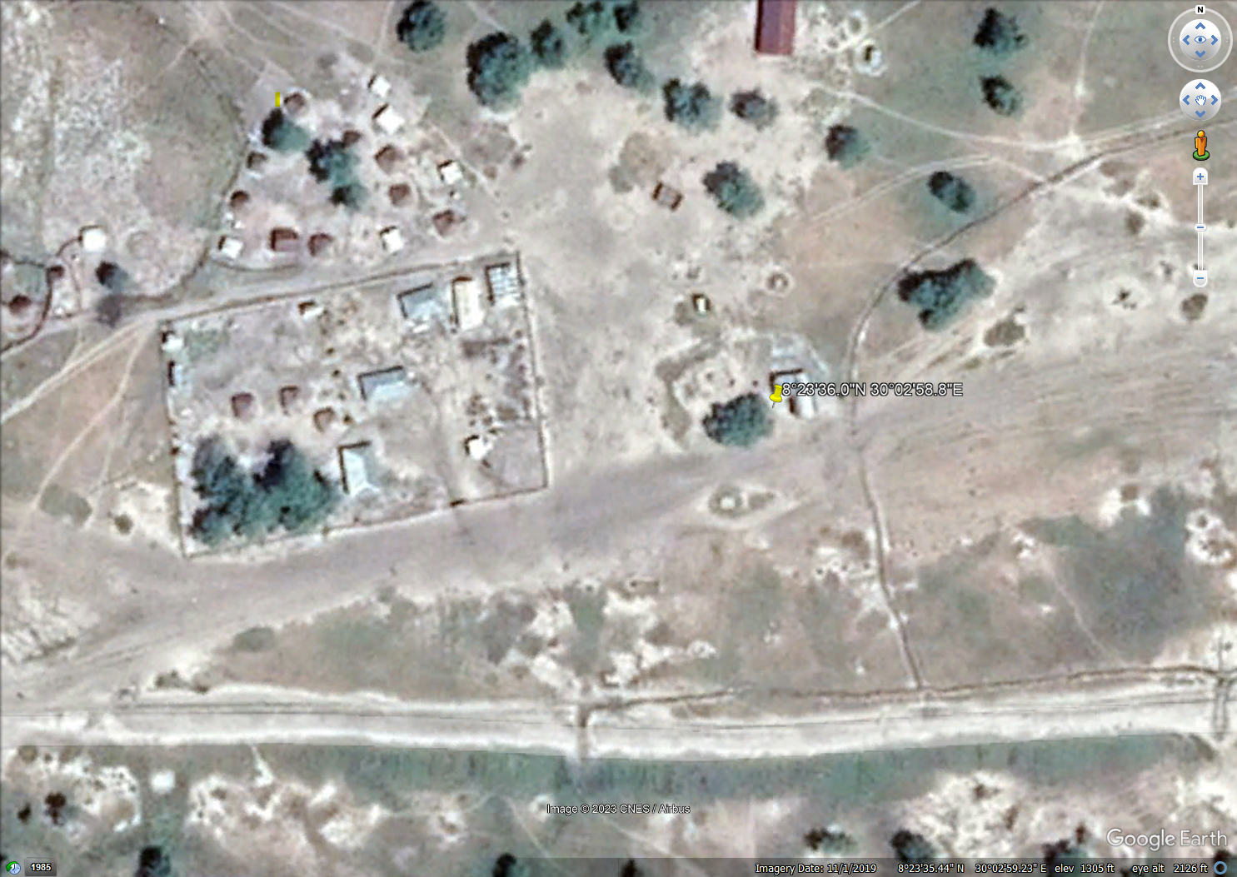

Location of: the Rubkuayi warehouse
- GPS Code: 8°23'9.44"N, 30° 4'54.59"E
- The ware house has two rubhall
- The warehouse is fenced with Chain Link wire with its gates facing the main road

