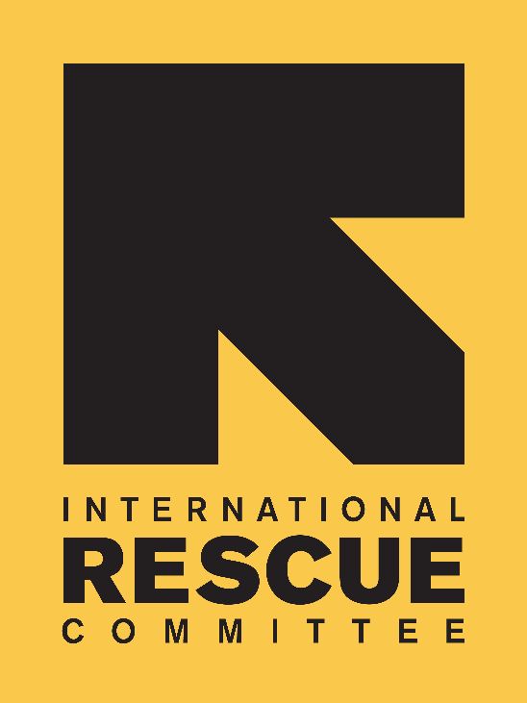 | Vacancy Announcement
 | Job Title: | Civil Engineer
 | Band / Level / Grade: | 8A
 | Department: | HEHS
 | Location: | Malualkon, South Sudan
 | Overtime Eligible: (per local law) | Exempt

The International Rescue Committee, one of the world’s largest humanitarian agencies, provides relief, rehabilitation, and post-conflict support to victims of oppression and violent conflict in 42 countries. IRC is committed to bold leadership, innovation, and creative partnerships. South Sudan, an independent nation since 9 July 2011, is emerging from decades of brutal civil war rooted in disputes over religion, ethnicity, resources, governance, and self-determination. The security situation remains unpredictable, and the operational context is challenging. IRC has operated in South Sudan for over 30 years now delivering humanitarian relief, post-conflict assistance, and development programs in both refugees, internally displaced and host community settings. IRC operates in 10 field offices including in Juba with field program portfolio covering health, nutrition, child protection, Economic Recovery and Development (Livelihoods), women’s protection and empowerment and general protection. IRC continues to provide life-saving assistance and humanitarian aid to vulnerable South Sudanese and continues to work with the affected to rebuild their lives and restore peace.
SCOPE OF WORK.
The IRC is operating in Northern Bahr El Ghazal state and the position will be based in Aweil/Malaukon IRC field office, under the direct supervision of the Field Coordinator and technical supervision from the Environmental Health Coordinator based in Juba. The Civil Engineer will be responsible for the IRC civil works and construction in selected counties. These will include the rehabilitation and repair of flood-damaged structures, boreholes dykes, roads. The work will involve ensuring the protection of the structures against future damage due to climate-related issues. The engineer will activities are implemented that ensure the assessment, design, rehabilitation, and construction up to completion of key facilities and structures within the targeted locations are in line with IRC and donor requirements. S/he will supervise construction technicians and contractors to ensure efficient use of resources. S/he will provide overview and technical expertise to the IRC team and ensure all construction projects are implemented within the standards and proposed project time frame.

Functional Responsibilities
The Civil Engineer will report directly to the Field Coordinator, and s/he will be accountable for the following specific responsibilities.
Feasibility Study and Design
- Actively involve and take responsibility for the preparation of field assessment reports, designs, and tender document preparation.
- Prepare tender documents such as the bill of quantities, breakdown of rates, specifications, drawings, particular conditions, schedules, work Programme.
- Engage in all technical investigations and associated designs.
Procurement
- Liaise and work with the Procurement Unit to review, incorporate comments and re-submit bid documents.
- Follow up and ascertain the publication of bid documents.
- Participate in bid clarification meetings.
- Prepare and issue minutes of clarification meetings and any addendum.
- Lead joint site visits and clarify any issues raised.
- Participate in the bid evaluation panel and prepare evaluation reports and recommendations.
Implementation
- Be involved in the preparation of project implementation plans for construction projects.
- At initial stages, perform the necessary reviews on design documents.
- Develop project designs, drawings, and bills of quantities.
- Develop and issue detailed tasks to all members of the team including inspection, checking, approval, reporting, and record-keeping procedures.
- Ensure all site clearances, certificates and site possessions are in place prior to the commencement of mobilization.
- Regular supervision and inspection of construction works, monitoring of progress and quality of works, reporting of daily progress; mobilization of subordinates in daily work activities; review of contractors work plan and method statements.
- Measurement of works and checking/verification in quantities of completed works / contractors works.
- Ensuring all completed works are in accordance with design and quality requirements. Provision of all necessary documentation and test results to confirm.
- Identification of site/work package risks, preparation of risk assessments and implementation of approved risk mitigation measures.
- Management, documentation and reporting of site expenditure and costs, including, but not limited to, contractor progress claims, casual labour payment and procurement of local materials.
- Operational planning, including preparation of plans, schedules, procedures and budget for recruitment, mobilization, operations, health, safety and environment, security and site closure.
- Preparation and maintenance of site or work package records, including documentation of all phases of the project lifecycle.
- Ensuring good working relationships with local authorities, representatives and stakeholders are developed and maintained.
- Preparation of all site/work package closure reports and handover documentation.
- Preparation of site instructions, including technical and quality specifications and design works.
- Preparation of draft contractual correspondence, interpreting contract conditions and specifications, monitoring the progress of work, preparation work plan, S-curve, Minutes of Meeting and any relevant documentation
- Perform periodic inspections during defect liability period and joint inspection and certification at completion.
- Prepare final project account and recommendations to the employer based on lessons learned.
Monitoring and Progress Controls
- Prepare and maintain proper records of work progress and project reports.
- Report project delivery progress against the works Programme, advise the concerned staff and contractor on corrective measures, if appropriate, and submit periodic progress reports in accordance with donor guidelines.
- Assist in the preparation of monthly payment certificates for contractors.
- Maintain site journals and other site-specific documents.
- Timely delivery of all site construction documentation.
- Prepare periodic and ad-hoc reports to relevant section within reporting deadlines.
Final Product
- Under the guidance of the EH Coordinator, prepare plans/drawings needed in the contract documents, project reports and during project implementation.
- Submission of all data and reports collected during the assignment.
- Satisfactory management of construction contracts that avoids construction disputes and/or claims.

Education/Experience
Education
- Bachelor’s degree in engineering, preferably Civil or Construction or related field is required.
- Master’s degree in engineering, preferably Civil or Construction Management is an asset.
- A Technical/Professional Diploma in engineering or related field with additional two (3) years of relevant experience may be accepted in lieu of the master’s or bachelor’s degree.
Certification
- Certification in PRINCE2 or other Project Management Discipline is desirable.
- Certification and use of design, drafting and planning software is desirable.
Work Experience
- Minimum 3 years of relevant experience working with NGOs or similar or the engineering and construction industry involving design, construction contracts administration and/or construction supervision of water structures, buildings and health facilities is required.
- Previous experience in post-conflict/ developing country contexts required.
- Experience in managing contraction activities as an asset.
- Experience in Infrastructure engineering design an asset
- Experience in the use of engineering software including AutoCAD, SolidWorks, Civil3D, etc
Languages
- Fluency in written and spoken English required.
- Knowledge of Arabic language desired.

Competencies
Treats all individuals with respect; responds sensitively to differences and encourages others to do the same. Upholds organizational and ethical norms. Maintains high standards of trustworthiness and as a role model for diversity and inclusion.
Acts as a positive role model contributing to the team spirit. Collaborates and supports the development of others.
Demonstrates understanding of the impact of own role on all partners and always puts the end beneficiary first. Builds and maintains strong external relationships and is a competent partner for others (if relevant to the role).

The IRC Core Values and Commitments:
Standards of Professional Conduct: The IRC and IRC workers must adhere to the values and principles outlined in IRC Way Standards for Professional Conduct. These are Integrity, Service, Accountability and Equality. In accordance with these values, the IRC operates and enforces policies on Beneficiary Protection from Exploitation and Abuse, Child Safeguarding, Anti Workplace Harassment, Fiscal Integrity, and Anti-Retaliation the IRC operates and enforces policies on Beneficiary Protection from Exploitation and Abuse, Child Safeguarding, Anti Workplace Harassment, Fiscal Integrity, and Anti-Retaliation.
Safeguarding policy: The IRC has a zero-tolerance policy for safeguarding violations by staff, incentive workers, visitors, sub-grantees, suppliers/sub-contractors, and implementing partners. Safeguarding at the IRC is an integral to the organizational values and ethics, and staff and associates are expected to take all reasonable steps to prevent the sexual exploitation, abuse, and harassment of any person linked to the program by both its employees and any downstream partner. The successful candidate will be subject to a thorough background check and satisfactory references.
Narrowing the Gender Gap: The International Rescue Committee is committed to narrowing the gender gap in leadership positions. We offer benefits that provide an enabling environment for women to participate in our workforce including a flexible hour (when possible), maternity leave, transportation support, and gender-sensitive security protocols.
Equal Opportunity Employer: IRC is an Equal Opportunity Employer. IRC considers all applicants because of merit without regard to race, sex, color, national origin, religion, sexual orientation, age, marital status, veteran status, disability, or any other characteristic protected by applicable laws.
How to apply:
Interested applicants should submit a CV with 3 references and a copy of their national ID to Human Resources Juba IRC Country Head Office-Located in Goshen House 2nd floor or you can e-mail applications to SS-HR@Rescue.org not later than 5th March 2024 @ 4:30pm.
NOTE: Only shortlisted candidates will be contacted and attach photocopies only while original will be asked at the interview panel and all the photocopies will remain the property of IRC.
CLEARLY LABEL YOUR APPLICATION, CIVIL ENGINEER - MALUALKON

“WOMEN, MINORTITIES AND PEOPLE LIVINING WITH DISABILITIES ARE ENCOURAGED TO APPLY”.

