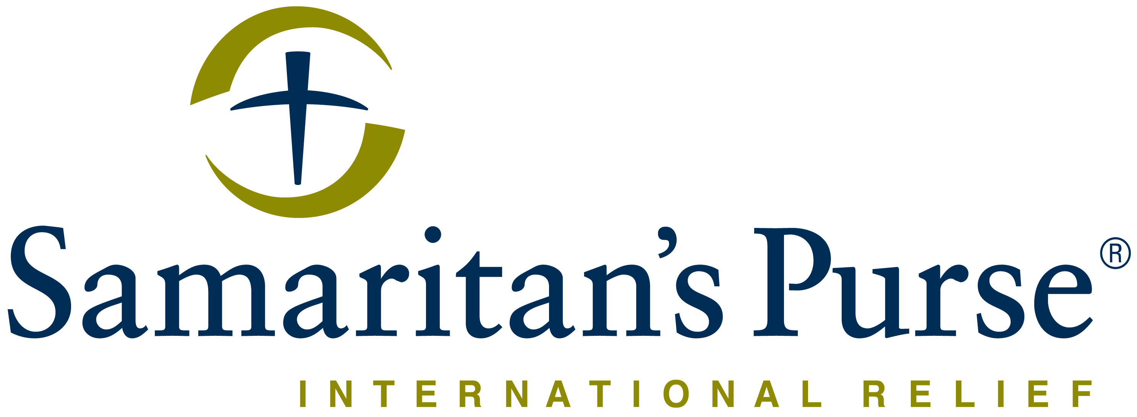

Franklin Graham President

REQUEST FOR QUOTE NOTICE

Deadline for submission of bids August 19th, 2020 before 5:00pm.

From: Samaritan’s Purse.
South Sudan, Hai Cinema next to
Quality Hotel, Old Juba Town Road.
E-mail: SouthSudanSealedBid@samaritan.org
Date: August 10 ^{the}, 2020

Subject: Public Tender-PR C19OFJB057 For Technical Advisor To Assess And Rehabilitate Hand Pumps

Samaritan’s Purse wishes to contract a legally recognized service provider (company) for Supply of Consultancy to Assess and Rehabilitate Hand Pumps as specified below as TOR attached;

Item  # | Qty | Unit | Item Description | Unit Cost (USD) | Total Cost (USD) | comment
1 | 1 | each | Technical Advisor for Consult on Bore Hole and Pump repair |  |  | Technical/mechanical assessment of Borehole and pump at Peiti HCF as they have been unable to get water from bore x 2 years they feel that pump is broken.

Manner of Submission
Please submit your tender in accordance with the requirements detailed below,
Either
By hand delivery to Samaritan’s Purse Juba office, HAI CINEMA NEXT TO QUALITY HOTEL, JUBA TOWN ROAD in sealed enveloped clearly marked PR for technical advisor C19OFJB057
OR
By Email to the following address (Tender committee email): SouthSudanSealedBid@samaritan.org with formal bid & additional supporting documentation indicated below. The subject line should be PR for technical advisor C19OFJB057
Sealing and Marking of Bids
The Bidder shall enclose the bid in a plain envelope securely sealed, the envelope shall:
- Be addressed to the tender committee (see above e-mail address), Juba office
- Bear the bid reference number PR for technical advisor C19OFJB057 and subject of the bid
- No other markings should be on the envelope.
- The bidder will drop the envelope into a tender box located at the Samaritan’s Purse office reception and shall register the company and name of the person dropping the envelope. If all envelopes are not sealed and marked as required, the tender committee will reject the bid during the review time.
Bidders with questions regarding this notice should send them in writing to the email address:
Copying SouthSudanSealedBid@samaritan.org Responses will be posted to the NGO Forum for all bidders.

Your bid should clearly indicate the following:
- Detailed specifications (if different from stipulated specifications):
- Limitations.
- Mode of payment, terms & conditions.

Conditions of bidding:
- Payment terms will be within 15-30 business days after receipt of goods and invoice, by Electronic bank transfer/checks.
- Business Contact details including President/Owners of the company.
- Samaritan’s Purse is not subject to VAT; therefore, all offers should be exclusive of VAT costs.
- NB: No tender documents are to be requested from the office. You only need to submit your quotation as instructed above.
- Should be legally registered company.
- With a track record or experience of Consultancy on Bore Hole and Pump repair
- Ability and capacity to supply the specified work to Samaritan’s Purse Juba office SP field Office.
- If submitting in an EMAIL format, only bids submitted solely to SouthSudanSealedBid@samaritan.org will be accepted.
  - Emailed Bids will be REJECTED if:
    - Another Samaritan’s Purse email is in copy
    - Submitted separately to any other party.
    - Any coercive behaviour is suspected.

Terms & Conditions:
- SAMARITAN’S PURSE accepts no responsibility and is under no obligation to reimburse applicants for the costs associated with preparation of their applications;
- Time of delivery of service is very important; the service provider should therefore indicate a reasonable time for supply upon receiving of Purchase Order (PO) otherwise delay penalties will be strictly implemented and no time extension would be granted unless for reasons beyond the contractor’s control.
- SAMARITAN’S PURSE reserves the right to award the most qualified service provider (contractor) regardless of the lowest price submitted;
- SAMARITAN’S PURSE reserves the right to award to more than one bidder or to reject all applicants and cancel the solicitation at any time.

Disqualification Criteria:
- Any Supplier that fails to attach the following documentation with bid will be disqualified immediately;
- Attach a copy of valid tax clearance.
- Attach a copy of company incorporation certificate (Renewed). Make sure to submit both sides.
- Written confirmation that the bid has at least 3 months quote validity
- Written clear delivery lead time- Period to complete the work
- Indicate currency of offer, should be USD with clear terms of payment terms.
- Sign & Stamp Samaritans Purse tender code of conduct and return it alongside quotations.
- Submit copies of minimum three (3) purchase orders or contracts that reflect delivering the same category of services to other organization.

Terms of Reference for service consultancy to Samaritan’s Purse
Organization | Samaritan’s Purse (SP)
Project | Covid-19 response
Specific areas | - Luri primary school (Luri Somba PHCC)  - Peiti PHCU and surrounding community

- Background of the project.
Samaritan’s Purse (SP), with funding from OFDA, is responding to the global pandemic of COVID-19 in prioritized health facilities within the central equatorial state through training of the health staffs and improving water security, hygiene practices, and sanitation at the health facilities to enhance preventive measures and guidelines put in place by the National Ministry of Health (MOH) through official Standards of Practice (SOP’s). The project’s aim is to protect healthcare workers and enable them to maintain IPC/WASH standards while caring for COVID-19 patients within their Healthcare Facility (HCF) setting. To this end SP has assessed needs of each HCF with the goal of providing IPC/WASH structure rehabilitation for increased ability to respond to COVID-19.
Purpose of the service consultancy
The scope of the service consultancy shall cover the following areas
- Conducting technical assessment in each of the five (05) hand pumps to ascertain the cause(s) of the malfunction and derive feasibility for rehabilitation and repairs.
- Providing technical quantification/estimate of spare parts for each of the hand pumps’ for rehabilitation and repair.
Roles and duties of Samaritan’s Purse during this consultancy
- Samaritan’s Purse will arrange for sites’ visitation to enable consultants, contractors/service providers be able to cost the workloads required for rehabilitation and repairs.
- Upon visit to the sites to understand the nature of the workloads required for each hand pumps, the bidders (contractors/service providers) will be provided with a technical specification to complete the costing of the workloads.
- The costs for mobilization and demobilization of consumable construction materials to the sites will be catered for by Samaritan’s Purse.
- Samaritan’s Purse will facilitate transportation of the contractor/service provider to the sites
- Samaritan’s Purse will directly supervise the quality and efficiency of the consultant/service provider work progress and subsequent supervision from the county WASH department will be expected during the rehabilitation.
Reporting requirements (roles of the consultant at pre-qualification stage) from the consultant
- Upon visiting the hand pumps’ locations the contractor/service provider will determine the status of hand pumps intended for rehabilitation and repair if these pumps are feasible for rehabilitation along with providing technical details and malfunction reports of each of the five hand pumps assessed.
- The contractor/service provider will develop possible materials (spare parts) list and quantities for rehabilitation and repairs of the hand pumps assessed
- The service provider will provide a detailed working plan including activities and respective milestones for complete rehabilitation and repairs of the hand pumps
- Cost the workload of rehabilitation and repairs of each hand pump based on the individual malfunction status
Consultant qualifications and competencies requirements
- The consultant should have accredited professional academic credentials and have at least five years of experience in borehole drilling, rehabilitation and repairs
- The consultant should be familiar with the WASH industry trends, product developments, and emerging technologies in the water supply, hygiene and sanitation promotion industries.
- Proven documents showing that the consultant has a comprehensive understanding of the underground water development especially India Mark II and has ever conducted India Mark II rehabilitation and repairs

- The contractor/service provider has competent workers for the execution of the works
- Experience and knowledge of best practices in engaging communities in taking ownership of water, Hygiene and sanitation facilities.
Eligible consultant, contractors or companies interested in applying for the consultancy will register with Samaritan’s Purse during working hours to arrange for site visits before collecting the technical specification form for bidding.

End.
Hai Cinema next to Quality Hotel
Juba, South Sudan
"All we have comes from God and we give it out of His hand.”
- 1 Chronicles 29:14b, Dutch Paraphrase

www.samaritanspurse.org

