FACE MASKS IN MARKET GET ONE FOR YOU SELF/RELATIVES AND FRIENDS AT AFFORDABLE PRICE
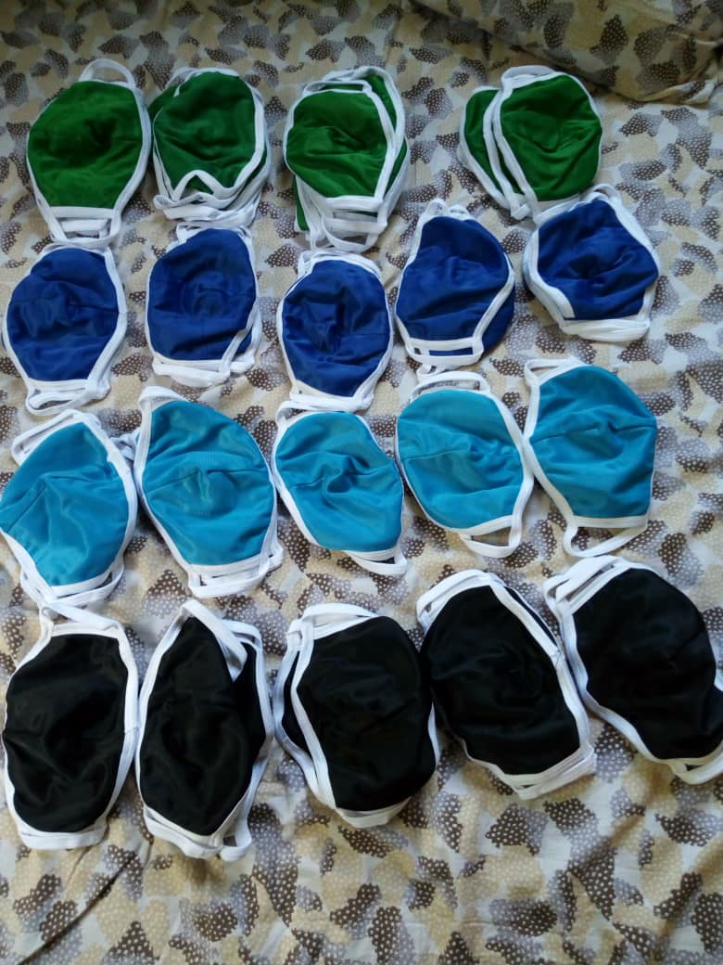

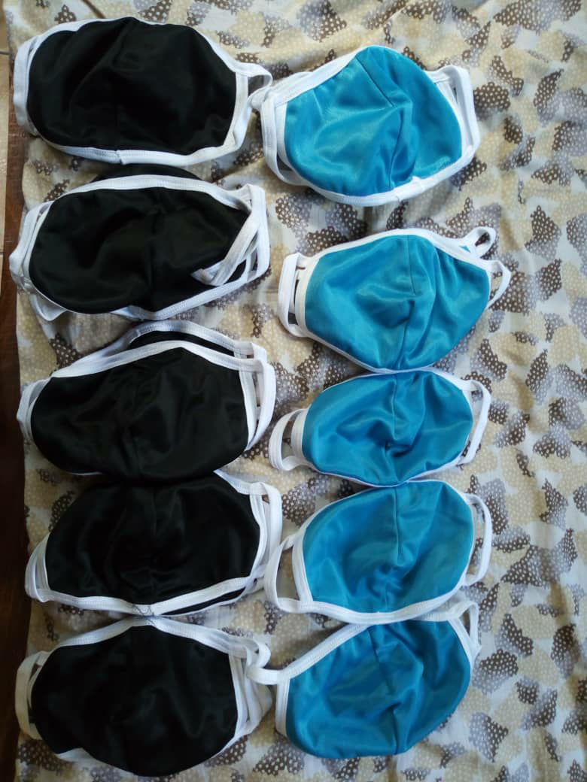
For your delivery or more information please contact us:
Twinamatsiko Brian
0922065785/0925823310

