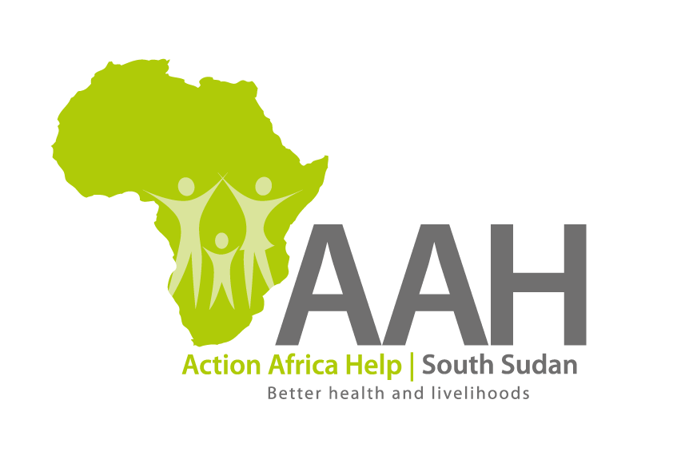
AAHI-South Sudan
Juba Office: Hai Gabat – Opp JIT Supermarket
Behind South Sudan Customs, Tel: +211 925 478 457
Email: ssudan@actionafricahelp.org
Website: www.actionafricahelp.org

INVITATION TO TENDER

Background
Action Africa Help International (AAH-I) is a nongovernmental and nonprofit making Organization operating in South Sudan with a mission to support disadvantaged Communities to sustainably improve their standard of living through Community empowerment approach in partnership with stakeholders. AAH-I implements Primary Health Care, Agriculture, Humanitarian aid projects and Capacity Building.

The organization is calling for quotations from reputable companies for provision of the following construction services in Jamjang.

 | DETAILS | LOCATION OF THE TENDER
1 | Construction of Ajuong Thok waiting shades,4 structures of (20m x8m) | Tender details to be picked from AAHI/UNHCR Logistic base OR AAHI Jamjang Logistic base
2 | Construction of Pamir waiting shade 2 structures of (20m x 8m)
3 | Construction of Ajuong Thok dining shade (6m x4m)
4 | Construction of 2 blocks of VIP latrines
5 | Extension of Ajoung thok field office fence,280 m
6 | Extension of Pamir field office fence, 50m
7 | Guard House Constriction at Pamir and Ajoung Thok UNHCR Field Office ,2 structures
8 | Partitioning of existing Pamir waiting shade, 3 structures
9 | Partitioning of existing Ajuong Thok waiting shade, 3 structures
10 | Partitioning of the existing Pamir meeting room and renovation of CRA accommodation in Jamjang.

The deadline for submission is Wednesday the 6th April, 2022, at 12:00 pm Local Time.

More information on the tender to be picked from AAHI/UNHCR Juba logistic base and AAHI Jamjang Logistics base.

