***(EN only) – to publish Wed. May 14, 2025***

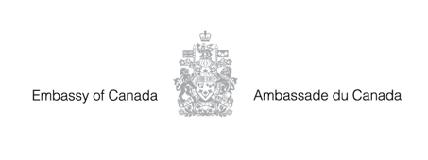

**The Embassy of Canada is hiring!**

The Embassy of Canada to South Sudan is seeking qualified candidates for the position of Political and Public Affairs Officer.

* **Application deadline:** Monday, May 26, 2025
* **Apply here:** <https://staffing-les.international.gc.ca/en> (select South Sudan)



*@CanSouthSudan*  *https://www.facebook.com/CanadainSouthSudan/*

