INVITATION TO TENDER
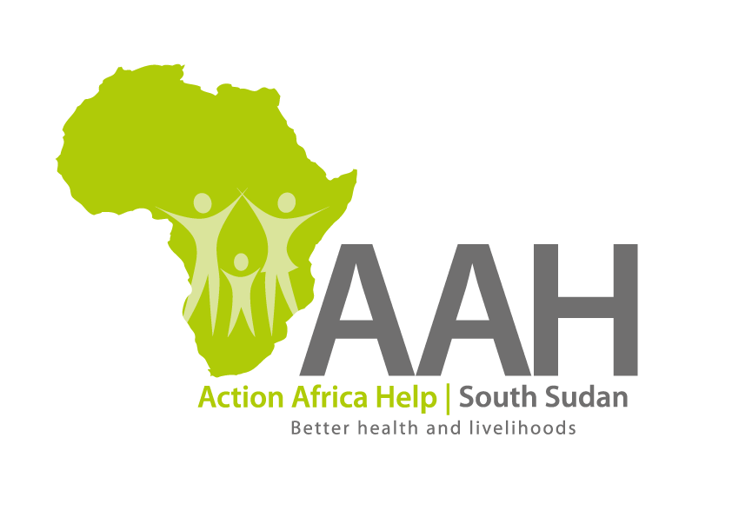
Background
Action Africa Help International (AAH-I) is a nongovernmental Organization and nonprofit making operating in South Sudan with a mission to support disadvantaged Communities to sustainably improve their standard of living through Community empowerment approach in partnership with stake holders. AAH-I implements Primary Health Care, Agriculture, Humanitarian aid projects and Capacity Building.

The organization is inviting bids from competent and reputable Companies for the bellow services.

 | Description of Goods/Services
1 | Provision of Labour and Materials for the construction of one stance Toilet Block at AAH-I Logistics Base
2 | Provision of Labour for Plumbing services at AAH-I Juba Logistics Base
3 | Provision of labour and materials for renovation of AAH-I Yei workshop office

More details on the said tenders can be picked from AAHI/UNHCR Juba Logistics base during working hours (Monday to Friday, 9:00am to 11.30am and 2:00pm to 4.00pm)

Deadline for submission of the bids will be on Monday 24th July, 2023 at 12:00pm.

