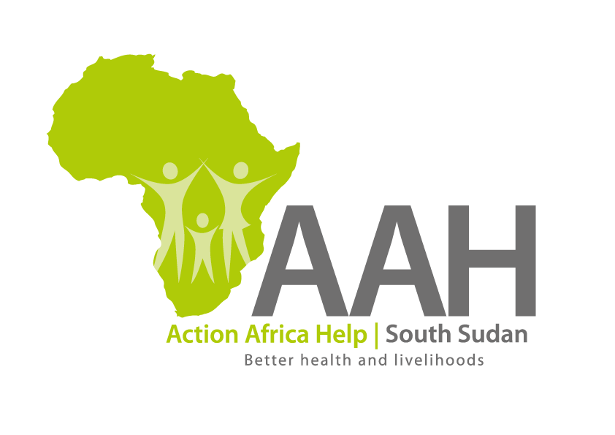
INVITATION TO BID

Background
Action Africa Help International (AAH-I) is a nongovernmental and nonprofit making Organization operating in South Sudan with a mission to support disadvantaged Communities to sustainably improve their standard of living through Community empowerment approach in partnership with stakeholders. AAH-I implements Primary Health Care, Agriculture, Humanitarian aid projects and Capacity Building.

The organization is inviting bids from reputable companies to get into a long-term framework agreement for construction of emergency family shelter in Kaya, Doro and Gendressa camps in Maban as per specification indicated below:

NO | WORK DESCRIPTION
1 | Construction of emergency family shelter (3x6m) as per the provided BOQ.

Interested bidders can collect detailed ITB and BOQ from AAHI/UNHCR Logistic base OR request through procurement.southsudan@actionafricahelp.org.

The deadline for the submission of the bids is 18th February, 2026.

