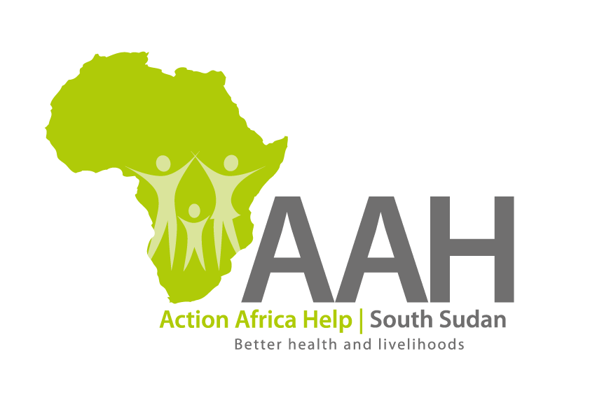
AAH South Sudan
Juba Office: Hai Gabat – Opp JIT Supermarket
Behind South Sudan Customs, Tel: +211 925 478 457
Email: ssudan@actionafricahelp.org
Website: www.actionafricahelp.org

INVITATION TO TENDER - RE-ADVERTISEMENT

Background
Action Africa Help International (AAH-I) is a nongovernmental and nonprofit making Organization operating in South Sudan with a mission to support disadvantaged Communities to sustainably improve their standard of living through Community empowerment approach in partnership with stake holders. AAH-I implements Primary Health Care, Food Security, Humanitarian aid and Public Works Projects.

The organization is inviting for bids from competent and reputable companies for supply of food items as indicated below:

s/n | Items description | U o M | Quantity
1 | Rice (20Kg) | Bag | 50
2 | Lentils (20kg) | bag | 50
3 | Sugar (50kg) | bag | 25
4 | Chicken stock (benny paste) 500g | Carton | 30
5 | Cooking oil (20 liters) | Jerrican | 20

Deadline for submission of the bids will be on 17th June, 2022.

