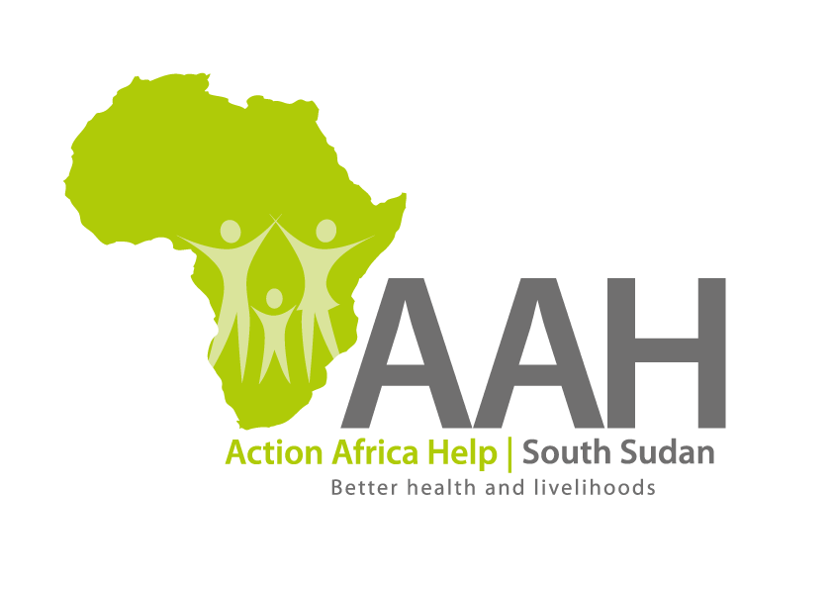
AAH South Sudan
Juba Office: Hai Gabat – Opp JIT Supermarket
Behind South Sudan Customs, Tel: +211 925 478 457
Email: ssudan@actionafricahelp.org
Website: www.actionafricahelp.org

INVITATION TO TENDER - RE-ADVERTISEMENT

Background
Action Africa Help International (AAH-I) is a nongovernmental and nonprofit making Organization operating in South Sudan with a mission to support disadvantaged Communities to sustainably improve their standard of living through Community empowerment approach in partnership with stake holders. AAH-I implements Primary Health Care, Food Security, Humanitarian aid and Public Works Projects.

The organization is inviting for bids from competent and reputable companies for supply of various spare parts and other supplies as indicated below:

 | DESCRIPTION | DETAILS
1. | Supply of armco steel culverts (1200mm) – (RF-7424) | Lists to be picked at AAHI/UNHCR Logistic base
4. | Supply of Isuzu spare parts – (RF-7924) | Lists to be picked at AAHI/UNHCR Logistic base
5. | Supply of CAT batteries – (RF-7532) | Lists to be picked at AAHI/UNHCR Logistic base

More details to be picked from AAHI/UNHCR Logistic base in Juba

The deadline for submission in on 8th June, 2022.

