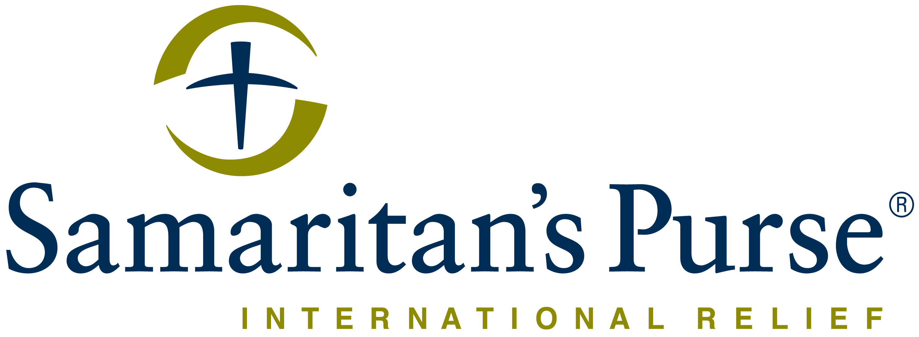
Franklin Graham President

WE PRACTICE PROCUREMENT WITH INTEGRITY.
EMAIL UNETHICAL BEHAVIOR TO SouthSudanSealedBid@Samaritan.org FOR CONFIDENTIAL REPORTING.

FROM: Date: 19th November 2019
Samaritan’s Purse International Relief
South Sudan, Hai Cinema next to
Quality Hotel, Old Juba Town Road.
E-mail: SouthSudanSealedBid@Samaritan.org

Subject: REQUEST FOR THE SUPPLY OF EMMERGENCY KITCHEN SUPPLIES FOR MABAN
Reference number: MBJU 32540

Samaritan’s Purse wishes to contract an aviation company for the supply of emergency kitchen supplies for Maban.

Please submit your tender in accordance with the requirements detailed below;

By hand delivery to Samaritan’s Purse Juba office in sealed enveloped clearly marked “supply of emergency kitchen supplies for Maban PR NO MBJU 32540’’.

By Email to the following address (Tender committee email): SouthSudanSealedBid@Samaritan.org with the email “supply of emergency kitchen supplies for Maban PR NO MBJU 32540’’.

- Deadline for submission of bids is 25St Nov 2019 before 5:00pm.

Item no. | Description | UNIT | QTY | PRICE (USD) | AMOUNT (USD)
1 | Jerrycan, rigid,20L, food grade plastic, screw cap 50mm | Pcs | 815
2 | Bucket, Plastic, 14L with clip cover and 50mm outlet | Pcs | 815
3 | Cooking pot, 7L, s.steel, diam 25cm, with handles | Pcs | 815
4 | Cooking pot, 5L, s.steel, diam 20cm, with handles and lid | Pc | 815
5 | Aluminium, food serving tray ( dia : 60cm) | Pc | 1630
6 | Cup, stainless steel, with handle, 300ml | Pc | 2445
7 | Plate, deep, stainless steel, diam.22cm, cap 0.75L | Pc | 3260

Your bid should clearly indicate the following:
- Currency of offer in USD
- Net price after deduction of discounts:
- Availability:
- Validity Must be minimum of 3 months year
- Detailed specifications (if different from stipulated specifications):
- Limitations
- Delivery should be DDP Juba (Delivery duty paid).

Sealing and Marking of Bids
The Bidder shall enclose the bid in a plain envelope securely sealed, the envelope shall:
- Be addressed to the tender committee ( See above e-mail addresses) Juba office
- Bear the bid reference number MBJU 32540 and subject of the bid category
- No other markings should be on the envelope.
- The bidder will drop the envelope into a tender box located at the Samaritan’s Purse office reception and shall register the company and name of the person dropping the envelope.
If all envelopes are not sealed and marked as required, the tender committee will reject the bid during the review time. Bidders with questions regarding this notice should send them in writing to the email address provided above.

Conditions of bidding:
- Bids must be valid for a minimum of 3 months.
- Submit samples but Samaritan’s Purse will not be liable for refund of the costs.
- Sign Tender code of conduct and return alongside your bid documents
- Payment terms will be within 30 business days after receipt of services and monthly invoice, by bank transfer/cheque only.
- A reference list with valid current phone numbers and emails.
- Business Contact details including President/Owners of the company
- Samaritan’s Purse is not subject to VAT; therefore all offers should be exclusive of VAT costs.
- Deadline for submission of bids is 25st Nov 2019 before 5:00pm.
- NB: No tender documents are to be requested from the office. You only need to submit your quotation as instructed above.
- If submitting in an EMAIL format, only bids submitted solely to SouthSudanSealedBid@Samaritan.org will be accepted. If contacted directly by Samaritan’s Purse, do not submit to the SP contacts email address.

Terms & Conditions:
- SAMARITAN’S PURSE accepts no responsibility and is under no obligation to reimburse applicants for the costs associated with preparation of their applications;
- SAMARITAN’S PURSE reserves the right to award the most qualified service provider (contractor) regardless of the lowest price submitted;
- Payment is upon delivery and after preliminary verification of the items specified; their functionality and originality;
- SAMARITAN’S PURSE reserves the right to award to more than one bidder or to reject all applicants and cancel the solicitation at any time.

Addis Ababa Road Hai Cinema
Juba, South Sudan "All we have comes from God and we give it out of His hand.”
- 1 Chronicles 29:14b, Dutch Paraphrase +211.914.444.567
www.samaritanspurse.org

Hai Cinema next to Quality Hotel
Juba, South Sudan

Addis Ababa Road Hai Cinema
Juba, South Sudan
"All we have comes from God and we give it out of His hand.”
- 1 Chronicles 29:14b, Dutch Paraphrase

